2026

MPLS & VPLS Backbone Design based on Islington College Using GNS3 and MikroTik

MPLS & VPLS

**SUBASH SUBEDI**

**Project@suashsubedi0.com.np**

**Scenario**

Islington College operates a multi-block campus network consisting of 9 academic and administrative blocks. The college owns a public IPv4 address range (160.30.132.0/24), which must be used for router loopback interfaces within an MPLS backbone.

We are required to design, implement, and verify an MPLS-based core network using MikroTik routers in GNS3, providing VPLS-based Layer-2 connectivity across all blocks while using a centralized DHCP server.

The LONDON_BLOCK is the main block, connected to the Internet (ISP), and all other blocks connect to it directly and via additional mesh links for redundancy and load balancing.

**Network Architecture and IP Addressing Plan:**

Core Design

* All block routers act as MPLS core routers
* OSPF is the IGP across all routers
* MPLS with LDP must be enabled on all core and mesh links
* ECMP / Load balancing must be implemented
* VPLS must be used to extend VLANs across all blocks
* No DHCP service should run on any router

Use the following explicit IP addressing scheme. All loopback addresses are from the public IPv4 range 160.30.132.0/24 (160.30.132.0 to 160.30.132.255). Do not use any other IPs for loopbacks or links.

**Block Routers and Loopback IPs**

* LONDON_BLOCK (main block, connected to ISP): Loopback IP 160.30.132.1/32
* UK_BLOCK: Loopback IP 160.30.132.11/32
* NEPAL_BLOCK: Loopback IP 160.30.132.12/32
* HIMAL_BLOCK: Loopback IP 160.30.132.13/32
* BRIT_BLOCK: Loopback IP 160.30.132.14/32
* SKILL_BLOCK: Loopback IP 160.30.132.15/32
* ALUMNI_BLOCK: Loopback IP 160.30.132.16/32
* KUMARI _BLOCK: Loopback IP 160.30.132.17/32

**Point-to-Point Links from LONDON_BLOCK (Private IPs, /30 subnets):**

* LONDON_BLOCK to UK_BLOCK: 10.0.0.0/30 (LONDON_BLOCK: 10.0.0.1, UK_BLOCK: 10.0.0.2)
* LONDON_BLOCK to NEPAL_BLOCK: 10.0.0.4/30 (LONDON_BLOCK: 10.0.0.5, NEPAL_BLOCK: 10.0.0.6)
* LONDON_BLOCK to HIMAL_BLOCK: 10.0.0.8/30 (LONDON_BLOCK: 10.0.0.9, HIMAL_BLOCK: 10.0.0.10)
* LONDON_BLOCK to BRIT_BLOCK: 10.0.0.12/30 (LONDON_BLOCK: 10.0.0.13, BRIT_BLOCK: 10.0.0.14)
* LONDON_BLOCK to SKILL_BLOCK: 10.0.0.16/30 (LONDON_BLOCK: 10.0.0.17, SKILL_BLOCK: 10.0.0.18)
* LONDON_BLOCK to KUMARI_BLOCK: 10.0.0.20/30 (LONDON_BLOCK: 10.0.0.21, KUMARI_BLOCK: 10.0.0.22)
* LONDON_BLOCK to ALUMNI_BLOCK: 10.0.0.24/30 (LONDON_BLOCK: 10.0.0.25, ALUMNI_BLOCK: 10.0.0.26)

**Mesh Connections (Router-to-Router Private IPs, /30 subnets for redundancy):**

* UK_BLOCK to NEPAL_BLOCK: 10.0.0.28/30 (UK_BLOCK: 10.0.0.29, NEPAL_BLOCK: 10.0.0.30)
* UK_BLOCK to HIMAL_BLOCK: 10.0.0.32/30 (UK_BLOCK: 10.0.0.34, HIMAL_BLOCK: 10.0.0.33)
* NEPAL_BLOCK to BRIT_BLOCK: 10.0.0.36/30 (NEPAL_BLOCK: 10.0.0.37, BRIT_BLOCK: 10.0.0.38)
* HIMAL_BLOCK to SKILL_BLOCK: 10.0.0.40/30 (HIMAL_BLOCK: 10.0.0.42, SKILL_BLOCK: 10.0.0.41)
* BRIT_BLOCK to KUMARI_BLOCK: 10.0.0.44/30 (BRIT_BLOCK: 10.0.0.46, KUMARI_BLOCK: 10.0.0.45)
* SKILL_BLOCK to ALUMNI_BLOCK: 10.0.0.48/30 (SKILL_BLOCK: 10.0.0.50, ALUMNI_BLOCK: 10.0.0.49)
* ALUMNI_BLOCK to KUMARI_BLOCK: 10.0.0.52/30 (ALUMNI_BLOCK: 10.0.0.53, KUMARI_BLOCK: 10.0.0.54)

**VLANs and End-Device Subnets (Provided by Centralized DHCP):**

* VLAN 100 (STUDENT): 172.16.0.0/19 (capacity for 5,000 student IPs)
* VLAN 200 (TEACHER): 172.16.32.0/22 (capacity for 1,000 teacher IPs)
* VLAN 300 (STAFF): 172.16.40.0/21 (capacity for 2,000 staff IPs)

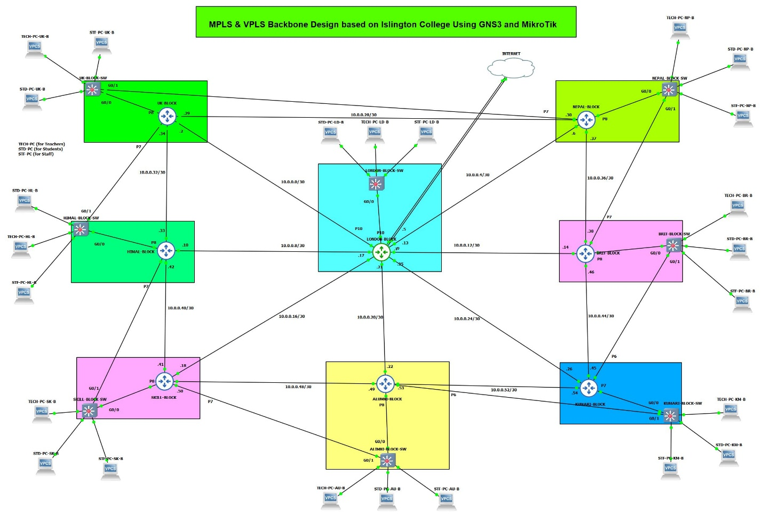

**Table of Contents**

1. Set Identity, Loopback Address and RoMON to all Routers 1

1.1. LONDON-BLOCK 1

1.2. UK-BLOCK 1

1.3. NEPAL-BLOCK 2

1.4. HIMAL-BLOCK 3

1.5. BRIT-BLOCK 4

1.6. SKILL-BLOCK 5

1.7. ALUMNI-BLOCK 6

1.8. KUMARI-BLOCK 7

2. Set Interface description, Enable Loop Protection & Disable Unused ports on all router 9

2.1. LONDON-BLOCK 9

2.2. UK-BLOCK 10

2.3. NEPAL-BLOCK 10

2.4. HIMAL-BLOCK 11

2.5. BRIT-BLOCK 12

2.6. SKILL-BLOCK 13

2.7. ALUMNI-BLOCK 14

2.8. KUMARI-BLOCK 15

3. Configuration IP in the Core Interface of all Routers 17

3.1. LONDON-BLOCK 17

3.2. UK-BLOCK 19

3.3. NEPAL-BLOCK 19

3.4. HIMAL-BLOCK 20

3.5. BRIT-BLOCK 21

3.6. SKILL-BLOCK 22

3.7. ALUMNI-BLOCK 23

3.8. KUMARI-BLOCK 24

4. Configurations Graphing on all router 26

4.1. LONDON-BLOCK 26

4.2. UK-BLOCK 26

4.3. NEPAL-BLOCK 26

4.4. HIMAL-BLOCK 27

4.5. BRIT-BLOCK 27

4.6. SKILL-BLOCK 27

4.7. ALUMNI-BLOCK 28

4.8. KUMARI-BLOCK 28

5. Configuration OSPF to all Core Routers 29

5.1. LONDON-BLOCK 29

5.2. UK-BLOCK 32

5.3. NEPAL-BLOCK 34

5.4. HIMAL-BLOCK 36

5.5. BRIT-BLOCK 38

5.6. SKILL-BLOCK 40

5.7. ALUMNI-BLOCK 42

5.8. KUMARI-BLOCK 44

6. Configure Management Access from PC to MPLS Loopback 46

6.1. PC (VMware Host) – Static Route Configuration 46

6.2. UK-BLOCK – OSPF Configuration (No Management Network Advertisement) 46

6.3. Disable RoMON temporarily to avoid confusion 47

6.4. End-to-End Verification (From PC) 47

7. Configuration MPLS to all Core Routers 49

7.1. LONDON-BLOCK 49

7.2. UK-BLOCK 49

7.3. NEPAL-BLOCK 50

7.4. HIMAL-BLOCK 51

7.5. BRIT-BLOCK 52

7.6. SKILL-BLOCK 53

7.7. ALUMNI-BLOCK 53

7.8. KUMARI-BLOCK 54

8. MPLS & LDP Configuration on Core Interfaces (with MTU) 56

8.1. LONDON-BLOCK 56

8.1.1. Enable LDP on Core Interfaces ONLY 56

8.1.2. Enable MPLS & Set MPLS MTU on interfaces 57

8.2. UK-BLOCK 58

8.2.1. Enable LDP on Core Interfaces ONLY 58

8.2.2. Enable MPLS & Set MPLS MTU on interfaces 58

8.3. NEPAL-BLOCK 59

8.3.1. Enable LDP on Core Interfaces ONLY 59

8.3.2. Enable MPLS & Set MPLS MTU on interfaces 60

8.4. HIMAL-BLOCK 61

8.4.1. Enable LDP on Core Interfaces ONLY 61

8.4.2. Enable MPLS & Set MPLS MTU on interfaces 61

8.5. BRIT-BLOCK 62

8.5.1. Enable LDP on Core Interfaces ONLY 62

8.5.2. Enable MPLS & Set MPLS MTU on interfaces 63

8.6. SKILL-BLOCK 64

8.6.1. Enable LDP on Core Interfaces ONLY 64

8.6.2. Enable MPLS & Set MPLS MTU on interfaces 65

8.7. ALUMNI-BLOCK 66

8.7.1. Enable LDP on Core Interfaces ONLY 66

8.7.2. Enable MPLS & Set MPLS MTU on interfaces 67

8.8. KUMARI-BLOCK 68

8.8.1. Enable LDP on Core Interfaces ONLY 68

8.8.2. Enable MPLS & Set MPLS MTU on interfaces 69

9. VPLS Configuration for VLAN Transport (Points to Points) Routers 71

9.1. LONDON-BLOCK 71

9.1.1. Create VPLS BRIDGES (L2 DOMAINS) 71

9.1.2. VPLS Full-Mesh for LONDON-BLOCK 71

9.2. UK-BLOCK 73

9.2.1. Create VPLS BRIDGES (L2 DOMAINS) 73

9.2.2. VPLS Configuration (UK-Points to LONDON-Points) 74

9.3. NEPAL-BLOCK 75

9.3.1. Create VPLS BRIDGES (L2 DOMAINS) 75

9.3.2. VPLS Configuration (NEPAL-Points to LONDON-Points) 76

9.4. HIMAL-BLOCK 77

9.4.1. Create VPLS BRIDGES (L2 DOMAINS) 77

9.4.2. VPLS Configuration (HIMAL-Points to LONDON-Points) 78

9.5. BRIT-BLOCK 79

9.5.1. Create VPLS BRIDGES (L2 DOMAINS) 79

9.5.2. VPLS Configuration (BRIT-Points to LONDON-Points) 79

9.6. SKILL-BLOCK 80

9.6.1. Create VPLS BRIDGES (L2 DOMAINS) 80

9.6.2. VPLS Configuration (SKILL-Points to LONDON-Points) 81

9.7. ALUMNI-BLOCK 82

9.7.1. Create VPLS BRIDGES (L2 DOMAINS) 82

9.7.2. VPLS Configuration (ALUMNI-Points to LONDON-Points) 83

9.8. KUMARI-BLOCK 84

9.8.1. Create VPLS BRIDGES (L2 DOMAINS) 84

9.8.2. VPLS Configuration (KUMARI-Points to LONDON-Points) 85

10. Switch TO Router Configuration of Each Block 86

10.1. LONDON-BLOCK 86

10.2. UK-BLOCK 88

10.3. NEPAL-BLOCK 91

10.4. HIMAL-BLOCK 93

10.5. BRIT-BLOCK 96

10.6. SKILL-BLOCK 99

10.7. ALUMNI-BLOCK 102

10.8. KUMARI-BLOCK 105

11. Router TO Switch Trunk Configuration of Each Block 109

11.1. LONDON-BLOCK 109

11.2. UK-BLOCK 110

11.2.1. Primary UK-BLOCK- SWITCH 110

11.2.2. Secondary HIMAL-BLOCK-SWITCH 111

11.3. NEPAL-BLOCK 112

11.3.1. Primary NEPAL-BLOCK-SWITCH 112

11.3.2. Secondary-UK-BLOCK-SWITCH 113

11.4. HIMAL-BLOCK 114

11.4.1. Primary HIMAL-BLOCK-SWITCH 114

11.4.2. Secondary SKILL-BLOCK-SWITCH 115

11.5. BRIT-BLOCK 116

11.5.1. Primary BRIT-BLOCK-SWITCH 116

11.5.2. Secondary NEPAL-BLOCK-SWITCH 117

11.6. SKILL-BLOCK 119

11.6.1. Primary SKILL-BLOCK-SWITCH 119

11.6.2. Secondary ALUMNI-BLOCK-SWITCH 120

11.7. ALUMNI-BLOCK 121

11.7.1. Primary ALUMNI-BLOCK-SWITCH 121

11.7.2. Secondary KUMARI-BLOCK-SWITCH 122

11.8. KUMARI-BLOCK 123

11.8.1. Primary KUMARI-BLOCK-SWITCH 123

11.8.2. Secondary BRIT-BLOCK-SWITCH 124

12. Centralized DHCP Server Configuration 125

12.1. LONDON-BLOCK 125

12.1.1. Assign Gateway IPs to VLAN bridges 125

12.1.2. Create DHCP pools 126

12.1.3. Create DHCP servers (one per VLAN bridge) 127

12.1.4. Define DHCP network options 128

13. DHCP Verification 130

13.1. LONDON-BLOCK 130

13.2. UK-BLOCK 131

14. Network Topology and Diagrams 132

14.1. Full Network Topology Diagram 132

15. Conclusion and Future Enhancements 134

15.1. Conclusion 134

15.2. Future Enhancements 135

**List of Figures**

Figure 1: Set Identity, Loopback Address and RoMoN of LONDON_BLOCK Router Through CMD 1

Figure 2: Set Identity, Loopback Address and RoMoN of LONDON_BLOCK Router Through WINBOX 1

Figure 3: Set Identity, Loopback Address and RoMoN of UK-BLOCK Router Through CMD 2

Figure 4: Set Identity, Loopback Address and RoMoN of UK-BLOCK Router Through WINBOX 2

Figure 5: Set Identity, Loopback Address and RoMoN of NEPAL-BLOCK Router Through CMD 3

Figure 6: Set Identity, Loopback Address and RoMoN of NEPAL-BLOCK Router Through WINBOX 3

Figure 7: Set Identity, Loopback Address and RoMoN of NEPAL-BLOCK Router Through CMD 4

Figure 8: Set Identity, Loopback Address and RoMoN of NEPAL-BLOCK Router Through WINBOX 4

Figure 9: Set Identity, Loopback Address and RoMoN of BRIT-BLOCK Router Through CMD 5

Figure 10: Set Identity, Loopback Address and RoMoN of BRIT-BLOCK Router Through WINBOX 5

Figure 11: Set Identity, Loopback Address and RoMoN of SKILL-BLOCK Router Through CMD 6

Figure 12: Set Identity, Loopback Address and RoMoN of SKILL-BLOCK Router Through WINBOX 6

Figure 13: Set Identity, Loopback Address and RoMoN of ALUMNI-BLOCK Router Through CMD 7

Figure 14: Set Identity, Loopback Address and RoMoN of ALUMNI-BLOCK Router Through WINBOX 7

Figure 15: Set Identity, Loopback Address and RoMoN of KUMARI-BLOCK Router Through CMD 7

Figure 16: Set Identity, Loopback Address and RoMoN of KUMARI-BLOCK Router Through WINBOX 8

Figure 17: Set Interface Description, Enable Loop Protection & Disable Unused ports on LONDON-BLOCK Router Through CMD 9

Figure 18: Set Interface Description, Enable Loop Protection & Disable Unused ports on LONDON-BLOCK Router Through WINBOX 9

Figure 19: Set Interface Description, Enable Loop Protection & Disable Unused ports on UK-BLOCK Router Through CMD 10

Figure 20: Set Interface Description, Enable Loop Protection & Disable Unused ports on UK-BLOCK Router Through WINBOX 10

Figure 21: Set Interface Description, Enable Loop Protection & Disable Unused ports on NEPAL-BLOCK Router Through CMD 11

Figure 22: Set Interface Description, Enable Loop Protection & Disable Unused ports on NEPAL-BLOCK Router Through WINBOX 11

Figure 23: Set Interface Description, Enable Loop Protection & Disable Unused ports on HIMAL-BLOCK Router Through CMD 12

Figure 24: Set Interface Description, Enable Loop Protection & Disable Unused ports on HIMAL-BLOCK Router Through WINBOX 12

Figure 25: Set Interface Description, Enable Loop Protection & Disable Unused ports on BRIT-BLOCK Router Through CMD 12

Figure 26: Set Interface Description, Enable Loop Protection & Disable Unused ports on BRIT-BLOCK Router Through WINBOX 13

Figure 27: Set Interface Description, Enable Loop Protection & Disable Unused ports on SKILL-BLOCK Router Through CMD 13

Figure 28: Set Interface Description, Enable Loop Protection & Disable Unused ports on SKILL-BLOCK Router Through WINBOX 14

Figure 29: Set Interface Description, Enable Loop Protection & Disable Unused ports on ALUMNI-BLOCK Router Through CMD 14

Figure 30: Set Interface Description, Enable Loop Protection & Disable Unused ports on ALUMNI-BLOCK Router Through WINBOX 15

Figure 31: Set Interface Description, Enable Loop Protection & Disable Unused ports on KUMARI-BLOCK Router Through CMD 15

Figure 32: Set Interface Description, Enable Loop Protection & Disable Unused ports on KUMARI-BLOCK Router Through WINBOX 16

Figure 33: Configuration IP in the Core Interface of LONDON-BLOCK Router Through CMD 17

Figure 34: Configuration IP in the Core Interface of LONDON-BLOCK Router Through WINBOX 18

Figure 35: Configuration IP in the Core Interface of UK-BLOCK Router Through CMD 19

Figure 36: Configuration IP in the Core Interface of UK-BLOCK Router Through WINBOX 19

Figure 37: Configuration IP in the Core Interface of NEPAL-BLOCK Router Through CMD 20

Figure 38: Configuration IP in the Core Interface of NEPAL-BLOCK Router Through WINBOX 20

Figure 39: Configuration IP in the Core Interface of HIMAL-BLOCK Router Through CMD 21

Figure 40: Configuration IP in the Core Interface of HIMAL-BLOCK Router Through WINBOX 21

Figure 41: Configuration IP in the Core Interface of BRIT-BLOCK Router Through CMD 21

Figure 42: Configuration IP in the Core Interface of BRIT-BLOCK Router Through WINBOX 22

Figure 43: Configuration IP in the Core Interface of SKILL-BLOCK Router Through CMD 22

Figure 44: Configuration IP in the Core Interface of SKILL-BLOCK Router Through WINBOX 23

Figure 45: Configuration IP in the Core Interface of ALUMNI-BLOCK Router Through CMD 23

Figure 46: Configuration IP in the Core Interface of ALUMNI-BLOCK Router Through WINBOX 24

Figure 47: Configuration IP in the Core Interface of KUMARI-BLOCK Router Through CMD 24

Figure 48: Configuration IP in the Core Interface of KUMARI-BLOCK Router Through WINBOX 25

Figure 49: Configurations Graphing on LONDON-BLOCK Router Through CMD 26

Figure 50: Configurations Graphing on UK-BLOCK Router Through CMD 26

Figure 51: Configurations Graphing on NEPAL-BLOCK Router Through CMD 26

Figure 52: Configurations Graphing on HIMAL-BLOCK Router Through CMD 27

Figure 53: Configurations Graphing on BRIT-BLOCK Router Through CMD 27

Figure 54: Configurations Graphing on SKILL-BLOCK Router Through CMD 28

Figure 55: Configurations Graphing on ALUMNI-BLOCK Router Through CMD 28

Figure 56: Configurations Graphing on KUMARI-BLOCK Router Through CMD 28

Figure 57: Configuration OSPF to Core LONDON-BLOCK Router Through CMD 30

Figure 58: Configuration OSPF Instances to Core LONDON-BLOCK Router Through WINBOX 31

Figure 59: Configuration OSPF Area to Core LONDON-BLOCK Router Through WINBOX 31

Figure 60: Configuration OSPF Interface-template to Core LONDON-BLOCK Router Through WINBOX 31

Figure 61: Configuration OSPF to UK-BLOCK Router Through CMD 32

Figure 62: Configuration OSPF Instances to UK-BLOCK Router Through WINBOX 33

Figure 63: Configuration OSPF Area to UK-BLOCK Router Through WINBOX 33

Figure 64: Configuration OSPF Interface-template to UK-BLOCK Router Through WINBOX 33

Figure 65: Configuration OSPF to NEPAL-BLOCK Router Through CMD 34

Figure 66: Configuration OSPF Instances to NEPAL-BLOCK Router Through WINBOX 35

Figure 67: Configuration OSPF Area to NEPAL-BLOCK Router Through WINBOX 35

Figure 68: Configuration OSPF Interface-template to NEPAL-BLOCK Router Through WINBOX 35

Figure 69: Configuration OSPF to HIMAL-BLOCK Router Through CMD 36

Figure 70: Configuration OSPF Instances to HIMAL-BLOCK Router Through WINBOX 37

Figure 71: Configuration OSPF Area to HIMAL-BLOCK Router Through WINBOX 37

Figure 72: Configuration OSPF Interface-template to HIMAL-BLOCK Router Through WINBOX 37

Figure 73: Configuration OSPF to BRIT-BLOCK Router Through CMD 38

Figure 74: Configuration OSPF Instances to BRIT-BLOCK Router Through WINBOX 39

Figure 75: Configuration OSPF Area to BRIT-BLOCK Router Through WINBOX 39

Figure 76: Configuration OSPF Interface-template to BRIT-BLOCK Router Through WINBOX 39

Figure 77: Configuration OSPF to SKILL-BLOCK Router Through CMD 40

Figure 78: Configuration OSPF Instances to SKILL-BLOCK Router Through WINBOX 41

Figure 79: Configuration OSPF Area to SKILL-BLOCK Router Through WINBOX 41

Figure 80: Configuration OSPF Interface-template to SKILL-BLOCK Router Through WINBOX 41

Figure 81: Configuration OSPF to ALUMNI-BLOCK Router Through CMD 42

Figure 82: Configuration OSPF Instances to ALUMNI-BLOCK Router Through WINBOX 43

Figure 83: Configuration OSPF Area to ALUMNI-BLOCK Router Through WINBOX 43

Figure 84: Configuration OSPF Interface-template to ALUMNI-BLOCK Router Through WINBOX 43

Figure 85: Configuration OSPF to KUMARI-BLOCK Router Through CMD 44

Figure 86: Configuration OSPF Instances to KUMARI-BLOCK Router Through WINBOX 45

Figure 87: Configuration OSPF Area to KUMARI-BLOCK Router Through WINBOX 45

Figure 88: Configuration OSPF Interface-template to KUMARI-BLOCK Router Through WINBOX 45

Figure 89: 6.1. PC (VMware Host) - Static Route Configuration 46

Figure 90: 6.2. UK-BLOCK - OSPF Configuration (No Management Network Advertisement) 46

Figure 91: 6.4.: End-to-End Verification (From PC) 48

Figure 92: Configuration MPLS to LONDON-BLOCK Router Through CMD 49

Figure 93: Configuration MPLS to LONDON-BLOCK Router Through WINBOX 49

Figure 94: Configuration MPLS to UK-BLOCK Router Through CMD 50

Figure 95: Configuration MPLS to UK-BLOCK Router Through WINBOX 50

Figure 96: Configuration MPLS to NEPAL-BLOCK Router Through CMD 50

Figure 97: Configuration MPLS to NEPAL-BLOCK Router Through WINBOX 51

Figure 98: Configuration MPLS to HIMAL-BLOCK Router Through CMD 51

Figure 99: Configuration MPLS to HIMAL-BLOCK Router Through WINBOX 52

Figure 100: Configuration MPLS to BRIT-BLOCK Router Through CMD 52

Figure 101: Configuration MPLS to BRIT-BLOCK Router Through WINBOX 52

Figure 102: Configuration MPLS to SKILL-BLOCK Router Through CMD 53

Figure 103: Configuration MPLS to SKILL-BLOCK Router Through WINBOX 53

Figure 104: Configuration MPLS to ALUMNI-BLOCK Router Through CMD 53

Figure 105: Configuration MPLS to ALUMNI-BLOCK Router Through WINBOX 54

Figure 106: Configuration MPLS to KUMARI-BLOCK Router Through CMD 54

Figure 107: Configuration MPLS to KUMARI-BLOCK Router Through CMD 54

Figure 108: Configuration MPLS LDP Interfaces to LONDON-BLOCK Router Through CMD 56

Figure 109: Configuration MPLS LDP nterfaces to LONDON-BLOCK Router Through WINBOX 56

Figure 110: Configuration MPLS MTU on Interfaces to LONDON-BLOCK Router Through CMD 57

Figure 111: Configuration MPLS MTU on Interfaces to LONDON-BLOCK Router Through WINBOX 57

Figure 112: Configuration MPLS LDP Interfaces to UK-BLOCK Router Through CMD 58

Figure 113: Configuration MPLS LDP Interfaces to UK-BLOCK Router Through WINBOX 58

Figure 114: Configuration MPLS MTU on Interfaces to UK-BLOCK Router Through CMD 59

Figure 115: Configuration MPLS MTU on Interfaces to UK-BLOCK Router Through WINBOX 59

Figure 116: Configuration MPLS LDP Interfaces to NEPAL-BLOCK Router Through CMD 59

Figure 117: Configuration MPLS LDP Interfaces to NEPAL-BLOCK Router Through WINBOX 60

Figure 118: Configuration MPLS MTU on Interfaces to NEPAL-BLOCK Router Through CMD 60

Figure 119: Configuration MPLS MTU on Interfaces to NEPAL-BLOCK Router Through WINBOX 60

Figure 120: Configuration MPLS LDP Interfaces to HIMAL-BLOCK Router Through CMD 61

Figure 121: Configuration MPLS LDP Interfaces to HIMAL-BLOCK Router Through WINBOX 61

Figure 122: Configuration MPLS MTU on Interfaces to HIMAL-BLOCK Router Through CMD 62

Figure 123: Configuration MPLS MTU on Interfaces to HIMAL-BLOCK Router Through WINBOX 62

Figure 124: Configuration MPLS LDP Interfaces to BRIT-BLOCK Router Through CMD 62

Figure 125: Configuration MPLS LDP Interfaces to BRIT-BLOCK Router Through WINBOX 63

Figure 126: Configuration MPLS MTU on Interfaces to BRIT-BLOCK Router Through CMD 63

Figure 127: Configuration MPLS MTU on Interfaces to BRIT-BLOCK Router Through WINBOX 64

Figure 128: Configuration MPLS LDP Interfaces to SKILL-BLOCK Router Through CMD 64

Figure 129: Configuration MPLS LDP Interfaces to SKILL-BLOCK Router Through WINBOX 65

Figure 130: Configuration MPLS MTU on Interfaces to SKILL-BLOCK Router Through CMD 65

Figure 131: Configuration MPLS MTU on Interfaces to SKILL-BLOCK Router Through WINBOX\ 66

Figure 132: Configuration MPLS LDP Interfaces to ALUMNI-BLOCK Router Through CMD 66

Figure 133: Configuration MPLS LDP Interfaces to ALUMNI-BLOCK Router Through WINBOX 67

Figure 134: Configuration MPLS MTU on Interfaces to ALUMNI-BLOCK Router Through CMD 67

Figure 135: Configuration MPLS MTU on Interfaces to ALUMNI-BLOCK Router Through WINBOX 68

Figure 136: Configuration MPLS LDP Interfaces to KUMARI-BLOCK Router Through CMD 68

Figure 137: Configuration MPLS LDP Interfaces to KUMARI-BLOCK Router Through WINBOX 69

Figure 138: Configuration MPLS MTU on Interfaces to KUMARI-BLOCK Router Through CMD 69

Figure 139: Configuration MPLS MTU on Interfaces to KUMARI-BLOCK Router Through WINBOX 70

Figure 140: Create VPLS BRIDGES (L2 DOMAINS) on LONDON-BLOCK Router Through CMD 71

Figure 141: Create VPLS BRIDGES (L2 DOMAINS) on KUMARI-BLOCK Router Through WINBOX 71

Figure 142: Configuration VPLS Full-Mesh on LONDON-BLOCK Router Through CMD 73

Figure 143: Configuration VPLS Full-Mesh on LONDON-BLOCK Router Through CMD 73

Figure 144: Create VPLS BRIDGES (L2 DOMAINS) on UK-BLOCK Router Through CMD 74

Figure 145: Create VPLS BRIDGES (L2 DOMAINS) on UK-BLOCK Router Through WINBOX 74

Figure 146: VPLS Configuration (UK-Points to LONDON-Points) on UK-BLOCK Router Through CMD 75

Figure 147: VPLS Configuration (UK-Points to LONDON-Points) on UK-BLOCK Router Through WINBOX 75

Figure 148: Create VPLS BRIDGES (L2 DOMAINS) on NEPAL-BLOCK Router Through CMD 75

Figure 149: Create VPLS BRIDGES (L2 DOMAINS) on NEPAL-BLOCK Router Through WINBOX 76

Figure 150: VPLS Configuration (NEPAL-Points to LONDON-Points) on NEPAL-BLOCK Router Through CMD 76

Figure 151: VPLS Configuration (NEPAL-Points to LONDON-Points) on NEPAL-BLOCK Router Through WINBOX 77

Figure 152: Create VPLS BRIDGES (L2 DOMAINS) on HIMAL-BLOCK Router Through CMD 77

Figure 153: Create VPLS BRIDGES (L2 DOMAINS) on HIMAL-BLOCK Router Through WINBOX 77

Figure 154: VPLS Configuration (HIMAL-Points to LONDON-Points) on HIMAL-BLOCK Router Through CMD 78

Figure 155: VPLS Configuration (HIMAL-Points to LONDON-Points) on HIMAL-BLOCK Router Through WINBOX 78

Figure 156: Create VPLS BRIDGES (L2 DOMAINS) on BRIT-BLOCK Router Through CMD 79

Figure 157: Create VPLS BRIDGES (L2 DOMAINS) on BRIT-BLOCK Router Through WINBOX 79

Figure 158: VPLS Configuration (BRIT-Points to LONDON-Points) on BRIT-BLOCK Router Through CMD 80

Figure 159: VPLS Configuration (BRIT-Points to LONDON-Points) on BRIT-BLOCK Router Through WINBOX 80

Figure 160: Create VPLS BRIDGES (L2 DOMAINS) on SKILL-BLOCK Router Through CMD 81

Figure 161: Create VPLS BRIDGES (L2 DOMAINS) on SKILL-BLOCK Router Through WINBOX 81

Figure 162: VPLS Configuration (SKILL-Points to LONDON-Points) on SKILL-BLOCK Router Through CMD 82

Figure 163: VPLS Configuration (SKILL-Points to LONDON-Points) on SKILL-BLOCK Router Through WINBOX 82

Figure 164: Create VPLS BRIDGES (L2 DOMAINS) on ALUMNI-BLOCK Router Through CMD 82

Figure 165: Create VPLS BRIDGES (L2 DOMAINS) on ALUMNI-BLOCK Router Through WINBOX 83

Figure 166: VPLS Configuration (ALUMNI-Points to LONDON-Points) on ALUMNI-BLOCK Router Through CMD 83

Figure 167: VPLS Configuration (ALUMNI-Points to LONDON-Points) on ALUMNI-BLOCK Router Through WINBOX 84

Figure 168: Create VPLS BRIDGES (L2 DOMAINS) on KUMARI-BLOCK Router Through CMD 84

Figure 169: Create VPLS BRIDGES (L2 DOMAINS) on KUMARI-BLOCK Router Through WINBOX 84

Figure 170: VPLS Configuration (KUMARI-Points to LONDON-Points) on KUMARI-BLOCK Router Through CMD 85

Figure 171: VPLS Configuration (KUMARI-Points to LONDON-Points) on KUMARI-BLOCK Router Through WINBOX 85

Figure 172: Configuration of Switch to Router Links at LONDON-BLOCK (i) 88

Figure 173: Configuration of Switch to Router Links at LONDON-BLOCK (ii) 88

Figure 174: Configuration of Switch to Router Links at UK-BLOCK (i) 90

Figure 175: Configuration of Switch to Router Links at UK-BLOCK (ii) 90

Figure 176: Configuration of Switch to Router Links at NEPAL-BLOCK (i) 93

Figure 177: Configuration of Switch to Router Links at NEPAL-BLOCK (ii) 93

Figure 178: Configuration of Switch to Router Links at HIMAL-BLOCK (i) 96

Figure 179: Configuration of Switch to Router Links at HIMAL-BLOCK (ii) 96

Figure 180: Configuration of Switch to Router Links at BRIT-BLOCK (i) 99

Figure 181: Configuration of Switch to Router Links at BRIT-BLOCK (ii) 99

Figure 182: Configuration of Switch to Router Links at SKILL-BLOCK (i) 102

Figure 183: Configuration of Switch to Router Links at SKILL-BLOCK (ii) 102

Figure 184: Configuration of Switch to Router Links at ALUMNI-BLOCK (i) 105

Figure 185: Configuration of Switch to Router Links at ALUMNI-BLOCK (ii) 105

Figure 186: Configuration of Switch to Router Links at KUMARI-BLOCK (i) 108

Figure 187: Configuration of Switch to Router Links at KUMARI-BLOCK (ii) 108

Figure 188: Router TO Switch Trunk Configuration on LONDON-BLOCK Router Through CMD 109

Figure 189: Router TO Switch Trunk Configuration on LONDON-BLOCK Router Through WINBOX 110

Figure 190: Router TO Switch Primary Trunk Configuration on UK-BLOCK Router Through CMD 110

Figure 191: Router TO Switch Primary Trunk Configuration on UK-BLOCK Router Through WINBOX 111

Figure 192: Router TO Switch Secondary Trunk Configuration on UK-BLOCK Router Through CMD 111

Figure 193: Router TO Switch Secondary Trunk Configuration on UK-BLOCK Router Through WINBOX 112

Figure 194: Router TO Switch Primary Trunk Configuration on NEPAL-BLOCK Router Through CMD 113

Figure 195: Router TO Switch Primary Trunk Configuration on NEPAL-BLOCK Router Through WINBOX 113

Figure 196: Router TO Switch Secondary Trunk Configuration on SKILL-BLOCK Router Through CMD 114

Figure 197: Router TO Switch Secondary Trunk Configuration on SKILL-BLOCK Router Through WINBOX 114

Figure 198: Router TO Switch Primary Trunk Configuration on HIMAL-BLOCK Router Through CMD 115

Figure 199: Router TO Switch Primary Trunk Configuration on HIMAL-BLOCK Router Through WINBOX 115

Figure 200: Router TO Switch Secondary Trunk Configuration on HIMAL-BLOCK Router Through CMD 116

Figure 201: Router TO Switch Secondary Trunk Configuration on HIMAL-BLOCK Router Through WINBOX 116

Figure 202: Router TO Switch Primary Trunk Configuration on BRIT-BLOCK Router Through CMD 117

Figure 203: Router TO Switch Primary Trunk Configuration on BRIT-BLOCK Router Through WINBOX 117

Figure 204: Router TO Switch Secondary Trunk Configuration on BRIT-BLOCK Router Through CMD 118

Figure 205: Router TO Switch Secondary Trunk Configuration on BRIT-BLOCK Router Through WINBOX 118

Figure 206: Router TO Switch Primary Trunk Configuration on SKILL-BLOCK Router Through CMD 119

Figure 207: Router TO Switch Primary Trunk Configuration on SKILL-BLOCK Router Through WINBOX 119

Figure 208: Router TO Switch Secondary Trunk Configuration on SKILL-BLOCK Router Through CMD 120

Figure 209: Router TO Switch Secondary Trunk Configuration on SKILL-BLOCK Router Through WINBOX 121

Figure 210: Router TO Switch Primary Trunk Configuration on ALUMNI-BLOCK Router Through CMD 122

Figure 211: Router TO Switch Primary Trunk Configuration on ALUMNI-BLOCK Router Through WINBOX 122

Figure 212: Router TO Switch Secondary Trunk Configuration on ALUMNI-BLOCK Router Through CMD 123

Figure 213: Router TO Switch Secondary Trunk Configuration on ALUMNI-BLOCK Router Through WINBOX 123

Figure 214: Router TO Switch Primary Trunk Configuration on KUMARI-BLOCK Router Through CMD 124

Figure 215: Router TO Switch Primary Trunk Configuration on KUMARI-BLOCK Router Through WINBOX 124

Figure 216: Router TO Switch Secondary Trunk Configuration on KUMARI-BLOCK Router Through CMD 125

Figure 217: Router TO Switch Secondary Trunk Configuration on KUMARI-BLOCK Router Through WINBOX 125

Figure 218: Assign Gateway IPs to VLAN bridges for DHCP on LONDON-BLOCK Router Through CMD 126

Figure 219: Assign Gateway IPs to VLAN bridges for DHCP on LONDON-BLOCK Router Through WINBOX 126

Figure 220: Create DHCP pools for DHCP on LONDON-BLOCK Router Through CMD 127

Figure 221: Create DHCP pools for DHCP on LONDON-BLOCK Router Through WINBOX 127

Figure 222: Create DHCP servers (one per VLAN bridge) on LONDON-BLOCK Router Through CMD 127

Figure 223: Create DHCP servers (one per VLAN bridge) on LONDON-BLOCK Router Through WINBOX 128

Figure 224: Define DHCP network options on LONDON-BLOCK Router Through CMD 128

Figure 225: Define DHCP network options on LONDON-BLOCK Router Through WINBOX 129

Figure 226: DHCP Verification of Student PC on LONDON-BLOCK 130

Figure 227: DHCP Verification of Teacher PC on LONDON-BLOCK 130

Figure 228: DHCP Verification of Staff PC on LONDON-BLOCK 130

Figure 229: DHCP Verification of Student PC on UK-BLOCK 131

Figure 230: DHCP Verification of Teacher PC on UK-BLOCK 131

Figure 231: DHCP Verification of Staff PC on UK-BLOCK 131

# Set Identity, Loopback Address and RoMON to all Routers

## LONDON-BLOCK

**CMD**

|  |
| --- |
| /system identity set name=LONDON-BLOCK  /interface bridge add name=loopback comment=“LONDON-BLOCK_160.30.132.1_LOOPBACK”  /ip address add address=160.30.132.1/32 interface=loopback comment=“LONDON-BLOCK_160.30.132.1_LOOPBACK”  /tool/romon/set enabled=yes |

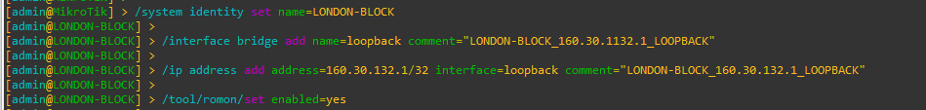

Figure 1: Set Identity, Loopback Address and RoMoN of LONDON_BLOCK Router Through CMD

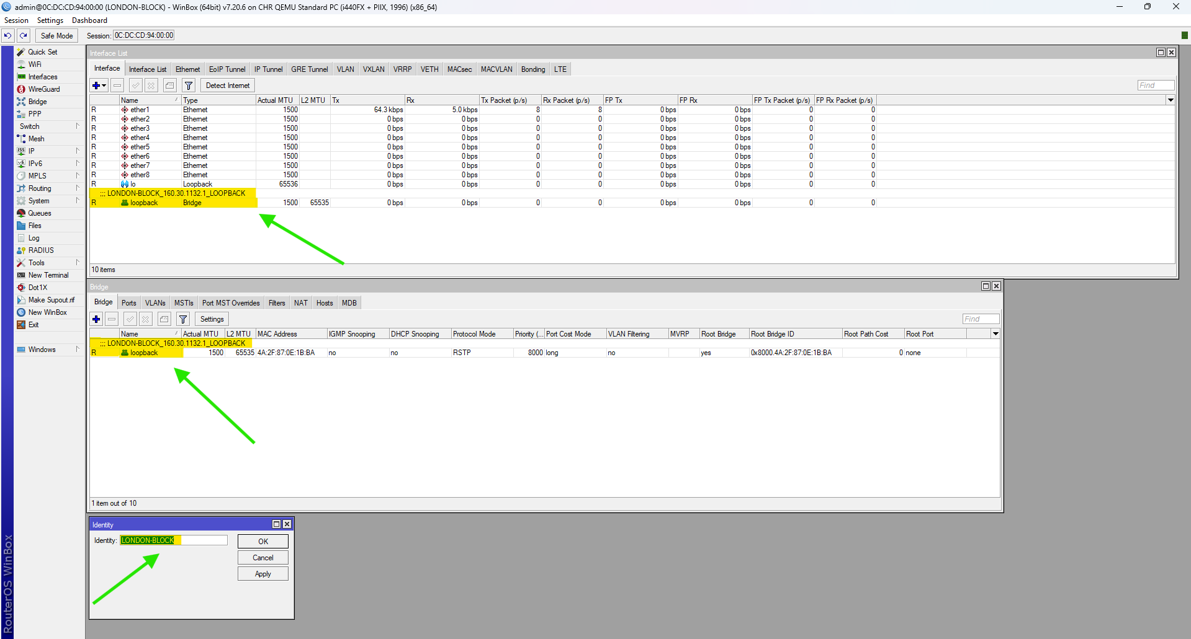

Figure 2: Set Identity, Loopback Address and RoMoN of LONDON_BLOCK Router Through WINBOX

## UK-BLOCK

**CMD**

|  |
| --- |
| /system identity set name= UK-BLOCK  /interface bridge add name=loopback comment=“ UK-BLOCK_160.30.132.11_LOOPBACK”  /ip address add address=160.30.132.11/32 interface=loopback comment=“ UK-BLOCK_160.30.132.11_LOOPBACK”  /tool/romon/set enabled=yes |

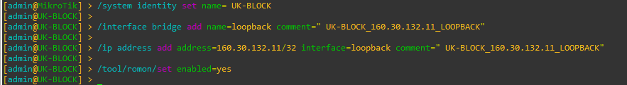

Figure 3: Set Identity, Loopback Address and RoMoN of UK-BLOCK Router Through CMD

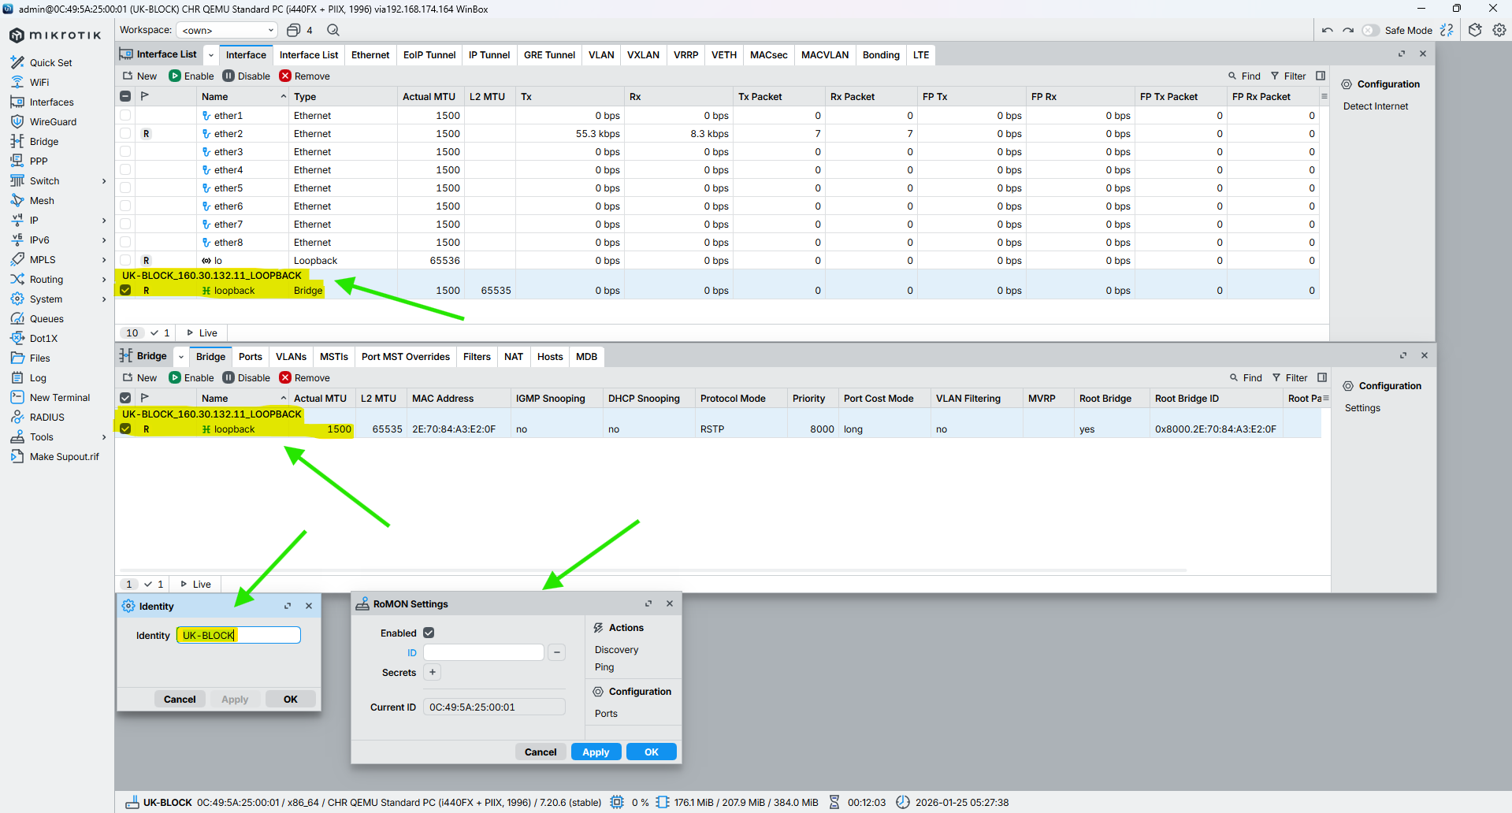

Figure 4: Set Identity, Loopback Address and RoMoN of UK-BLOCK Router Through WINBOX

## NEPAL-BLOCK

**CMD**

|  |
| --- |
| /system identity set name=NEPAL-BLOCK  /interface bridge add name=loopback comment=“NEPAL-BLOCK_160.30.132.12_LOOPBACK”  /ip address add address=160.30.132.12/32 interface=loopback comment=“NEPAL-BLOCK_160.30.132.12_LOOPBACK”  /tool/romon/set enabled=yes |

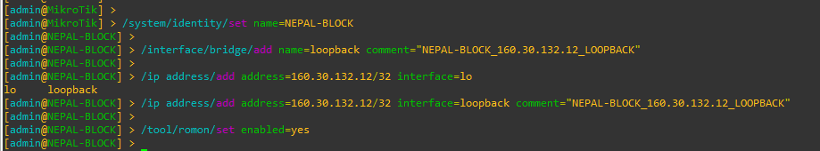

Figure 5: Set Identity, Loopback Address and RoMoN of NEPAL-BLOCK Router Through CMD

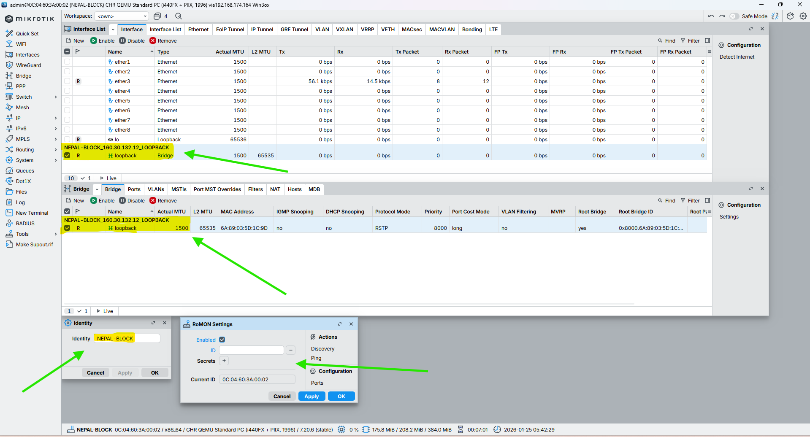

Figure 6: Set Identity, Loopback Address and RoMoN of NEPAL-BLOCK Router Through WINBOX

## HIMAL-BLOCK

**CMD**

|  |
| --- |
| /system identity set name=HIMAL-BLOCK  /interface bridge add name=loopback comment=“HIMAL-BLOCK_160.30.132.13_LOOPBACK”  /ip address add address=160.30.132.13/32 interface=loopback comment=“HIMAL-BLOCK_160.30.132.13_LOOPBACK”  /tool/romon/set enabled=yes |

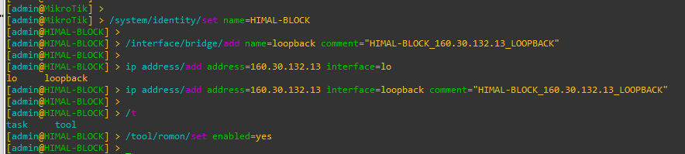

Figure 7: Set Identity, Loopback Address and RoMoN of NEPAL-BLOCK Router Through CMD

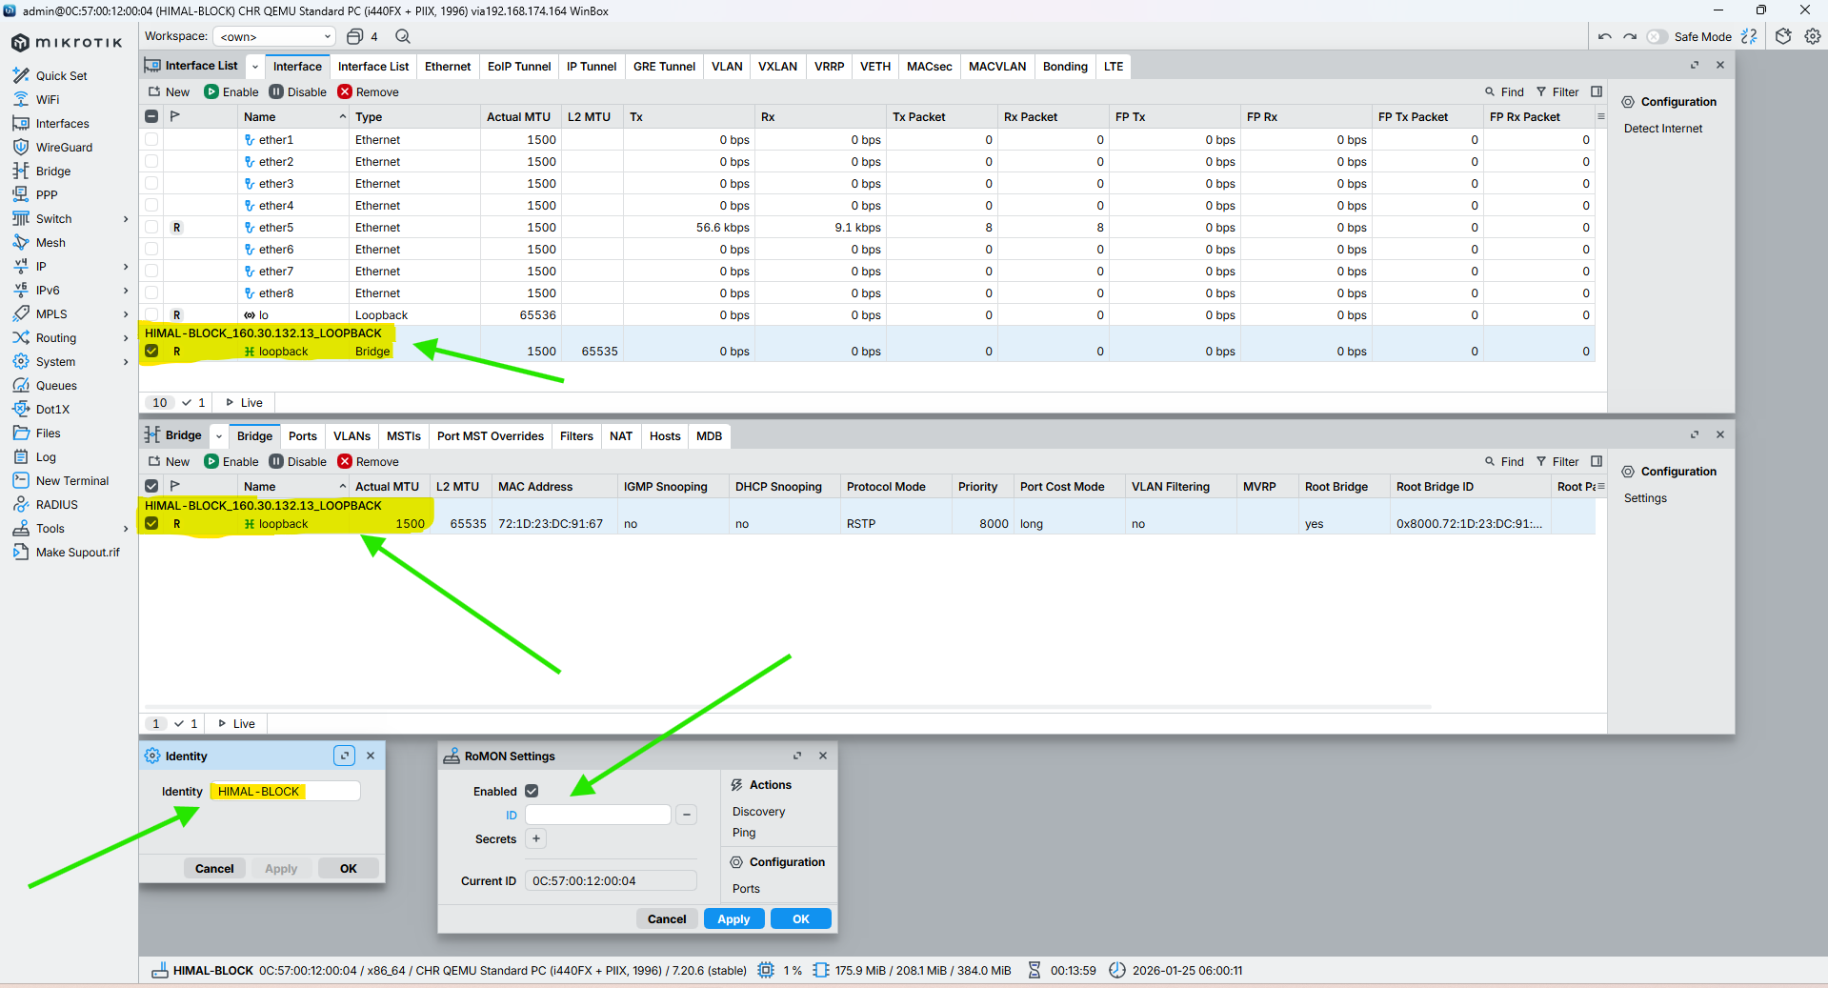

Figure 8: Set Identity, Loopback Address and RoMoN of NEPAL-BLOCK Router Through WINBOX

## BRIT-BLOCK

**CMD**

|  |
| --- |
| /system identity set name=BRIT-BLOCK  /interface bridge add name=loopback comment=“BRIT-BLOCK_160.30.132.14_LOOPBACK”  /ip address add address=160.30.132.14/32 interface=loopback comment=“BRIT-BLOCK_160.30.132.14_LOOPBACK”  /tool/romon/set enabled=yes |

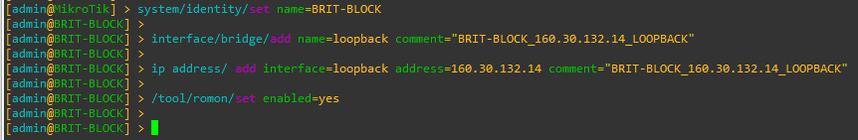

Figure 9: Set Identity, Loopback Address and RoMoN of BRIT-BLOCK Router Through CMD

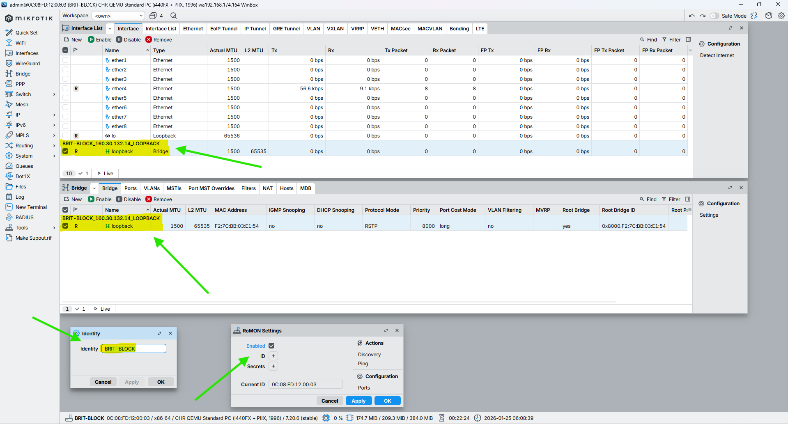

Figure 10: Set Identity, Loopback Address and RoMoN of BRIT-BLOCK Router Through WINBOX

## SKILL-BLOCK

**CMD**

|  |
| --- |
| /system identity set name=SKILL-BLOCK  /interface bridge add name=loopback comment=“SKILL-BLOCK_160.30.132.15_LOOPBACK”  /ip address add address=160.30.132.15/32 interface=loopback comment=“SKILL-BLOCK_160.30.132.15_LOOPBACK”  /tool/romon/set enabled=yes |

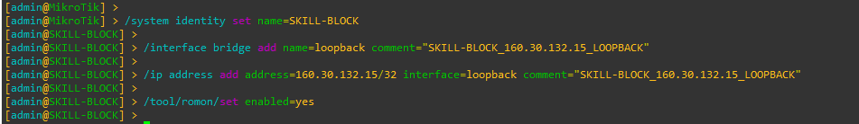

Figure 11: Set Identity, Loopback Address and RoMoN of SKILL-BLOCK Router Through CMD

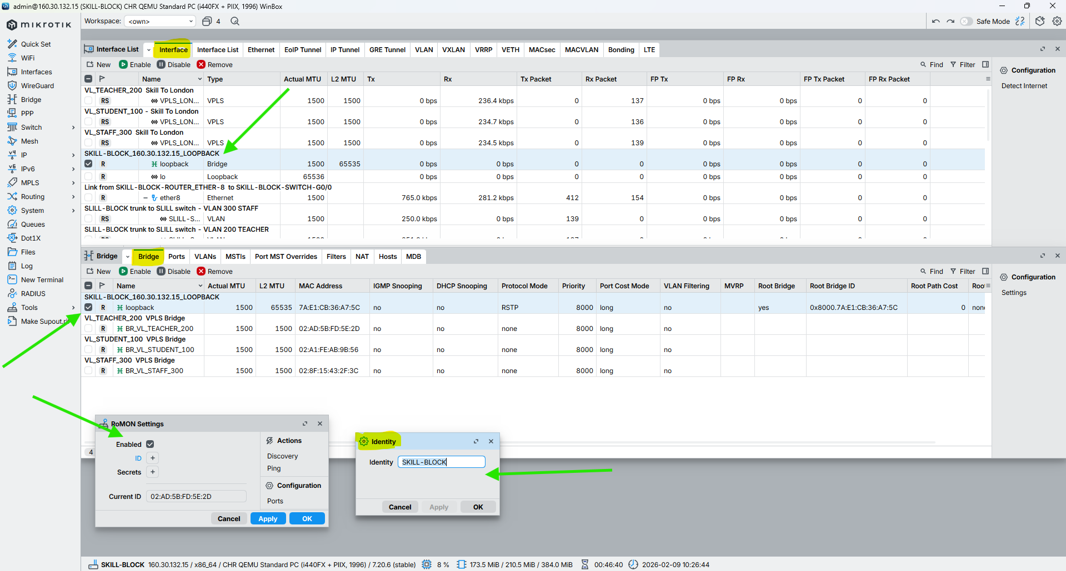

Figure 12: Set Identity, Loopback Address and RoMoN of SKILL-BLOCK Router Through WINBOX

## ALUMNI-BLOCK

**CMD**

|  |
| --- |
| /system identity set name=ALUMNI-BLOCK  /interface bridge add name=loopback comment=“ALUMNI-BLOCK_160.30.132.16_LOOPBACK”  /ip address add address=160.30.132.16/32 interface=loopback comment=“ALUMNI-BLOCK_160.30.132.16_LOOPBACK”  /tool/romon/set enabled=yes |

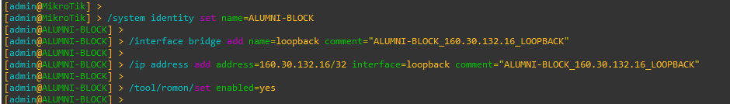

Figure 13: Set Identity, Loopback Address and RoMoN of ALUMNI-BLOCK Router Through CMD

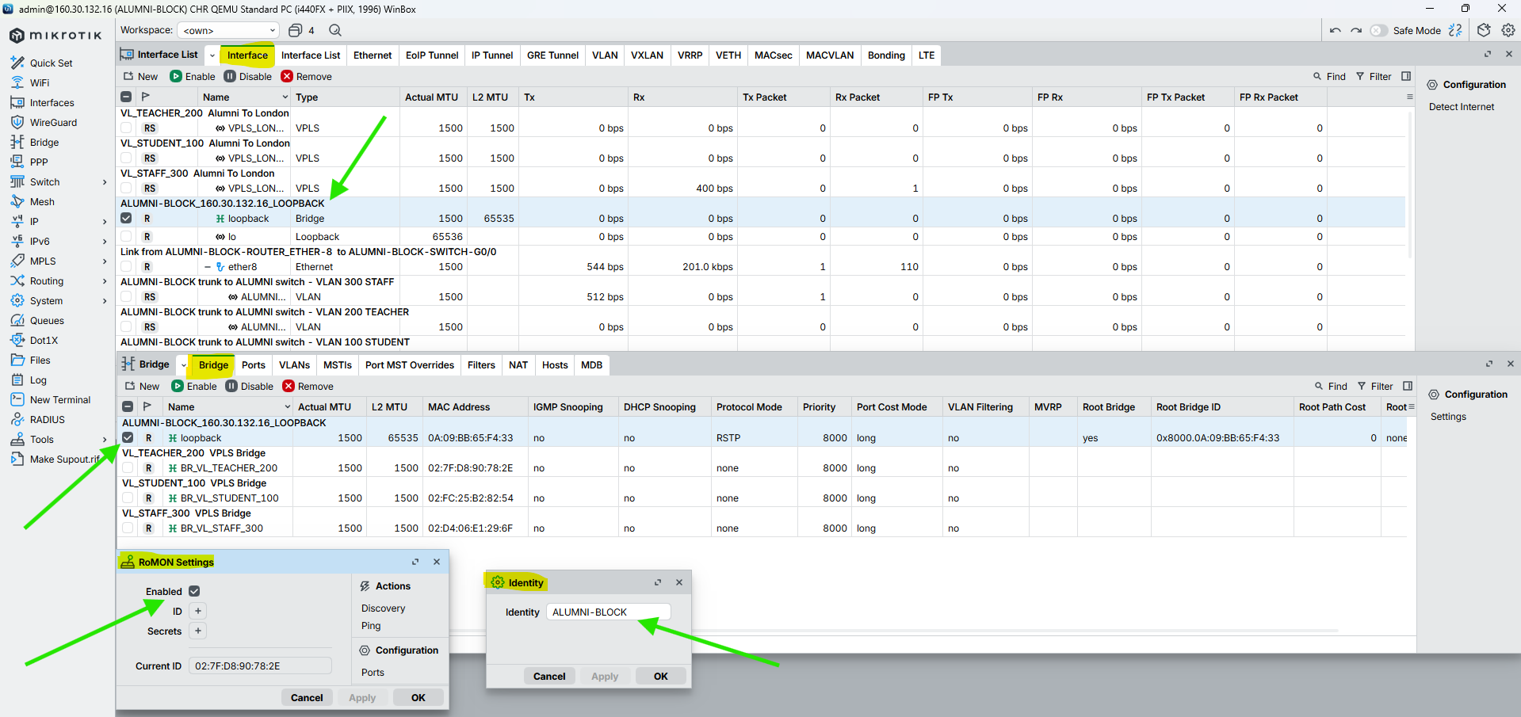

Figure 14: Set Identity, Loopback Address and RoMoN of ALUMNI-BLOCK Router Through WINBOX

## KUMARI-BLOCK

**CMD**

|  |
| --- |
| /system identity set name=KUMARI-BLOCK  /interface bridge add name=loopback comment=“KUMARI-BLOCK_160.30.132.17_LOOPBACK”  /ip address add address=160.30.132.17/32 interface=loopback comment=“KUMARI-BLOCK_160.30.132.17_LOOPBACK”  /tool/romon/set enabled=yes |

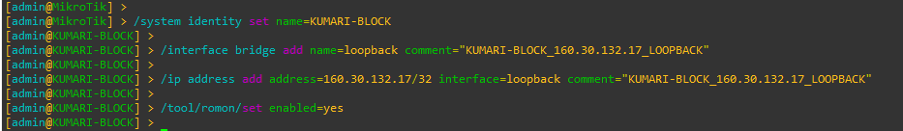

Figure 15: Set Identity, Loopback Address and RoMoN of KUMARI-BLOCK Router Through CMD

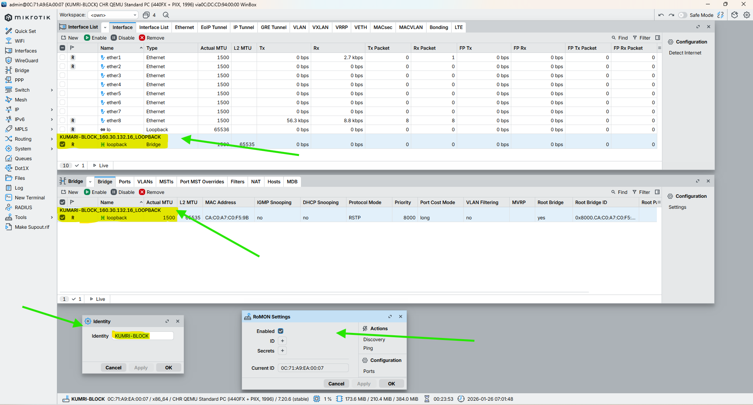

Figure 16: Set Identity, Loopback Address and RoMoN of KUMARI-BLOCK Router Through WINBOX

# Set Interface description, Enable Loop Protection & Disable Unused ports on all router

## LONDON-BLOCK

CMD

|  |
| --- |
| /interface ethernet set ether2 loop-protect=on comment=“Link from LONDON-BLOCK (10.0.0.1/30) to UK-BLOCK (10.0.0.2/30)”  /interface/ethernet set ether3 loop-protect=on comment=“Link from LONDON-BLOCK (10.0.0.5/30) to NEPAL-BLOCK (10.0.0.6/30)”  /interface ethernet set ether4 loop-protect=on comment=“Link from LONDON-BLOCK (10.0.0.9/30) to HIMAL-BLOCK (10.0.0.10/30)”  /interface ethernet set ether5 loop-protect=on comment=“Link from LONDON-BLOCK (10.0.0.13/30) to BRIT-BLOCK (10.0.0.14/30)”  /interface ethernet set ether6 loop-protect=on comment=“Link from LONDON-BLOCK (10.0.0.17/30) to SKILL-BLOCK (10.0.0.18/30)”  /interface ethernet set ether7 loop-protect=on comment=“Link from LONDON-BLOCK (10.0.0.21/30) to ALUMNI-BLOCK (10.0.0.22/30)”  /interface ethernet set ether8 loop-protect=on comment=“Link from LONDON-BLOCK (10.0.0.25/30) to KUMARI-BLOCK (10.0.0.26/30)”  /interface ethernet set ether9 loop-protect=on comment=“LAN / Management link from LONDON-BLOCK to Local Network (192.168.174.0/24)” |

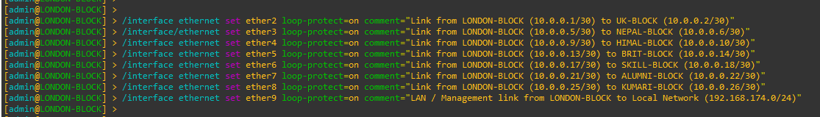

Figure 17: Set Interface Description, Enable Loop Protection & Disable Unused ports on LONDON-BLOCK Router Through CMD

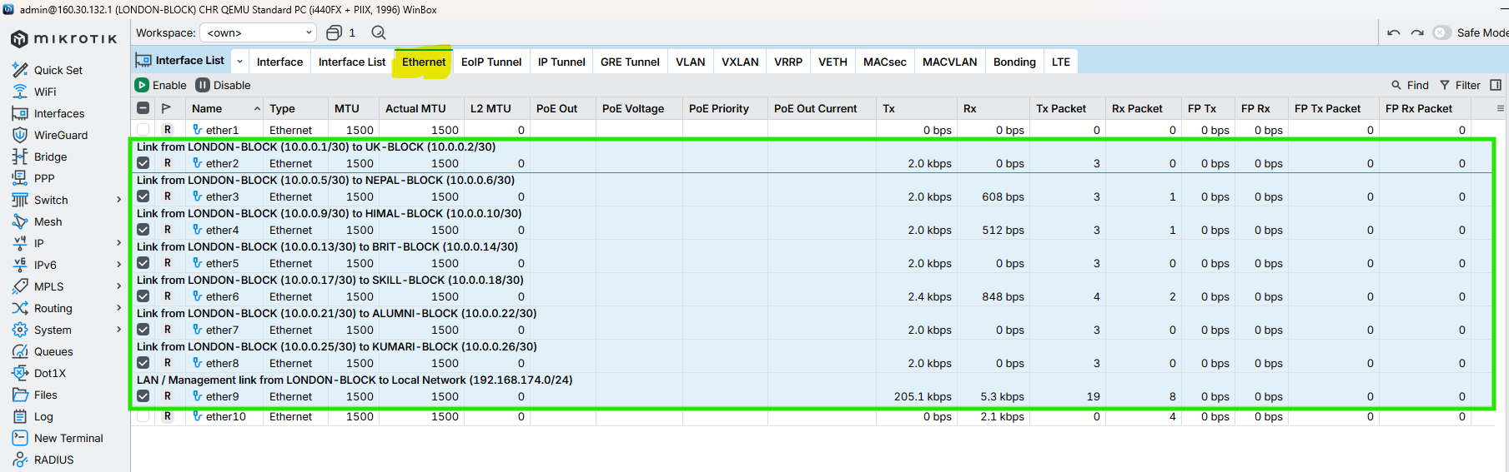

Figure 18: Set Interface Description, Enable Loop Protection & Disable Unused ports on LONDON-BLOCK Router Through WINBOX

## UK-BLOCK

CMD

|  |
| --- |
| /interface ethernet set ether2 comment=“Link from UK-BLOCK (10.0.0.2/30) to LONDON-BLOCK (10.0.0.1/30)”  /interface ethernet set ether1 comment=“Link from UK-BLOCK (10.0.0.29/30) to NEPAL-BLOCK (10.0.0.30/30)”  /interface ethernet set ether3 comment=“Link from UK-BLOCK (10.0.0.34/30) to HIMAL-BLOCK (10.0.0.33/30)”  /interface ethernet set ether7 loop-protect=on comment=“Link from UK-BLOCK-ROUTER_ETHER-7 to HIMAL-BLOCK-SWITCH-G0/1”  /interface ethernet set ether8 loop-protect=on comment=“Link from UK-BLOCK-ROUTER_ETHER-8 to UK-BLOCK-SWITCH-G0/0”  interface/ethernet/set ether4 loop-protect=on disabled=yes  interface/ethernet/set ether5 loop-protect=on disabled=yes  interface/ethernet/set ether6 loop-protect=on disabled=yes |



Figure 19: Set Interface Description, Enable Loop Protection & Disable Unused ports on UK-BLOCK Router Through CMD

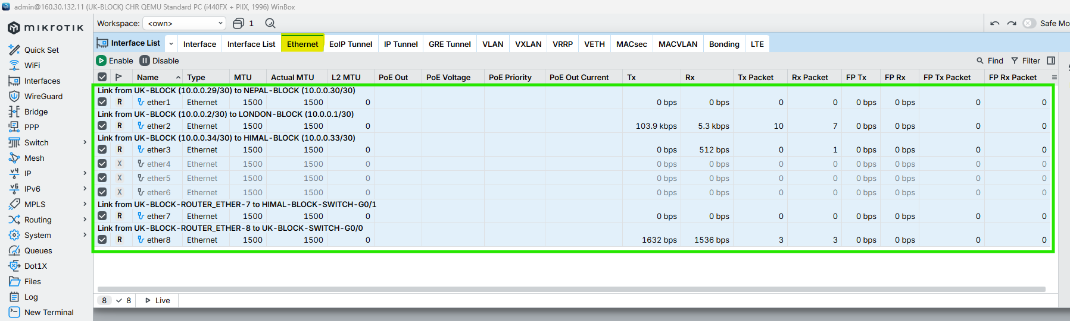

Figure 20: Set Interface Description, Enable Loop Protection & Disable Unused ports on UK-BLOCK Router Through WINBOX

## NEPAL-BLOCK

CMD

|  |
| --- |
| /interface ethernet set ether3 loop-protect=on comment=“Link from NEPAL-BLOCK (10.0.0.6/30) to LONDON-BLOCK (10.0.0.5/30)”  /interface ethernet set ether1 loop-protect=on comment=“Link from NEPAL-BLOCK (10.0.0.30/30) to UK-BLOCK (10.0.0.29/30)”  /interface ethernet set ether2 loop-protect=on comment=“Link from NEPAL-BLOCK (10.0.0.37/30) to BRIT-BLOCK (10.0.0.38/30)”  /interface ethernet set ether8 loop-protect=on comment=“Link from NEPAL-BLOCK-ROUTER_ETHER-8 to NEPAL-BLOCK-SWITCH-G0/0”  /interface ethernet set ether7 loop-protect=on comment=“Link from NEPAL-BLOCK-ROUTER_ETHER-7 to UK-BLOCK-SWITCH-G0/0”  interface/ethernet/set ether4 loop-protect=on disabled=yes  interface/ethernet/set ether5 loop-protect=on disabled=yes  interface/ethernet/set ether6 loop-protect=on disabled=yes |



Figure 21: Set Interface Description, Enable Loop Protection & Disable Unused ports on NEPAL-BLOCK Router Through CMD

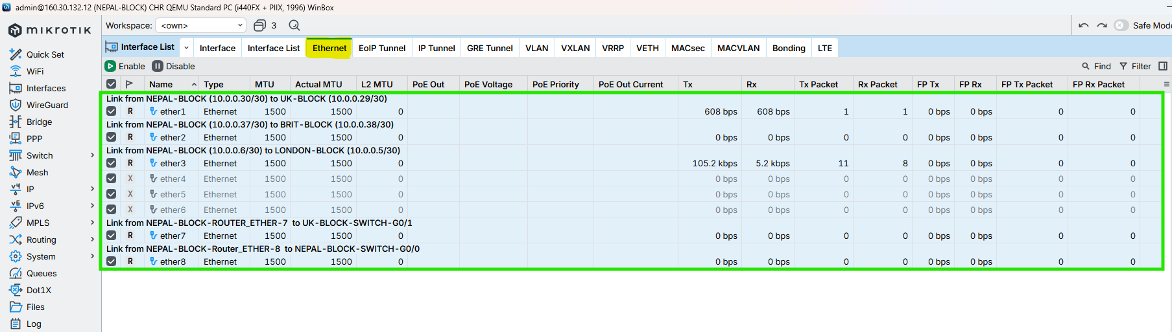

Figure 22: Set Interface Description, Enable Loop Protection & Disable Unused ports on NEPAL-BLOCK Router Through WINBOX

## HIMAL-BLOCK

CMD

|  |
| --- |
| /interface ethernet set ether3 loop-protect=on comment=“Link from HIMAL-BLOCK (10.0.0.33/30) to UK-BLOCK (10.0.0.34/30)”  /interface ethernet set ether4 loop-protect=on comment=“Link from HIMAL-BLOCK (10.0.0.10/30) to LONDON-BLOCK (10.0.0.9/30)”  /interface ethernet set ether2 loop-protect=on comment=“Link from HIMAL-BLOCK (10.0.0.42/30) to SKILL-BLOCK (10.0.0.41/30)”  /interface ethernet set ether7 loop-protect=on comment=“Link from HIMAL-BLOCK-ROUTER_ETHER-7 to SKILL-BLOCK-SWITCH-G0/1”  /interface ethernet set ether8 loop-protect=on comment=“Link from HIMAL-BLOCK-ROUTER_ETHER-8 to HIMAL-BLOCK-SWITCH-G0/0”  interface/ethernet/set ether1 loop-protect=on disabled=yes  interface/ethernet/set ether5 loop-protect=on disabled=yes  interface/ethernet/set ether6 loop-protect=on disabled=yes |



Figure 23: Set Interface Description, Enable Loop Protection & Disable Unused ports on HIMAL-BLOCK Router Through CMD

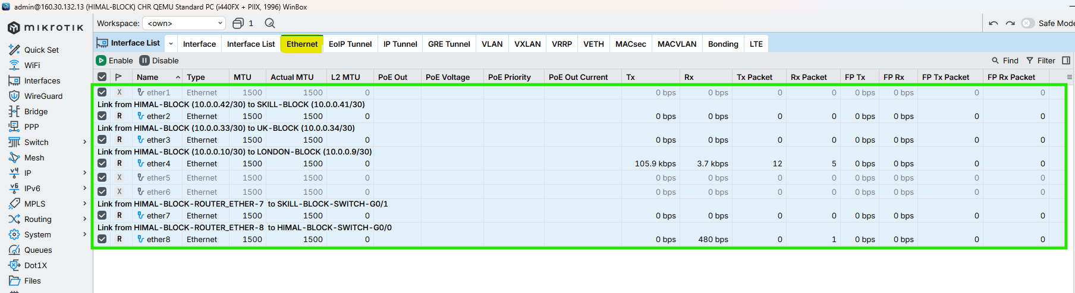

Figure 24: Set Interface Description, Enable Loop Protection & Disable Unused ports on HIMAL-BLOCK Router Through WINBOX

## BRIT-BLOCK

CMD

|  |
| --- |
| /interface ethernet set ether2 loop-protect=on comment=“Link from BRIT-BLOCK (10.0.0.38/30) to NEPAL-BLOCK (10.0.0.37/30)”  /interface ethernet set ether5 loop-protect=on comment=“Link from BRIT-BLOCK (10.0.0.14/30) to LONDON-BLOCK (10.0.0.13/30)”  /interface ethernet set ether1 loop-protect=on comment=“Link from BRIT-BLOCK (10.0.0.46/30) to KUMARI-BLOCK (10.0.0.44/30)”  /interface ethernet set ether7 loop-protect=on comment=“Link from BRIT-BLOCK-ROUTER_ETHER-7 to NEPAL-BLOCK-SWITCH-G0/1”  /interface ethernet set ether8 loop-protect=on comment=“Link from BRIT-BLOCK-ROUTER_ETHER-8 to BRIT-BLOCK-SWITCH-G0/0”  interface/ethernet/set ether3 loop-protect=on disabled=yes  interface/ethernet/set ether4 loop-protect=on disabled=yes  interface/ethernet/set ether6 loop-protect=on disabled=yes |



Figure 25: Set Interface Description, Enable Loop Protection & Disable Unused ports on BRIT-BLOCK Router Through CMD

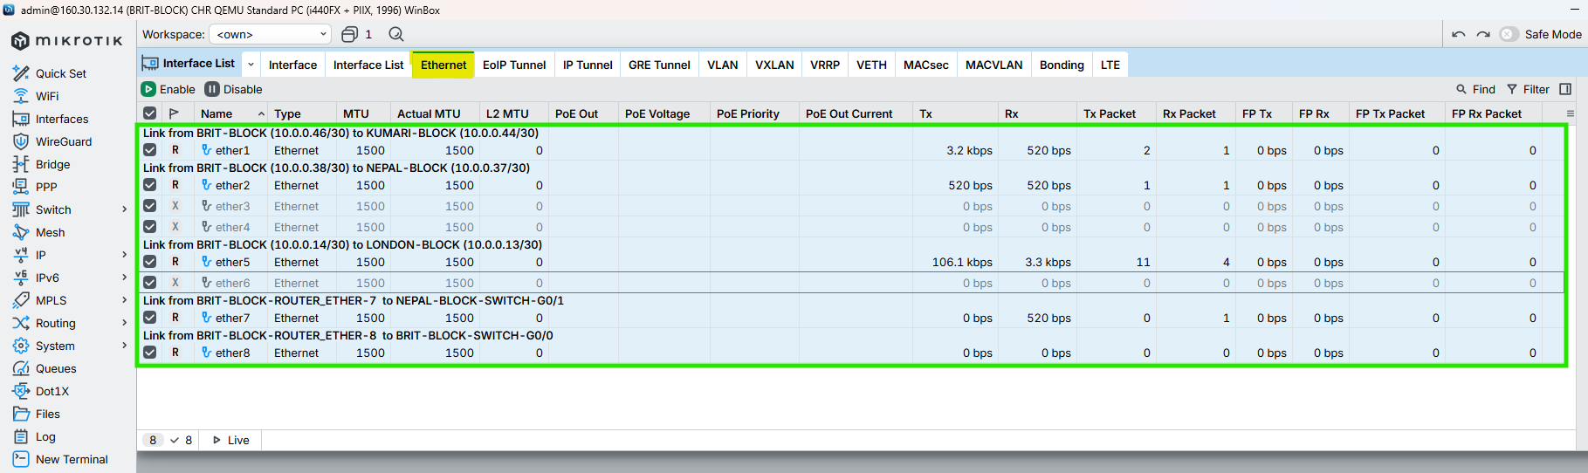

Figure 26: Set Interface Description, Enable Loop Protection & Disable Unused ports on BRIT-BLOCK Router Through WINBOX

## SKILL-BLOCK

CMD

|  |
| --- |
| /interface ethernet set ether2 loop-protect=on comment=“Link from SKILL-BLOCK (10.0.0.41/30) to HIMAL-BLOCK (10.0.0.42/30)”  /interface ethernet set ether6 loop-protect=on comment=“Link from SKILL-BLOCK (10.0.0.18/30) to LONDON-BLOCK (10.0.0.17/30)”  /interface ethernet set ether1 loop-protect=on comment=“Link from SKILL-BLOCK (10.0.0.50/30) to KUMARI-BLOCK (10.0.0.49/30)”  /interface ethernet set ether7 loop-protect=on comment=“Link from SKILL-BLOCK-ROUTER_ETHER-7 to ALUMNI-BLOCK-SWITCH-G0/1”  /interface ethernet set ether8 loop-protect=on comment=“Link from SKILL-BLOCK-ROUTER_ETHER-8 to SKILL-BLOCK-SWITCH-G0/0”  interface/ethernet/set ether3 loop-protect=on disabled=yes  interface/ethernet/set ether4 loop-protect=on disabled=yes  interface/ethernet/set ether5 loop-protect=on disabled=yes |



Figure 27: Set Interface Description, Enable Loop Protection & Disable Unused ports on SKILL-BLOCK Router Through CMD

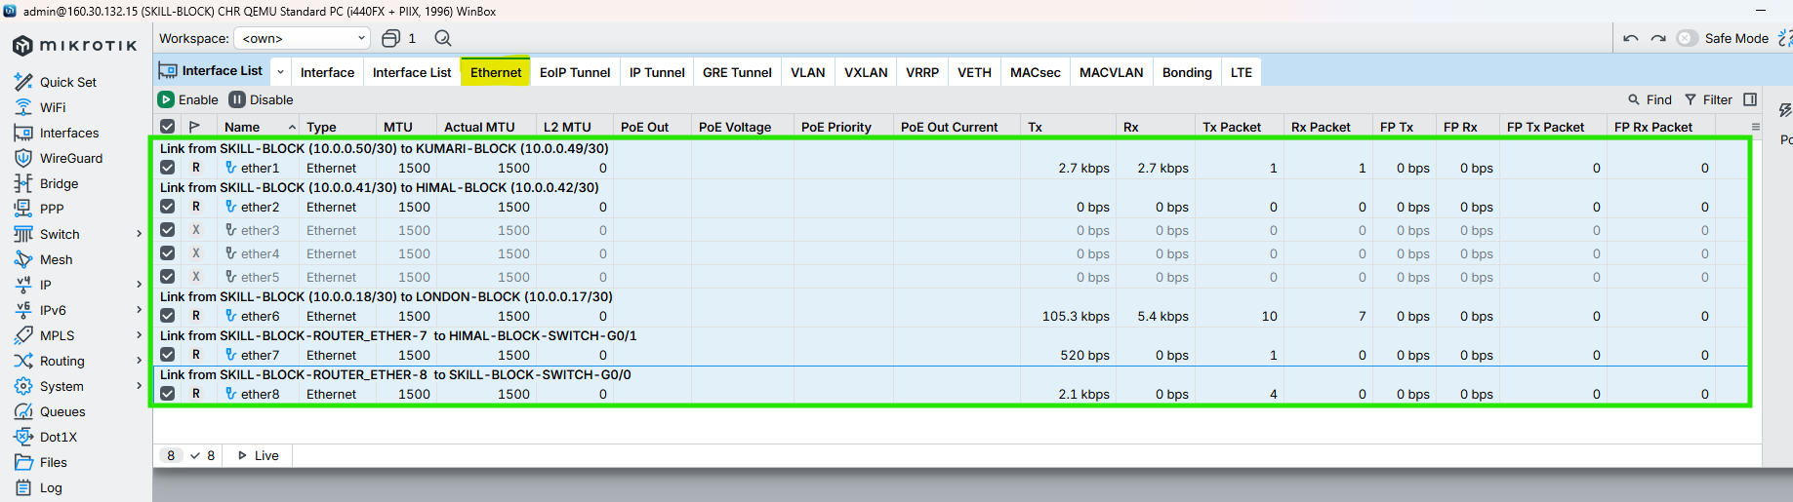

Figure 28: Set Interface Description, Enable Loop Protection & Disable Unused ports on SKILL-BLOCK Router Through WINBOX

## ALUMNI-BLOCK

CMD

|  |
| --- |
| /interface ethernet set ether7 loop-protect=on comment=“Link from ALUMNI-BLOCK (10.0.0.22/30) to LONDON-BLOCK (10.0.0.21/30)”  /interface ethernet set ether1 loop-protect=on comment=“Link from ALUMNI-BLOCK (10.0.0.49/30) to SKILL-BLOCK (10.0.0.50/30)”  /interface ethernet set ether2 loop-protect=on comment=“Link from ALUMNI-BLOCK (10.0.0.53/30) to KUMARI-BLOCK (10.0.0.54/30)”  /interface ethernet set ether6 loop-protect=on comment=“Link from ALUMNI-BLOCK-ROUTER_ETHER-6 to KUMARI-BLOCK-SWITCH-G0/1”  /interface ethernet set ether8 loop-protect=on comment=“Link from ALUMNI-BLOCK-ROUTER_ETHER-8 to ALUMNI-BLOCK-SWITCH-G0/0”  interface/ethernet/set ether3 loop-protect=on disabled=yes  interface/ethernet/set ether4 loop-protect=on disabled=yes  interface/ethernet/set ether5 loop-protect=on disabled=yes |



Figure 29: Set Interface Description, Enable Loop Protection & Disable Unused ports on ALUMNI-BLOCK Router Through CMD

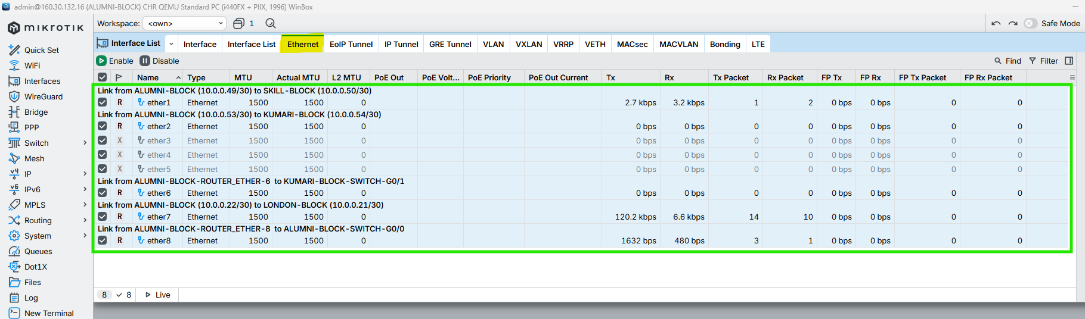

Figure 30: Set Interface Description, Enable Loop Protection & Disable Unused ports on ALUMNI-BLOCK Router Through WINBOX

## KUMARI-BLOCK

CMD

|  |
| --- |
| /interface ethernet set ether8 loop-protect=on comment=“Link from KUMARI-BLOCK (10.0.0.26/30) to LONDON-BLOCK (10.0.0.25/30)”  /interface ethernet set ether2 loop-protect=on comment=“Link from KUMARI-BLOCK (10.0.0.54/30) to ALUMNI-BLOCK (10.0.0.53/30)”  /interface ethernet set ether1 loop-protect=on comment=“Link from KUMARI-BLOCK (10.0.0.44/30) to BRIT-BLOCK (10.0.0.46/30)”  /interface ethernet set ether6 loop-protect=on comment=“Link from KUMARI-BLOCK-ROUTER_ETHER-6 to BRIT-BLOCK-SWITCH-G0/1”  /interface ethernet set ether7 loop-protect=on comment=“Link from KUMARI-BLOCK-ROUTER_ETHER-7 to KUMARI-BLOCK-SWITCH-G0/0”  interface/ethernet/set ether3 loop-protect=on disabled=yes  interface/ethernet/set ether4 loop-protect=on disabled=yes  interface/ethernet/set ether5 loop-protect=on disabled=yes |



Figure 31: Set Interface Description, Enable Loop Protection & Disable Unused ports on KUMARI-BLOCK Router Through CMD

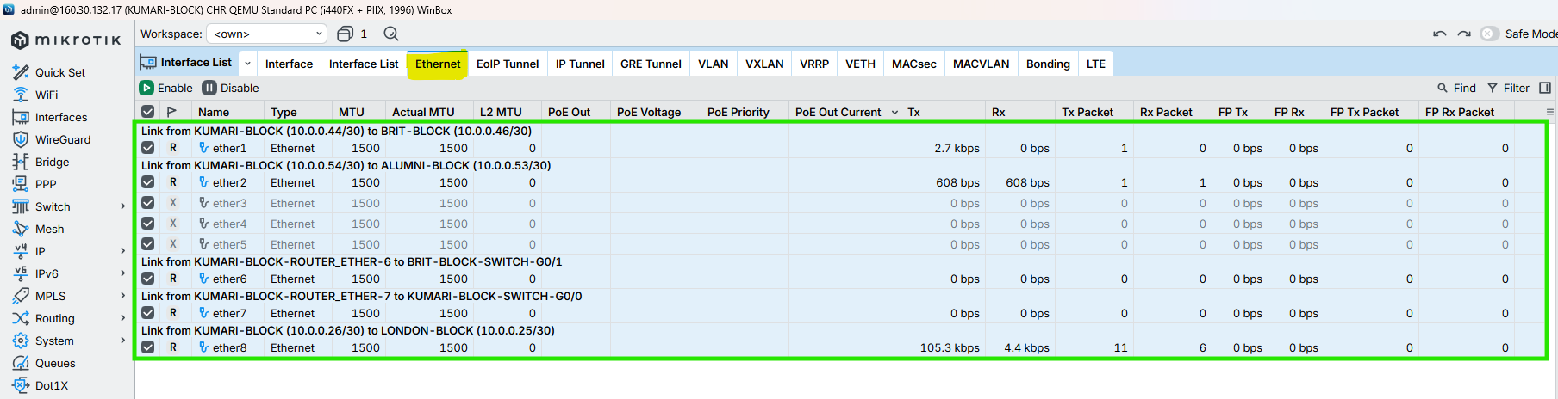

Figure 32: Set Interface Description, Enable Loop Protection & Disable Unused ports on KUMARI-BLOCK Router Through WINBOX

# Configuration IP in the Core Interface of all Routers

## LONDON-BLOCK

**CMD**

|  |
| --- |
| /ip address add address=10.0.0.1/30 interface=ether2 comment=“NETWORK-ID_10.0.0.0/30_LINK_FROM_LONDON-BLOCK_10.0.0.1/30_TO_UK-BLOCK_10.0.0.2/30”  /ip address add address=10.0.0.5/30 interface=ether3 comment=“NETWORK-ID_10.0.0.4/30_LINK_FROM_LONDON-BLOCK_10.0.0.5/30_TO_NEPAL-BLOCK_10.0.0.6/30”  /ip address add address=10.0.0.9/30 interface=ether4 comment=“NETWORK-ID_10.0.0.8/30_LINK_FROM_LONDON-BLOCK_10.0.0.9/30_TO_HIMAL-BLOCK_10.0.0.10/30”  /ip address add address=10.0.0.13/30 interface=ether5 comment=“NETWORK-ID_10.0.0.12/30_LINK_FROM_LONDON-BLOCK_10.0.0.13/30_TO_BRIT-BLOCK_10.0.0.14/30”  /ip address add address=10.0.0.17/30 interface=ether6 comment=“NETWORK-ID_10.0.0.16/30_LINK_FROM_LONDON-BLOCK_10.0.0.17/30_TO_SKILL-BLOCK_10.0.0.18/30”  /ip address add address=10.0.0.21/30 interface=ether7 comment=“NETWORK-ID_10.0.0.20/30_LINK_FROM_LONDON-BLOCK_10.0.0.21/30_TO_ALUMNI-BLOCK_10.0.0.22/30”  /ip address add address=10.0.0.25/30 interface=ether8 comment=“NETWORK-ID_10.0.0.24/30_LINK_FROM_LONDON-BLOCK_10.0.0.25/30_TO_KUMARI-BLOCK_10.0.0.26/30” |

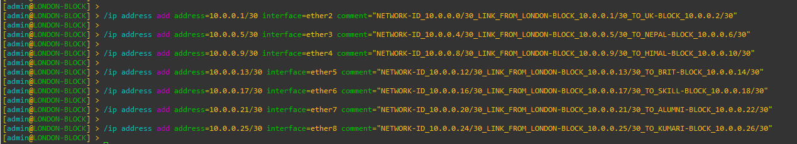

Figure 33: Configuration IP in the Core Interface of LONDON-BLOCK Router Through CMD

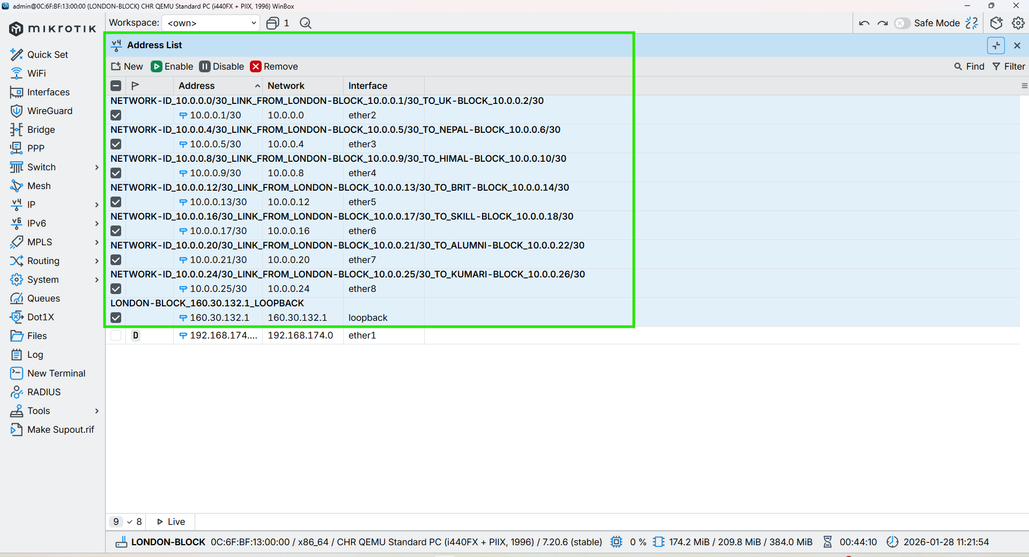

Figure 34: Configuration IP in the Core Interface of LONDON-BLOCK Router Through WINBOX

## UK-BLOCK

**CMD**

|  |
| --- |
| /ip address add address=10.0.0.2/30 interface=ether2 comment=“NETWORK-ID_10.0.0.0/30_LINK_FROM_UK-BLOCK_10.0.0.2/30_TO_LONDON-BLOCK_10.0.0.1/30”  /ip address add address=10.0.0.29/30 interface=ether1 comment=“NETWORK-ID_10.0.0.28/30_LINK_FROM_UK-BLOCK_10.0.0.29/30_TO_NEPAL-BLOCK_10.0.0.30/30”  /ip address add address=10.0.0.34/30 interface=ether3 comment=“NETWORK-ID_10.0.0.32/30_LINK_FROM_UK-BLOCK_10.0.0.34/30_TO_HIMAL-BLOCK_10.0.0.33/30” |



Figure 35: Configuration IP in the Core Interface of UK-BLOCK Router Through CMD

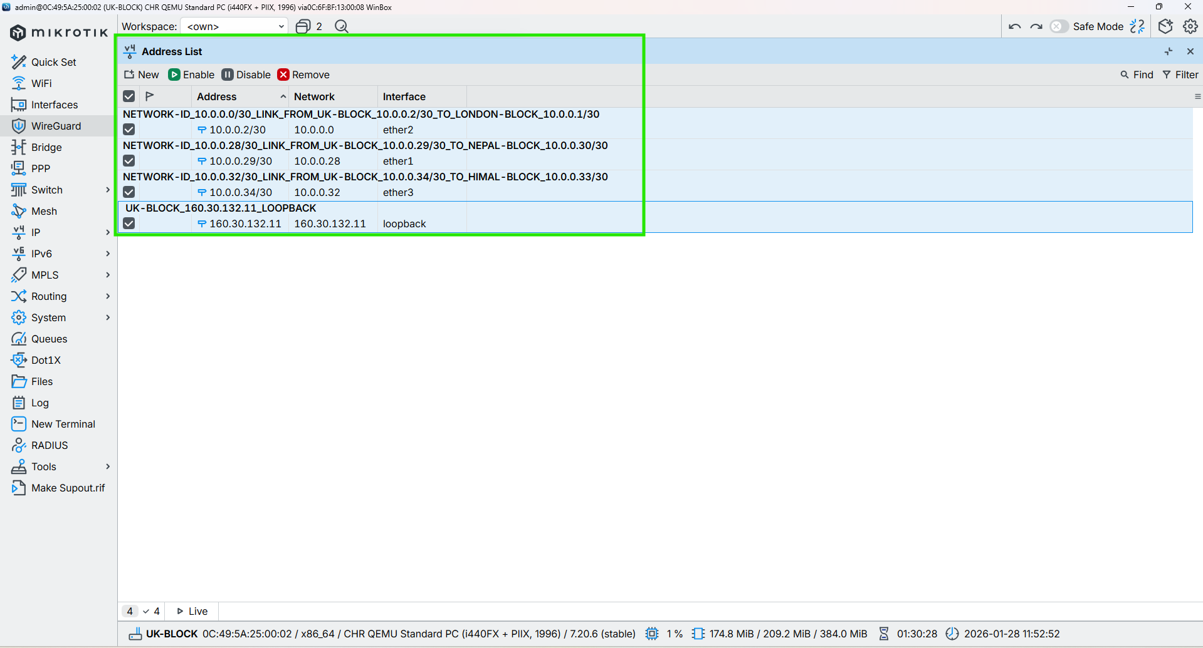

Figure 36: Configuration IP in the Core Interface of UK-BLOCK Router Through WINBOX

## NEPAL-BLOCK

**CMD**

|  |
| --- |
| /ip address add address=10.0.0.6/30 interface=ether3 comment=“NETWORK-ID_10.0.0.4/30_LINK_FROM_NEPAL-BLOCK_10.0.0.6/30_TO_LONDON-BLOCK_10.0.0.5/30”  /ip address add address=10.0.0.30/30 interface=ether1 comment=“NETWORK-ID_10.0.0.28/30_LINK_FROM_NEPAL-BLOCK_10.0.0.30/30_TO_UK-BLOCK_10.0.0.29/30”  /ip address add address=10.0.0.37/30 interface=ether2 comment=“NETWORK-ID_10.0.0.36/30_LINK_FROM_NEPAL-BLOCK_10.0.0.37/30_TO_BRIT-BLOCK_10.0.0.38/30” |



Figure 37: Configuration IP in the Core Interface of NEPAL-BLOCK Router Through CMD

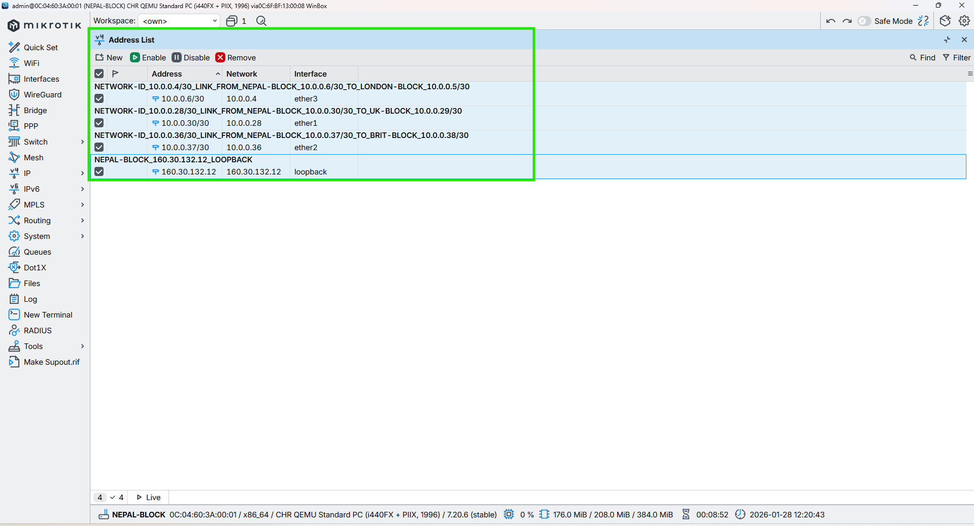

Figure 38: Configuration IP in the Core Interface of NEPAL-BLOCK Router Through WINBOX

## HIMAL-BLOCK

**CMD**

|  |
| --- |
| /ip address add address=10.0.0.33/30 interface=ether3 comment=“NETWORK-ID_10.0.0.32/30_LINK_FROM_HIMAL-BLOCK_10.0.0.33/30_TO_UK-BLOCK_10.0.0.34/30”  /ip address add address=10.0.0.10/30 interface=ether4 comment=“NETWORK-ID_10.0.0.8/30_LINK_FROM_HIMAL-BLOCK_10.0.0.10/30_TO_LONDON-BLOCK_10.0.0.9/30”  /ip address add address=10.0.0.42/30 interface=ether2 comment=“NETWORK-ID_10.0.0.40/30_LINK_FROM_HIMAL-BLOCK_10.0.0.42/30_TO_SKILL-BLOCK_10.0.0.41/30” |



Figure 39: Configuration IP in the Core Interface of HIMAL-BLOCK Router Through CMD

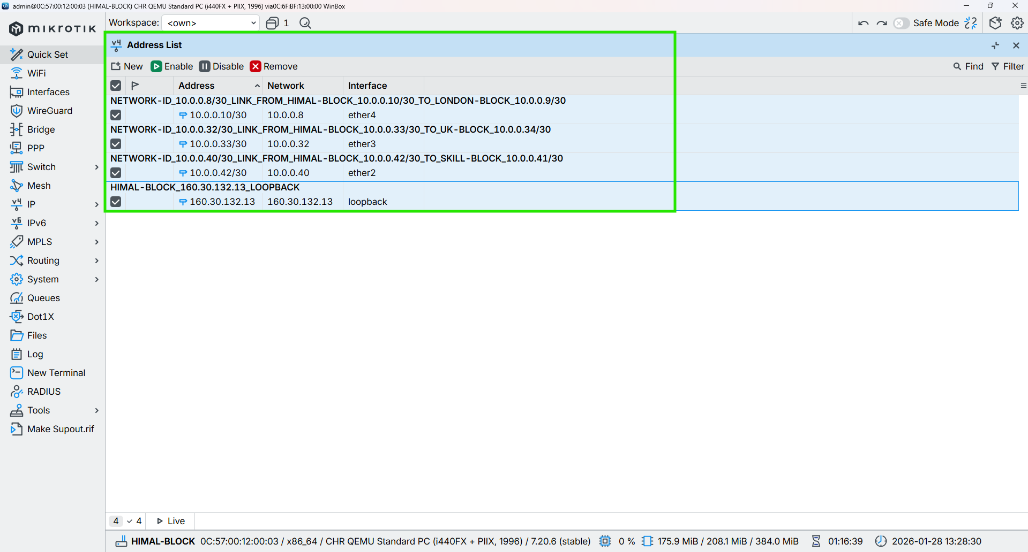

Figure 40: Configuration IP in the Core Interface of HIMAL-BLOCK Router Through WINBOX

## BRIT-BLOCK

**CMD**

|  |
| --- |
| /ip address add address=10.0.0.38/30 interface=ether2 comment=“NETWORK-ID_10.0.0.36/30_LINK_FROM_BRIT-BLOCK_10.0.0.38/30_TO_NEPAL-BLOCK_10.0.0.37/30”  /ip address add address=10.0.0.14/30 interface=ether5 comment=“NETWORK-ID_10.0.0.12/30_LINK_FROM_BRIT-BLOCK_10.0.0.14/30_TO_LONDON-BLOCK_10.0.0.13/30”  /ip address add address=10.0.0.46/30 interface=ether1 comment=“NETWORK-ID_10.0.0.44/30_LINK_FROM_BRIT-BLOCK_10.0.0.46/30_TO_KUMARI-BLOCK_10.0.0.45/30” |



Figure 41: Configuration IP in the Core Interface of BRIT-BLOCK Router Through CMD

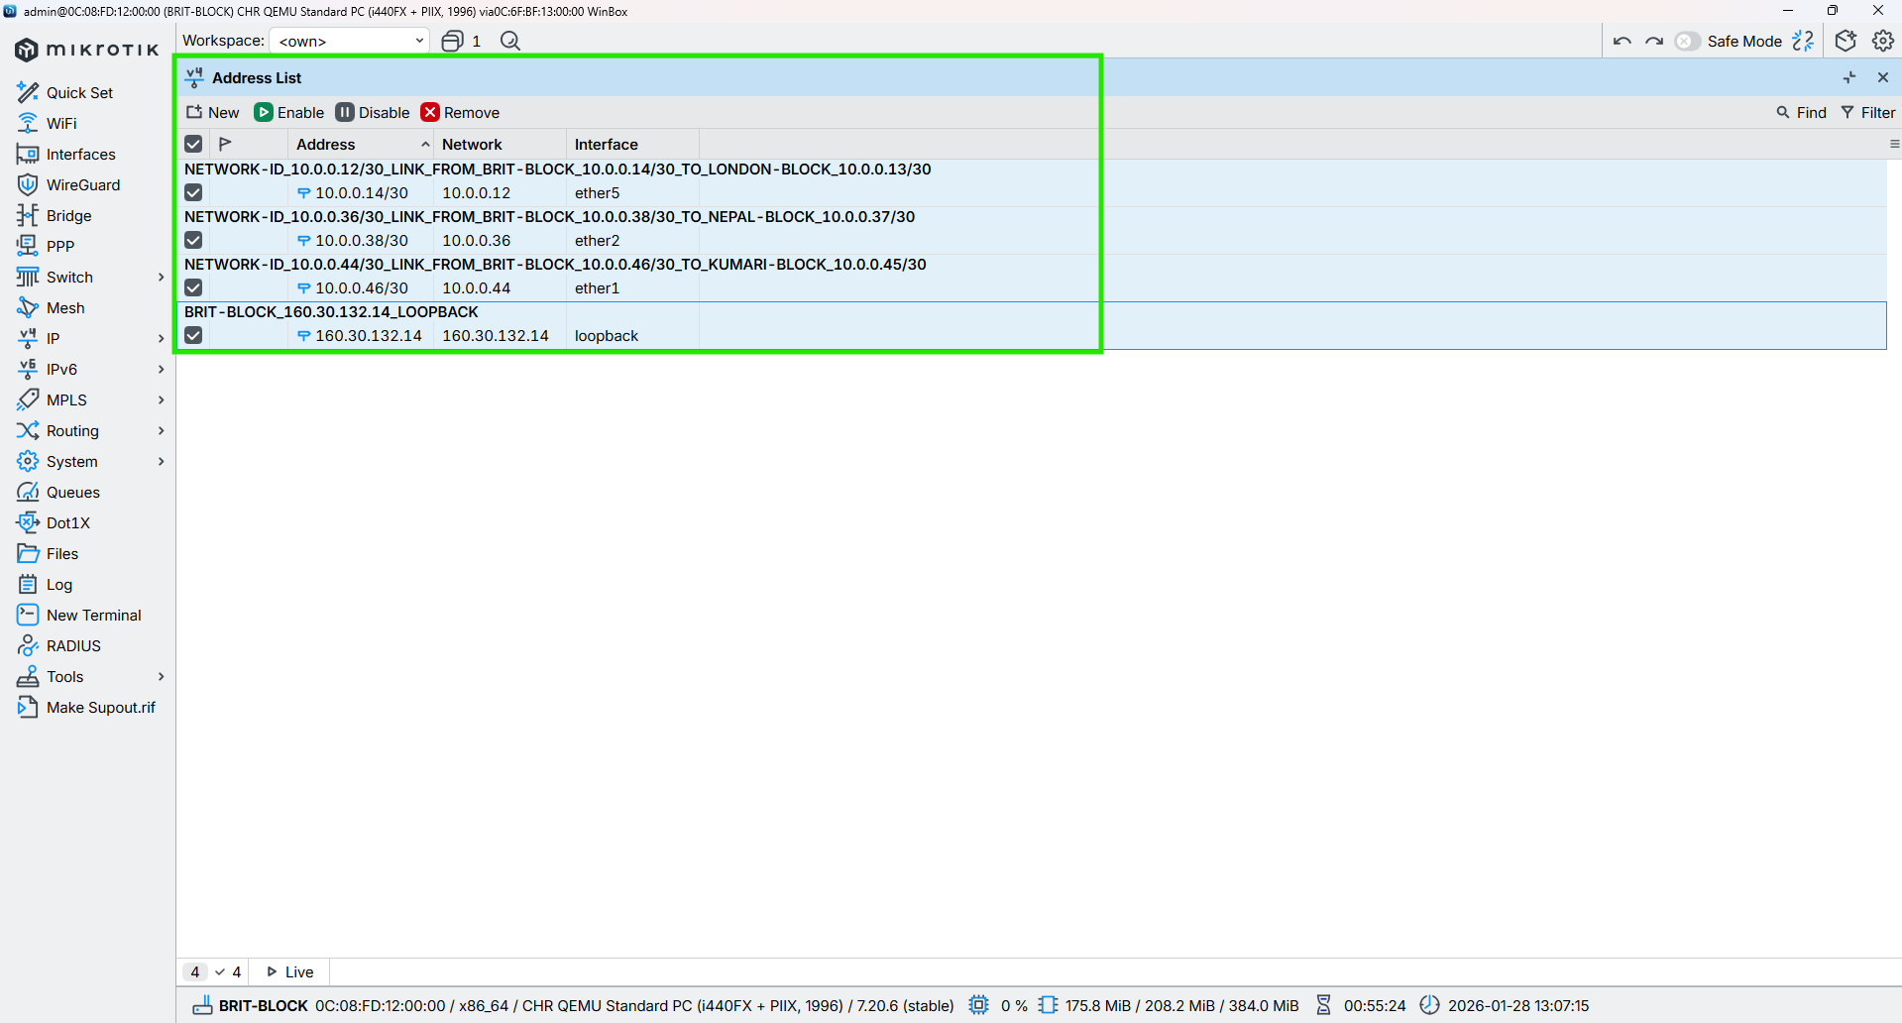

Figure 42: Configuration IP in the Core Interface of BRIT-BLOCK Router Through WINBOX

## SKILL-BLOCK

**CMD**

|  |
| --- |
| /ip address add address=10.0.0.41/30 interface=ether2 comment=“NETWORK-ID_10.0.0.40/30_LINK_FROM_SKILL-BLOCK_10.0.0.41/30_TO_NEPAL-BLOCK_10.0.0.42/30”  /ip address add address=10.0.0.18/30 interface=ether6 comment=“NETWORK-ID_10.0.0.16/30_LINK_FROM_SKILL-BLOCK_10.0.0.18/30_TO_LONDON-BLOCK_10.0.0.17/30”  /ip address add address=10.0.0.50/30 interface=ether1 comment=“NETWORK-ID_10.0.0.48/30_LINK_FROM_SKILL-BLOCK_10.0.0.50/30_TO_KUMARI-BLOCK_10.0.0.49/30” |



Figure 43: Configuration IP in the Core Interface of SKILL-BLOCK Router Through CMD

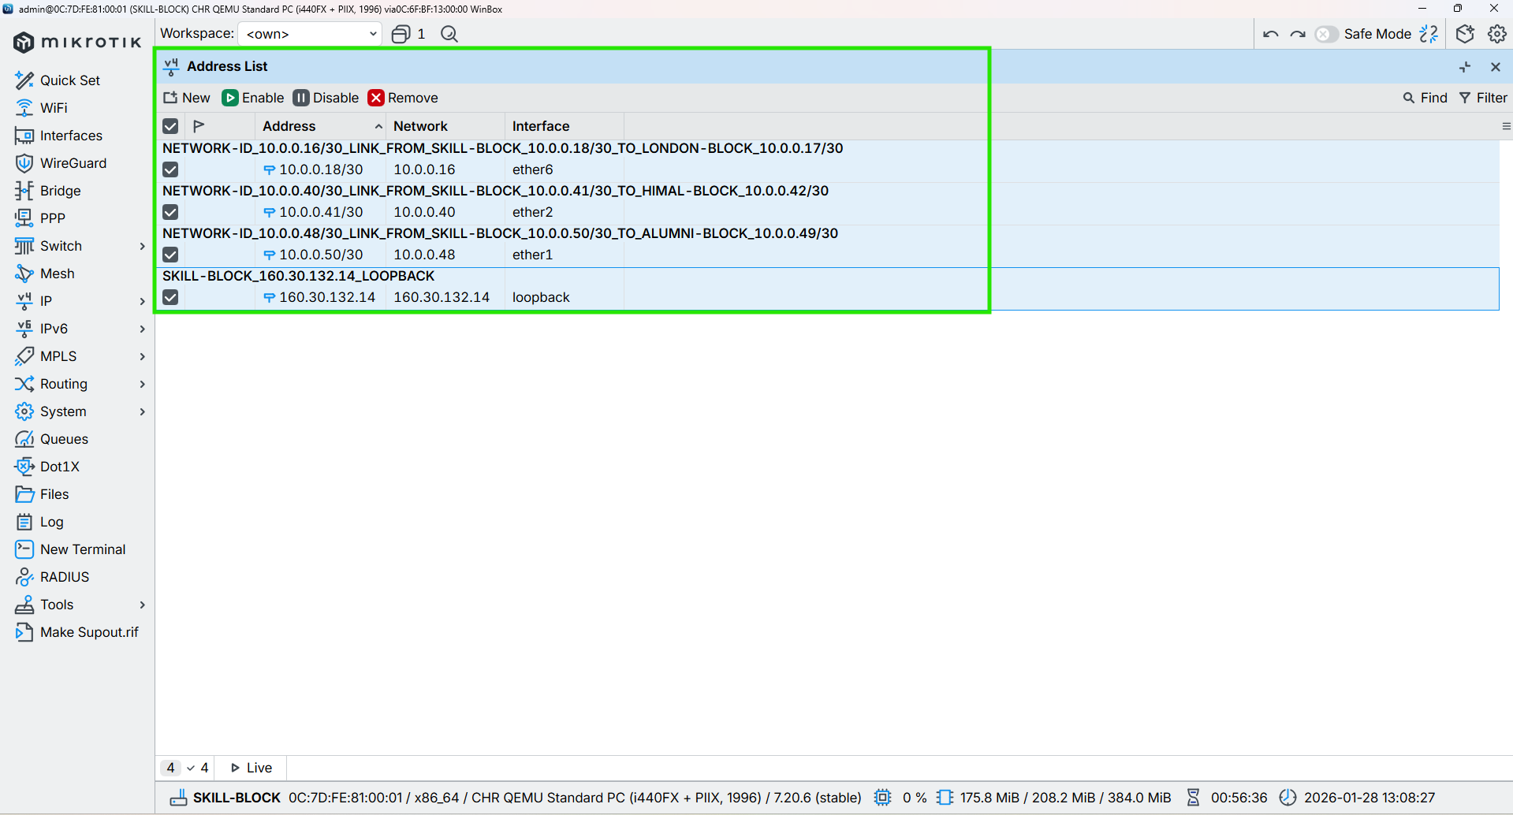

Figure 44: Configuration IP in the Core Interface of SKILL-BLOCK Router Through WINBOX

## ALUMNI-BLOCK

**CMD**

|  |
| --- |
| /ip address add address=10.0.0.22/30 interface=ether7 comment=“NETWORK-ID_10.0.0.20/30_LINK_FROM_ALUMNI-BLOCK_10.0.0.22/30_TO_LONDON-BLOCK_10.0.0.21/30”  /ip address add address=10.0.0.49/30 interface=ether1 comment=“NETWORK-ID_10.0.0.48/30_LINK_FROM_ALUMNI-BLOCK_10.0.0.49/30_TO_SKILL-BLOCK_10.0.0.50/30”  /ip address add address=10.0.0.53/30 interface=ether2 comment=“NETWORK-ID_10.0.0.52/30_LINK_FROM_ALUMNI-BLOCK_10.0.0.53/30_TO_KUMARI-BLOCK_10.0.0.54/30” |

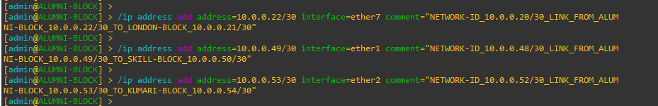

Figure 45: Configuration IP in the Core Interface of ALUMNI-BLOCK Router Through CMD

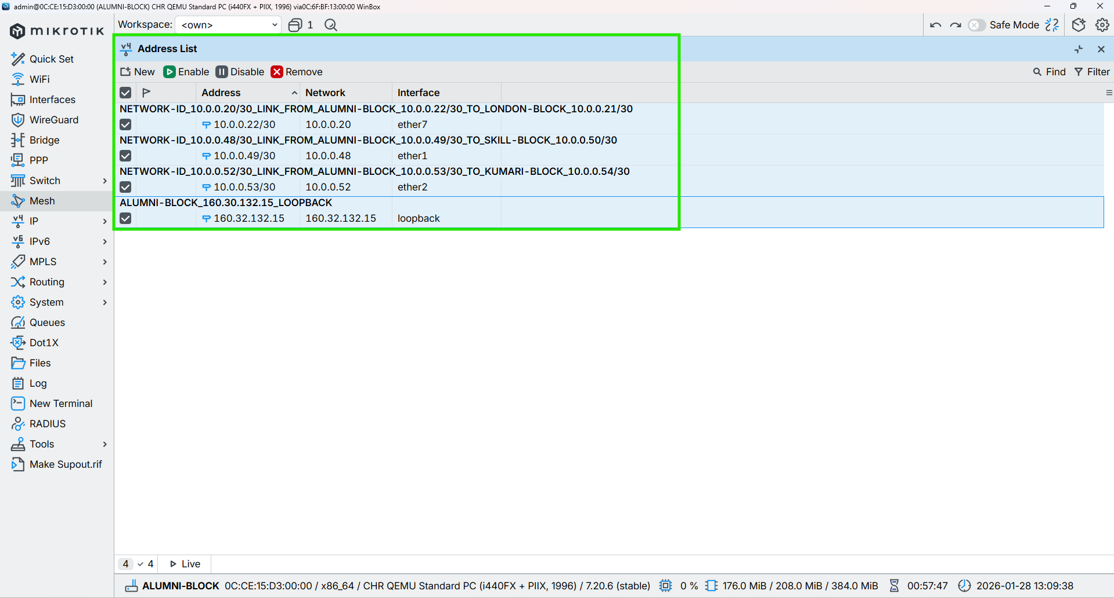

Figure 46: Configuration IP in the Core Interface of ALUMNI-BLOCK Router Through WINBOX

## KUMARI-BLOCK

**CMD**

|  |
| --- |
| /ip address add address=10.0.0.26/30 interface=ether8 comment=“NETWORK-ID_10.0.0.24/30_LINK_FROM_KUMARI-BLOCK_10.0.0.26/30_TO_LONDON-BLOCK_10.0.0.25/30”  /ip address add address=10.0.0.54/30 interface=ether2 comment=“NETWORK-ID_10.0.0.52/30_LINK_FROM_KUMARI-BLOCK_10.0.0.54/30_TO_ALUMNI-BLOCK_10.0.0.53/30”  /ip address add address=10.0.0.44/30 interface=ether1 comment=“NETWORK-ID_10.0.0.44/30_LINK_FROM_KUMARI-BLOCK_10.0.0.44/30_TO_BRIT-BLOCK_10.0.0.46/30” |



Figure 47: Configuration IP in the Core Interface of KUMARI-BLOCK Router Through CMD

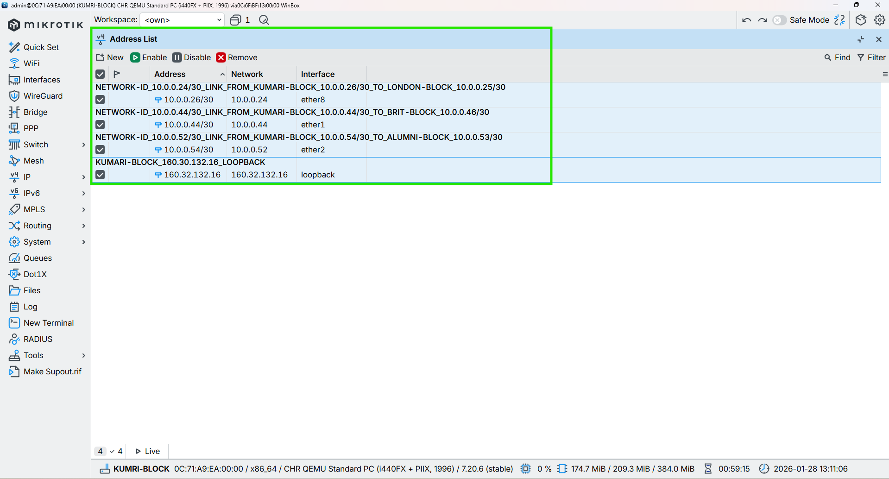

Figure 48: Configuration IP in the Core Interface of KUMARI-BLOCK Router Through WINBOX

# Configurations Graphing on all router

## LONDON-BLOCK

CMD

|  |
| --- |
| /tool/graphing/interface/add interface=all comment=“Monitors all interfaces for traffic”  /tool/graphing/queue/add simple-queue=all allow-address=0.0.0.0/0 comment=“Monitors all simple queues for bandwidth usage”  /tool/graphing/resource/add allow-address=0.0.0.0/0 comment=“Monitors system resources” |



Figure 49: Configurations Graphing on LONDON-BLOCK Router Through CMD

## UK-BLOCK

CMD

|  |
| --- |
| /tool/graphing/interface/add interface=all comment=“Monitors all interfaces for traffic”  /tool/graphing/queue/add simple-queue=all allow-address=0.0.0.0/0 comment=“Monitors all simple queues for bandwidth usage”  /tool/graphing/resource/add allow-address=0.0.0.0/0 comment=“Monitors system resources” |

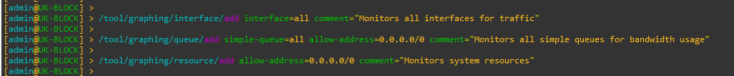

Figure 50: Configurations Graphing on UK-BLOCK Router Through CMD

## NEPAL-BLOCK

CMD

|  |
| --- |
| /tool/graphing/interface/add interface=all comment=“Monitors all interfaces for traffic”  /tool/graphing/queue/add simple-queue=all allow-address=0.0.0.0/0 comment=“Monitors all simple queues for bandwidth usage”  /tool/graphing/resource/add allow-address=0.0.0.0/0 comment=“Monitors system resources” |

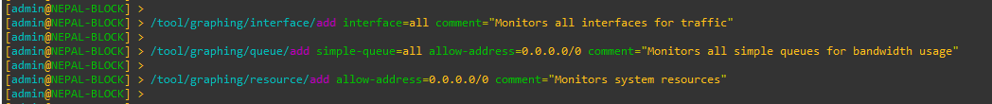

Figure 51: Configurations Graphing on NEPAL-BLOCK Router Through CMD

## HIMAL-BLOCK

CMD

|  |
| --- |
| /tool/graphing/interface/add interface=all comment=“Monitors all interfaces for traffic”  /tool/graphing/queue/add simple-queue=all allow-address=0.0.0.0/0 comment=“Monitors all simple queues for bandwidth usage”  /tool/graphing/resource/add allow-address=0.0.0.0/0 comment=“Monitors system resources” |

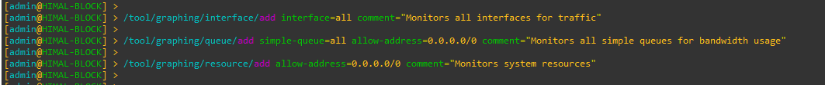

Figure 52: Configurations Graphing on HIMAL-BLOCK Router Through CMD

## BRIT-BLOCK

CMD

|  |
| --- |
| /tool/graphing/interface/add interface=all comment=“Monitors all interfaces for traffic”  /tool/graphing/queue/add simple-queue=all allow-address=0.0.0.0/0 comment=“Monitors all simple queues for bandwidth usage”  /tool/graphing/resource/add allow-address=0.0.0.0/0 comment=“Monitors system resources” |

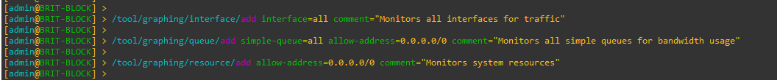

Figure 53: Configurations Graphing on BRIT-BLOCK Router Through CMD

## SKILL-BLOCK

CMD

|  |
| --- |
| /tool/graphing/interface/add interface=all comment=“Monitors all interfaces for traffic”  /tool/graphing/queue/add simple-queue=all allow-address=0.0.0.0/0 comment=“Monitors all simple queues for bandwidth usage”  /tool/graphing/resource/add allow-address=0.0.0.0/0 comment=“Monitors system resources” |

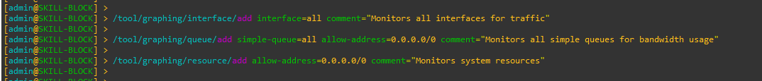

Figure 54: Configurations Graphing on SKILL-BLOCK Router Through CMD

## ALUMNI-BLOCK

CMD

|  |
| --- |
| /tool/graphing/interface/add interface=all comment=“Monitors all interfaces for traffic”  /tool/graphing/queue/add simple-queue=all allow-address=0.0.0.0/0 comment=“Monitors all simple queues for bandwidth usage”  /tool/graphing/resource/add allow-address=0.0.0.0/0 comment=“Monitors system resources” |

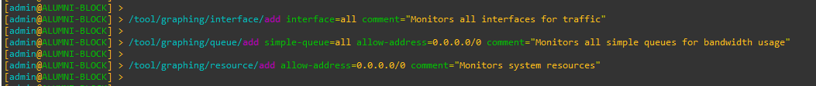

Figure 55: Configurations Graphing on ALUMNI-BLOCK Router Through CMD

## KUMARI-BLOCK

CMD

|  |
| --- |
| /tool/graphing/interface/add interface=all comment=“Monitors all interfaces for traffic”  /tool/graphing/queue/add simple-queue=all allow-address=0.0.0.0/0 comment=“Monitors all simple queues for bandwidth usage”  /tool/graphing/resource/add allow-address=0.0.0.0/0 comment=“Monitors system resources” |

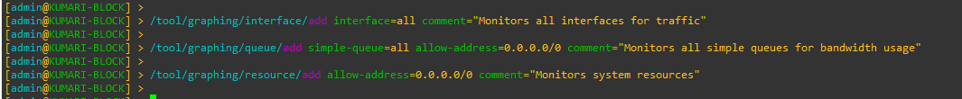

Figure 56: Configurations Graphing on KUMARI-BLOCK Router Through CMD

# Configuration OSPF to all Core Routers

## LONDON-BLOCK

CMD

|  |
| --- |
| /routing ospf instance add name=OSPF_LONDON_BLOCK router-id=160.30.132.1 comment=“OSPF instance for London block, router-id 160.30.132.1”  /routing ospf area add name=backbone area-id=0.0.0.0 instance=OSPF_LONDON_BLOCK comment=“Backbone area 0.0.0.0 for London OSPF”  /routing ospf interface-template  add interfaces=loopback area=backbone passive comment=“Loopback London router-id 160.30.132.1 (passive)”  add networks=10.0.0.0/30 interfaces=ether2 area=backbone type=ptp comment=“ETHER-2_LINK_FROM_LONDON-BLOCK_10.0.0.1_TO_UK-BLOCK_10.0.0.2”  add networks=10.0.0.4/30 interfaces=ether3 area=backbone type=ptp comment=“ETHER-3_LINK_FROM_LONDON-BLOCK_10.0.0.5_TO_NEPAL-BLOCK_10.0.0.6”  add networks=10.0.0.8/30 interfaces=ether4 area=backbone type=ptp comment=“ETHER-4_LINK_FROM_LONDON-BLOCK_10.0.0.9_TO_HIMAL-BLOCK_10.0.0.10”  add networks=10.0.0.12/30 interfaces=ether5 area=backbone type=ptp comment=“ETHER-5_LINK_FROM_LONDON-BLOCK_10.0.0.13_TO_BRIT-BLOCK_10.0.0.14”  add networks=10.0.0.16/30 interfaces=ether6 area=backbone type=ptp comment=“ETHER-6_LINK_FROM_LONDON-BLOCK_10.0.0.17_TO_SKILL-BLOCK_10.0.0.18”  add networks=10.0.0.20/30 interfaces=ether7 area=backbone type=ptp comment=“ETHER-7_LINK_FROM_LONDON-BLOCK_10.0.0.21_TO_ALUMNI-BLOCK_10.0.0.22”  add networks=10.0.0.24/30 interfaces=ether8 area=backbone type=ptp comment=“ETHER-8_LINK_FROM_LONDON-BLOCK_10.0.0.25_TO_KUMARI-BLOCK_10.0.0.26”  / |

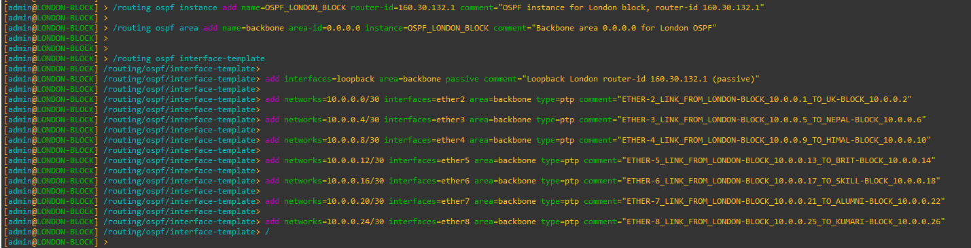

Figure 57: Configuration OSPF to Core LONDON-BLOCK Router Through CMD

|  |
| --- |
| Figure 58: Configuration OSPF Instances to Core LONDON-BLOCK Router Through WINBOX |
| Figure 59: Configuration OSPF Area to Core LONDON-BLOCK Router Through WINBOX |
| Figure 60: Configuration OSPF Interface-template to Core LONDON-BLOCK Router Through WINBOX |

## UK-BLOCK

CMD

|  |
| --- |
| /routing ospf instance add name=OSPF_UK_BLOCK router-id=160.30.132.11 comment=“OSPF instance for UK block, router-id 160.30.132.11”  /routing ospf area add name=backbone area-id=0.0.0.0 instance=OSPF_UK_BLOCK comment=“Backbone area 0.0.0.0 for UK OSPF”  /routing ospf interface-template  add interfaces=loopback area=backbone comment=“Loopback UK router-id 160.30.132.11 (passive)”  add networks=10.0.0.0/30 interfaces=ether2 area=backbone type=ptp comment=“ETHER-2_LINK_FROM_UK-BLOCK_10.0.0.2_TO_LONDON-BLOCK_10.0.0.1”  add networks=10.0.0.28/30 interfaces=ether1 area=backbone type=ptp comment=“ETHER-3_LINK_FROM_UK-BLOCK_10.0.0.29_TO_NEPAL-BLOCK_10.0.0.30”  add networks=10.0.0.32/30 interfaces=ether3 area=backbone type=ptp comment=“ETHER-3_LINK_FROM_UK-BLOCK_10.0.0.34_TO_HIMAL-BLOCK_10.0.0.33”  / |

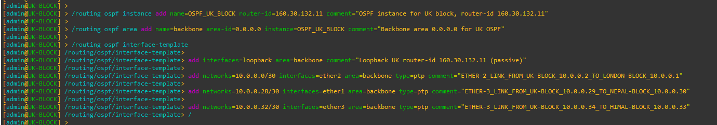

Figure 61: Configuration OSPF to UK-BLOCK Router Through CMD

|  |
| --- |
| Figure 62: Configuration OSPF Instances to UK-BLOCK Router Through WINBOX |
| Figure 63: Configuration OSPF Area to UK-BLOCK Router Through WINBOX |
| Figure 64: Configuration OSPF Interface-template to UK-BLOCK Router Through WINBOX |

## NEPAL-BLOCK

**CMD**

|  |
| --- |
| /routing ospf instance add name=OSPF_NEPAL_BLOCK router-id=160.30.132.12 comment=“OSPF instance for NEPAL block, router-id 160.30.132.12”  /routing ospf area add name=backbone area-id=0.0.0.0 instance=OSPF_NEPAL_BLOCK comment=“Backbone area 0.0.0.0 for NEPAL OSPF”  /routing ospf interface-template  add interfaces=loopback area=backbone comment=“Loopback NEPAL router-id 160.30.132.12 (passive)”  add networks=10.0.0.28/30 interfaces=ether1 area=backbone type=ptp comment=“ETHER-1_LINK_FROM_NEPAL-BLOCK_10.0.0.30_TO_UK-BLOCK_10.0.0.29”  add networks=10.0.0.4/30 interfaces=ether3 area=backbone type=ptp comment=“ETHER-3_LINK_FROM_NEPAL-BLOCK_10.0.0.6_TO_LONDON-BLOCK_10.0.0.5”  add networks=10.0.0.36/30 interfaces=ether2 area=backbone type=ptp comment=“ETHER-2_LINK_FROM_NEPAL-BLOCK_10.0.0.37_TO_BRIT-BLOCK_10.0.0.38”  / |

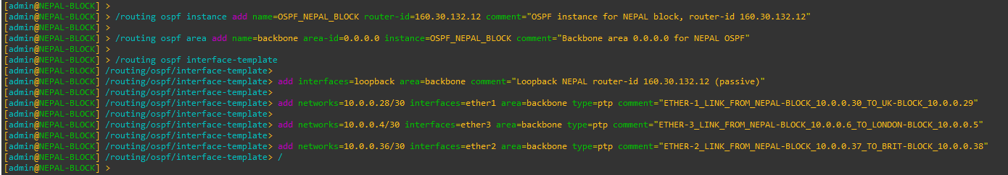

Figure 65: Configuration OSPF to NEPAL-BLOCK Router Through CMD

|  |
| --- |
| Figure 66: Configuration OSPF Instances to NEPAL-BLOCK Router Through WINBOX |
| Figure 67: Configuration OSPF Area to NEPAL-BLOCK Router Through WINBOX |
| Figure 68: Configuration OSPF Interface-template to NEPAL-BLOCK Router Through WINBOX |

## HIMAL-BLOCK

CMD

|  |
| --- |
| /routing ospf instance add name=OSPF_HIMAL_BLOCK router-id=160.30.132.13 comment=“OSPF instance for HIMAL block, router-id 160.30.132.13”  /routing ospf area add name=backbone area-id=0.0.0.0 instance=OSPF_HIMAL_BLOCK comment=“Backbone area 0.0.0.0 for HIMAL OSPF”  /routing ospf interface-template  add interfaces=loopback area=backbone comment=“Loopback HIMAL router-id 160.30.132.13 (passive)”  add networks=10.0.0.32/30 interfaces=ether3 area=backbone type=ptp comment=“ETHER-3_LINK_FROM_HIMAL-BLOCK_10.0.0.33_TO_UK-BLOCK_10.0.0.34”  add networks=10.0.0.8/30 interfaces=ether4 area=backbone type=ptp comment=“ETHER-4_LINK_FROM_HIMAL-BLOCK_10.0.0.10_TO_LONDON-BLOCK_10.0.0.9”  add networks=10.0.0.40/30 interfaces=ether2 area=backbone type=ptp comment=“ETHER-2_LINK_FROM_HIMAL-BLOCK_10.0.0.42_TO_SKILL-BLOCK_10.0.0.41”  / |

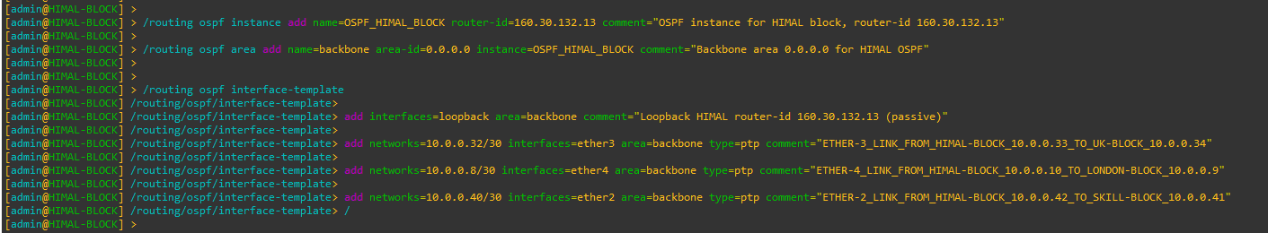

Figure 69: Configuration OSPF to HIMAL-BLOCK Router Through CMD

|  |
| --- |
| Figure 70: Configuration OSPF Instances to HIMAL-BLOCK Router Through WINBOX |
| Figure 71: Configuration OSPF Area to HIMAL-BLOCK Router Through WINBOX |
| Figure 72: Configuration OSPF Interface-template to HIMAL-BLOCK Router Through WINBOX |

## BRIT-BLOCK

**CMD**

|  |
| --- |
| /routing ospf instance add name=OSPF_BRIT_BLOCK router-id=160.30.132.14 comment=“OSPF instance for BRIT block, router-id 160.30.132.14”  /routing ospf area add name=backbone area-id=0.0.0.0 instance=OSPF_BRIT_BLOCK comment=“Backbone area 0.0.0.0 for BRIT OSPF”  /routing ospf interface-template  add interfaces=loopback area=backbone comment=“Loopback BRIT router-id 160.30.132.14 (passive)”  add networks=10.0.0.36/30 interfaces=ether2 area=backbone type=ptp comment=“ETHER-2_LINK_FROM_BRIT-BLOCK_10.0.0.38_TO_NEPAL-BLOCK_10.0.0.37”  add networks=10.0.0.12/30 interfaces=ether5 area=backbone type=ptp comment=“ETHER-5_LINK_FROM_BRIT-BLOCK_10.0.0.14_TO_LONDON-BLOCK_10.0.0.13”  add networks=10.0.0.44/30 interfaces=ether1 area=backbone type=ptp comment=“ETHER-1_LINK_FROM_BRIT-BLOCK_10.0.0.46_TO_SKILL-BLOCK_10.0.0.45” |

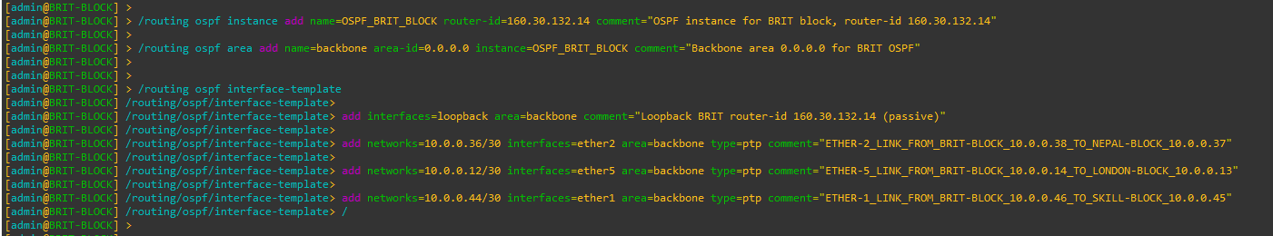

Figure 73: Configuration OSPF to BRIT-BLOCK Router Through CMD

|  |
| --- |
| Figure 74: Configuration OSPF Instances to BRIT-BLOCK Router Through WINBOX |
| Figure 75: Configuration OSPF Area to BRIT-BLOCK Router Through WINBOX |
| Figure 76: Configuration OSPF Interface-template to BRIT-BLOCK Router Through WINBOX |

## SKILL-BLOCK

CMD

|  |
| --- |
| /routing ospf instance add name=OSPF_SKILL_BLOCK router-id=160.30.132.15 comment=“OSPF instance for SKILL block, router-id 160.30.132.15”  /routing ospf area add name=backbone area-id=0.0.0.0 instance=OSPF_SKILL_BLOCK comment=“Backbone area 0.0.0.0 for SKILL OSPF”  /routing ospf interface-template  add interfaces=loopback area=backbone comment=“Loopback SKILL router-id 160.30.132.15 (passive)”  add networks=10.0.0.40/30 interfaces=ether2 area=backbone type=ptp comment=“ETHER-2_LINK_FROM_SKILL-BLOCK_10.0.0.41_TO_HIMAL-BLOCK_10.0.0.42”  add networks=10.0.0.16/30 interfaces=ether6 area=backbone type=ptp comment=“ETHER-6_LINK_FROM_SKILL-BLOCK_10.0.0.18_TO_LONDON-BLOCK_10.0.0.17”  add networks=10.0.0.48/30 interfaces=ether1 area=backbone type=ptp comment=“ETHER-1_LINK_FROM_SKILL-BLOCK_10.0.0.50_TO_ALUMNI-BLOCK_10.0.0.49” |

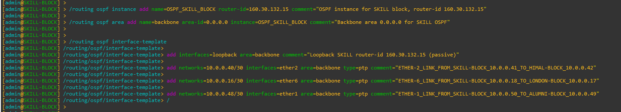

Figure 77: Configuration OSPF to SKILL-BLOCK Router Through CMD

|  |
| --- |
| Figure 78: Configuration OSPF Instances to SKILL-BLOCK Router Through WINBOX |
| Figure 79: Configuration OSPF Area to SKILL-BLOCK Router Through WINBOX |
| Figure 80: Configuration OSPF Interface-template to SKILL-BLOCK Router Through WINBOX |

## ALUMNI-BLOCK

CMD

|  |
| --- |
| /routing ospf instance add name=OSPF_ALUMNI_BLOCK router-id=160.30.132.16 comment=“OSPF instance for ALUMNI block, router-id 160.30.132.16”  /routing ospf area add name=backbone area-id=0.0.0.0 instance=OSPF_ALUMNI_BLOCK comment=“Backbone area 0.0.0.0 for ALUMNI OSPF”  /routing ospf interface-template  add interfaces=loopback area=backbone comment=“Loopback ALUMNI router-id 160.30.132.16 (passive)”  add networks=10.0.0.48/30 interfaces=ether1 area=backbone type=ptp comment=“ETHER-1_LINK_FROM_ALUMNI-BLOCK_10.0.0.49_TO_SKILL-BLOCK_10.0.0.50”  add networks=10.0.0.20/30 interfaces=ether7 area=backbone type=ptp comment=“ETHER-7_LINK_FROM_ALUMNI-BLOCK_10.0.0.22_TO_LONDON-BLOCK_10.0.0.21”  add networks=10.0.0.52/30 interfaces=ether2 area=backbone type=ptp comment=“ETHER-2_LINK_FROM_ALUMNI-BLOCK_10.0.0.53_TO_KUMARI-BLOCK_10.0.0.54” |

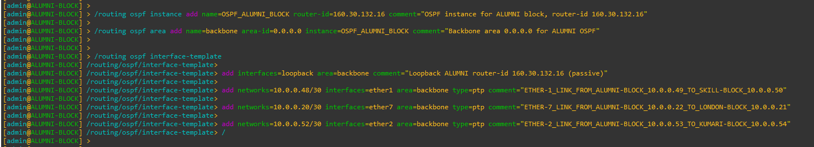

Figure 81: Configuration OSPF to ALUMNI-BLOCK Router Through CMD

|  |
| --- |
| Figure 82: Configuration OSPF Instances to ALUMNI-BLOCK Router Through WINBOX |
| Figure 83: Configuration OSPF Area to ALUMNI-BLOCK Router Through WINBOX |
| Figure 84: Configuration OSPF Interface-template to ALUMNI-BLOCK Router Through WINBOX |

## KUMARI-BLOCK

CMD

|  |
| --- |
| /routing ospf instance add name=OSPF_KUMARI_BLOCK router-id=160.30.132.17 comment=“OSPF instance for KUMARI block, router-id 160.30.132.17”  /routing ospf area add name=backbone area-id=0.0.0.0 instance=OSPF_KUMARI_BLOCK comment=“Backbone area 0.0.0.0 for KUMARI OSPF”  /routing ospf interface-template  add interfaces=loopback area=backbone comment=“Loopback KUMARI router-id 160.30.132.17 (passive)”  add networks=10.0.0.44/30 interfaces=ether1 area=backbone type=ptp comment=“ETHER-1_LINK_FROM_KUMARI-BLOCK_10.0.0.45_TO_BRIT-BLOCK_10.0.0.46”  add networks=10.0.0.24/30 interfaces=ether8 area=backbone type=ptp comment=“ETHER-8_LINK_FROM_KUMARI-BLOCK_10.0.0.26_TO_LONDON-BLOCK_10.0.0.25”  add networks=10.0.0.52/30 interfaces=ether2 area=backbone type=ptp comment=“ETHER-2_LINK_FROM_KUMARI-BLOCK_10.0.0.54_TO_ALUMNI-BLOCK_10.0.0.53” |

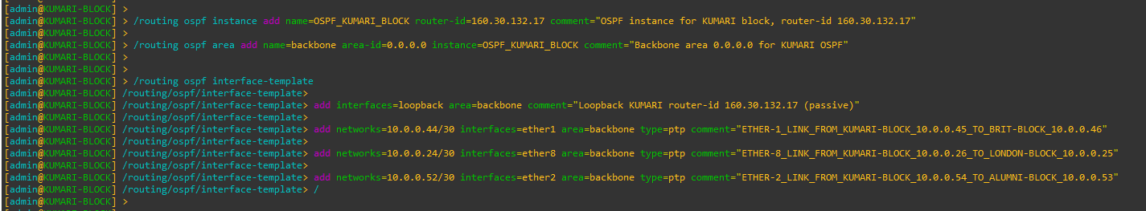

Figure 85: Configuration OSPF to KUMARI-BLOCK Router Through CMD

|  |
| --- |
| Figure 86: Configuration OSPF Instances to KUMARI-BLOCK Router Through WINBOX |
| Figure 87: Configuration OSPF Area to KUMARI-BLOCK Router Through WINBOX |
| Figure 88: Configuration OSPF Interface-template to KUMARI-BLOCK Router Through WINBOX |

# Configure Management Access from PC to MPLS Loopback

## PC (VMware Host) – Static Route Configuration

To allow the PC (VMware host) to reach the MPLS loopback network

160.30.132.0/24, a persistent static route is added on the PC pointing to the

LONDON-BLOCK management interface.

CMD (Windows PC)

|  |
| --- |
| route -p add 160.30.132.0 mask 255.255.255.0 192.168.174.173 |



Figure 89: 6.1. PC (VMware Host) - Static Route Configuration

## UK-BLOCK – OSPF Configuration (No Management Network Advertisement)

LONDON-BLOCK acts as the central management gateway between the PC and the MPLS core. UK-BLOCK participates only in MPLS core OSPF.

The VMware management network must not be added to OSPF.

|  |
| --- |
| /routing ospf interface-template  add networks=192.168.174.0/24 interfaces=ether9 area=backbone  / |



Figure 90: 6.2. UK-BLOCK - OSPF Configuration (No Management Network Advertisement)

## Disable RoMON temporarily to avoid confusion

Cmd

|  |
| --- |
| /tool romon set enabled=no |

## End-to-End Verification (From PC)

Ping Test

|  |
| --- |
| ping 160.30.132.1  ping 160.30.132.11  ping 160.30.132.14  ping 160.30.132.16 |

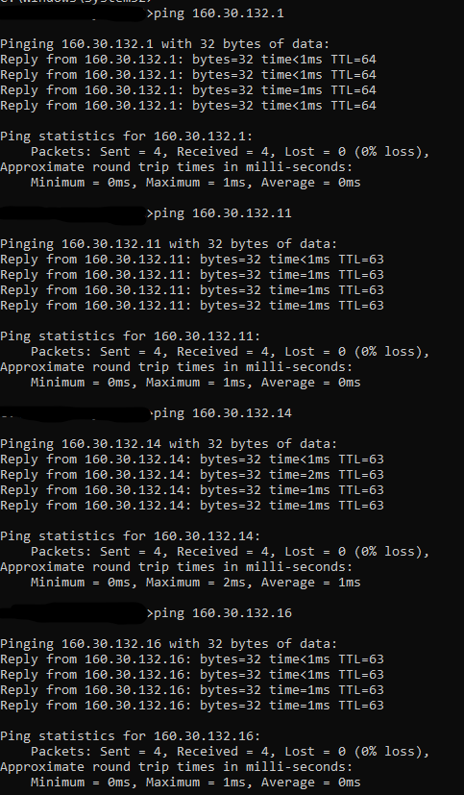

Figure 91: 6.4.: End-to-End Verification (From PC)

# Configuration MPLS to all Core Routers

## LONDON-BLOCK

CMD

|  |
| --- |
| /mpls ldp add lsr-id=160.30.132.1 transport-addresses=160.30.132.1 comment=“Enable MPLS LDP using loopback 160.30.132.1”  /mpls ldp set [find lsr-id=160.30.132.1] disabled=no comment=“Enable MPLS LDP using loopback 160.30.132.1” |



Figure 92: Configuration MPLS to LONDON-BLOCK Router Through CMD

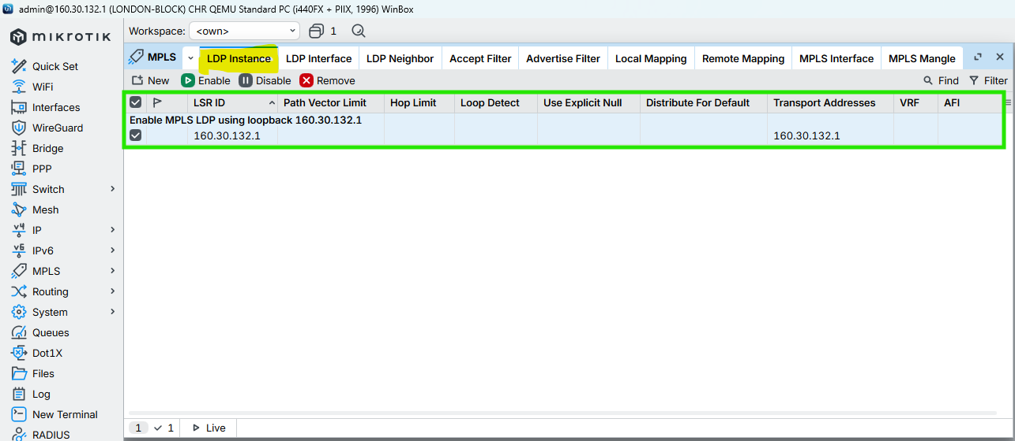

Figure 93: Configuration MPLS to LONDON-BLOCK Router Through WINBOX

## UK-BLOCK

CMD

|  |
| --- |
| /mpls ldp add lsr-id=160.30.132.11 transport-addresses=160.30.132.11 comment=“Enable MPLS LDP using loopback 160.30.132.11”  /mpls ldp set [find lsr-id=160.30.132.11] disabled=no comment=“Enable MPLS LDP using loopback 160.30.132.11” |



Figure 94: Configuration MPLS to UK-BLOCK Router Through CMD

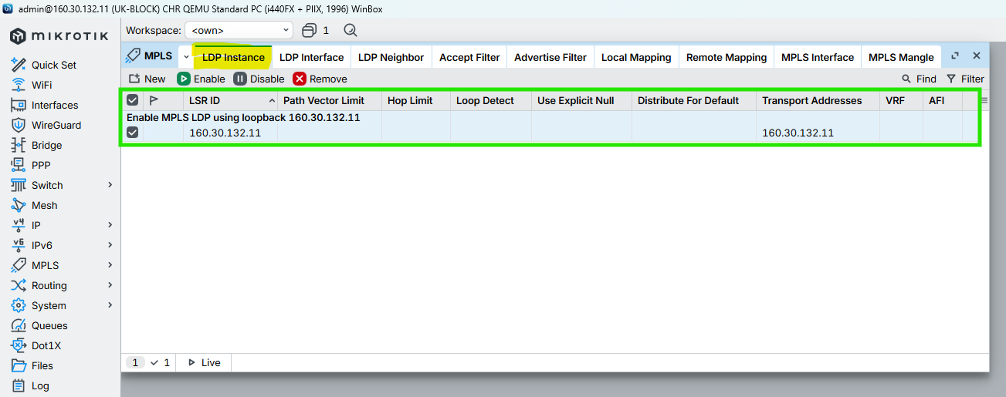

Figure 95: Configuration MPLS to UK-BLOCK Router Through WINBOX

## NEPAL-BLOCK

CMD

|  |
| --- |
| /mpls ldp add lsr-id=160.30.132.12 transport-addresses=160.30.132.12 comment=“Enable MPLS LDP using loopback 160.30.132.12”  /mpls ldp set [find lsr-id=160.30.132.12] disabled=no comment=“Enable MPLS LDP using loopback 160.30.132.12” |



Figure 96: Configuration MPLS to NEPAL-BLOCK Router Through CMD

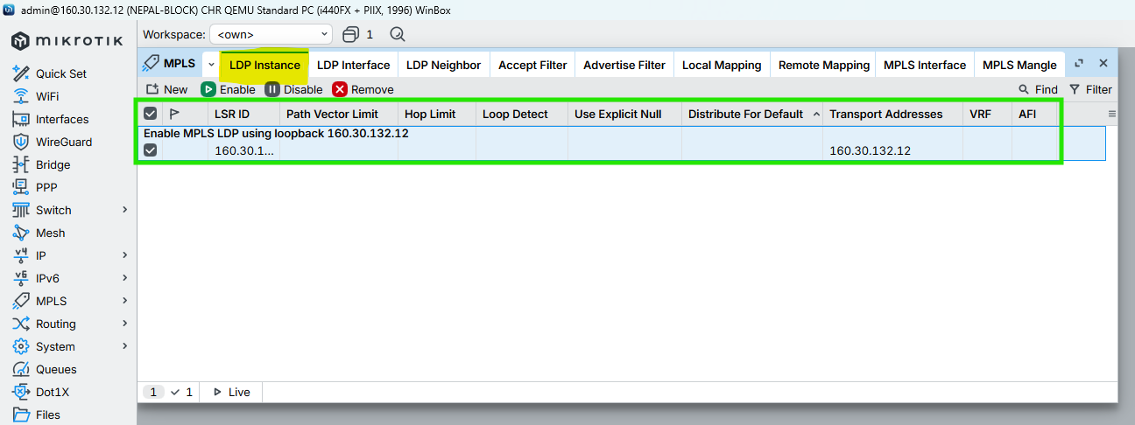

Figure 97: Configuration MPLS to NEPAL-BLOCK Router Through WINBOX

## HIMAL-BLOCK

CMD

|  |
| --- |
| /mpls ldp add lsr-id=160.30.132.13 transport-addresses=160.30.132.13 comment=“Enable MPLS LDP using loopback 160.30.132.13”  /mpls ldp set [find lsr-id=160.30.132.13] disabled=no comment=“Enable MPLS LDP using loopback 160.30.132.13” |



Figure 98: Configuration MPLS to HIMAL-BLOCK Router Through CMD

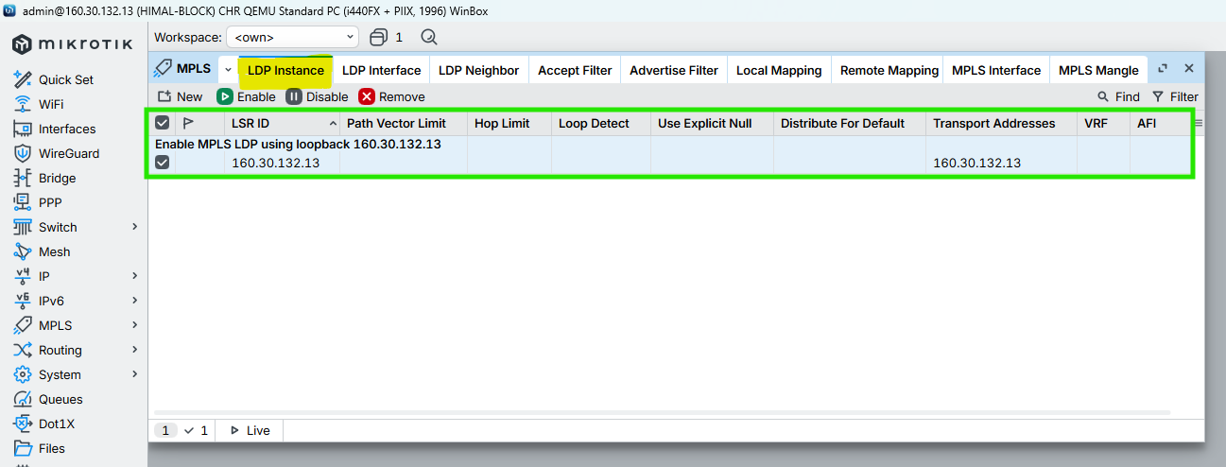

Figure 99: Configuration MPLS to HIMAL-BLOCK Router Through WINBOX

## BRIT-BLOCK

CMD

|  |
| --- |
| /mpls ldp add lsr-id=160.30.132.14 transport-addresses=160.30.132.14 comment=“Enable MPLS LDP using loopback 160.30.132.14”  /mpls ldp set [find lsr-id=160.30.132.14] disabled=no comment=“Enable MPLS LDP using loopback 160.30.132.14” |



Figure 100: Configuration MPLS to BRIT-BLOCK Router Through CMD

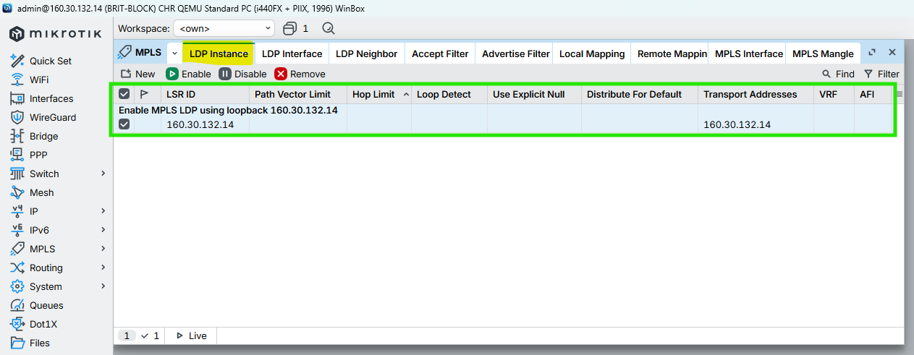

Figure 101: Configuration MPLS to BRIT-BLOCK Router Through WINBOX

## SKILL-BLOCK

CMD

|  |
| --- |
| /mpls ldp add lsr-id=160.30.132.15 transport-addresses=160.30.132.15 comment=“Enable MPLS LDP using loopback 160.30.132.15”  /mpls ldp set [find lsr-id=160.30.132.15] disabled=no comment=“Enable MPLS LDP using loopback 160.30.132.15” |



Figure 102: Configuration MPLS to SKILL-BLOCK Router Through CMD

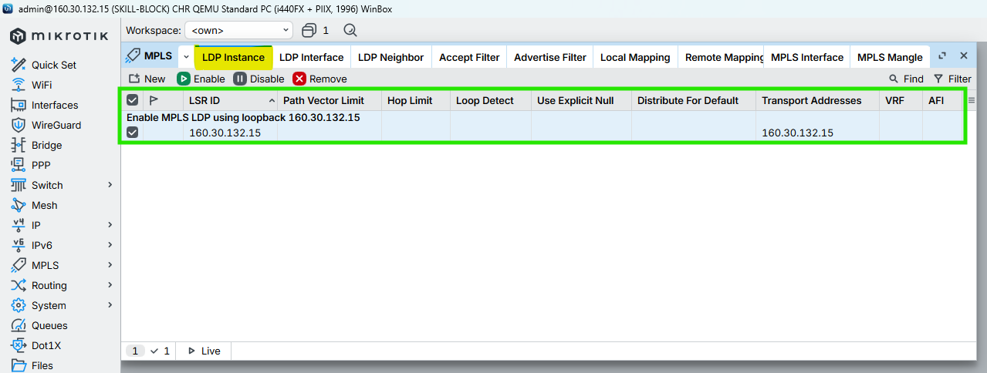

Figure 103: Configuration MPLS to SKILL-BLOCK Router Through WINBOX

## ALUMNI-BLOCK

CMD

|  |
| --- |
| /mpls ldp add lsr-id=160.30.132.16 transport-addresses=160.30.132.16 comment=“Enable MPLS LDP using loopback 160.30.132.16”  /mpls ldp set [find lsr-id=160.30.132.16] disabled=no comment=“Enable MPLS LDP using loopback 160.30.132.16” |



Figure 104: Configuration MPLS to ALUMNI-BLOCK Router Through CMD

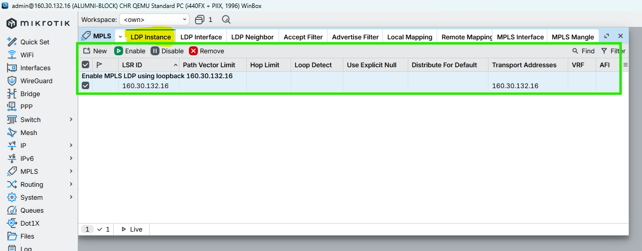

Figure 105: Configuration MPLS to ALUMNI-BLOCK Router Through WINBOX

## KUMARI-BLOCK

CMD

|  |
| --- |
| /mpls ldp add lsr-id=160.30.132.17 transport-addresses=160.30.132.17 comment=“Enable MPLS LDP using loopback 160.30.132.17”  /mpls ldp set [find lsr-id=160.30.132.17] disabled=no comment=“Enable MPLS LDP using loopback 160.30.132.17” |



Figure 106: Configuration MPLS to KUMARI-BLOCK Router Through CMD

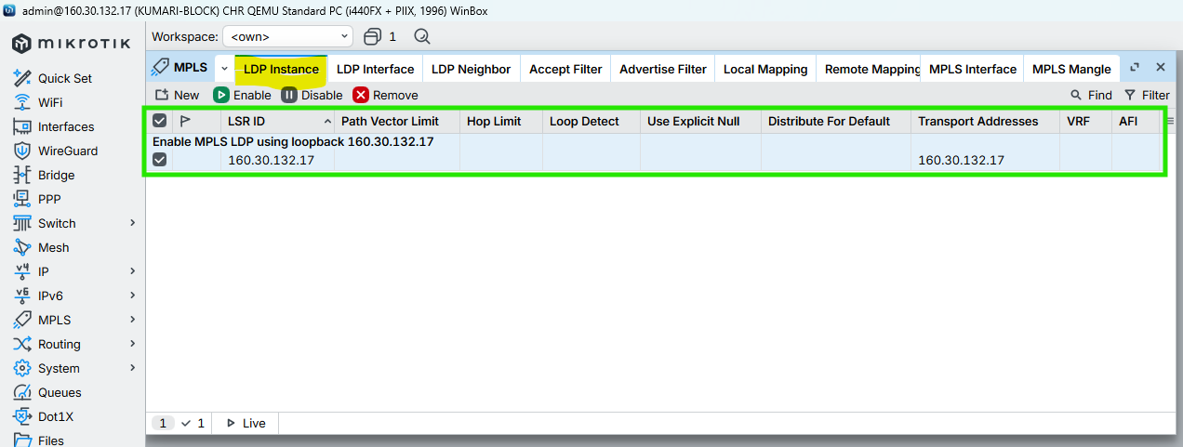

Figure 107: Configuration MPLS to KUMARI-BLOCK Router Through CMD

# MPLS & LDP Configuration on Core Interfaces (with MTU)

This section enables LDP signaling, MPLS forwarding, and configures MPLS MTU ( 1508) on all core-facing interfaces only to support VPLS without fragmentation.

## LONDON-BLOCK

### Enable LDP on Core Interfaces ONLY

CMD

|  |
| --- |
| /mpls ldp interface  add interface=ether2 comment=“LDP_CORE_LINK_LONDON-BLOCK_10.0.0.1/30_TO_UK-BLOCK_10.0.0.2/30”  add interface=ether3 comment=“LDP_CORE_LINK_LONDON-BLOCK_10.0.0.5/30_TO_NEPAL-BLOCK_10.0.0.6/30”  add interface=ether4 comment=“LDP_CORE_LINK_LONDON-BLOCK_10.0.0.9/30_TO_HIMAL-BLOCK_10.0.0.10/30”  add interface=ether5 comment=“LDP_CORE_LINK_LONDON-BLOCK_10.0.0.13/30_TO_BRIT-BLOCK_10.0.0.14/30”  add interface=ether6 comment=“LDP_CORE_LINK_LONDON-BLOCK_10.0.0.17/30_TO_SKILL-BLOCK_10.0.0.18/30”  add interface=ether7 comment=“LDP_CORE_LINK_LONDON-BLOCK_10.0.0.21/30_TO_ALUMNI-BLOCK_10.0.0.22/30”  add interface=ether8 comment=“LDP_CORE_LINK_LONDON-BLOCK_10.0.0.25/30_TO_KUMARI-BLOCK_10.0.0.26/30”  / |

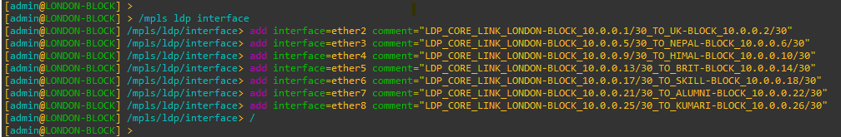

Figure 108: Configuration MPLS LDP Interfaces to LONDON-BLOCK Router Through CMD

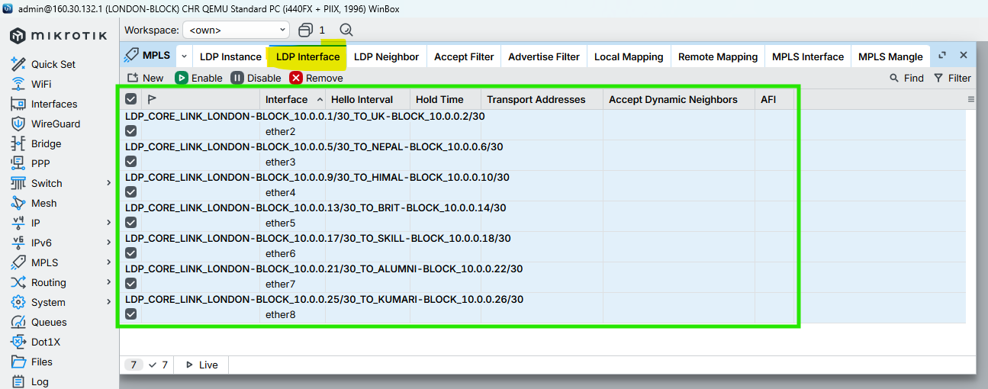

Figure 109: Configuration MPLS LDP nterfaces to LONDON-BLOCK Router Through WINBOX

### Enable MPLS & Set MPLS MTU on interfaces

CMD

|  |
| --- |
| /mpls interface  add interface=ether2 mpls-mtu= 1508 comment=“MPLS_CORE_LINK_LONDON-BLOCK_TO_UK-BLOCK_MTU 1508”  add interface=ether3 mpls-mtu= 1508 comment=“MPLS_CORE_LINK_LONDON-BLOCK_TO_NEPAL-BLOCK_MTU 1508”  add interface=ether4 mpls-mtu= 1508 comment=“MPLS_CORE_LINK_LONDON-BLOCK_TO_HIMAL-BLOCK_MTU 1508”  add interface=ether5 mpls-mtu= 1508 comment=“MPLS_CORE_LINK_LONDON-BLOCK_TO_BRIT-BLOCK_MTU 1508”  add interface=ether6 mpls-mtu= 1508 comment=“MPLS_CORE_LINK_LONDON-BLOCK_TO_SKILL-BLOCK_MTU 1508”  add interface=ether7 mpls-mtu= 1508 comment=“MPLS_CORE_LINK_LONDON-BLOCK_TO_ALUMNI-BLOCK_MTU 1508”  add interface=ether8 mpls-mtu= 1508 comment=“MPLS_CORE_LINK_LONDON-BLOCK_TO_KUMARI-BLOCK_MTU 1508”  / |

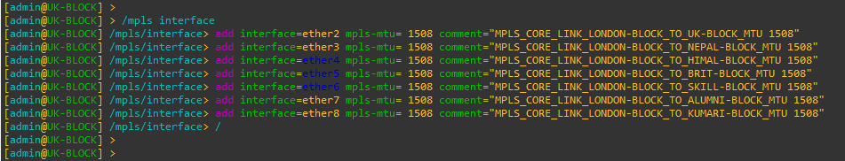

Figure 110: Configuration MPLS MTU on Interfaces to LONDON-BLOCK Router Through CMD

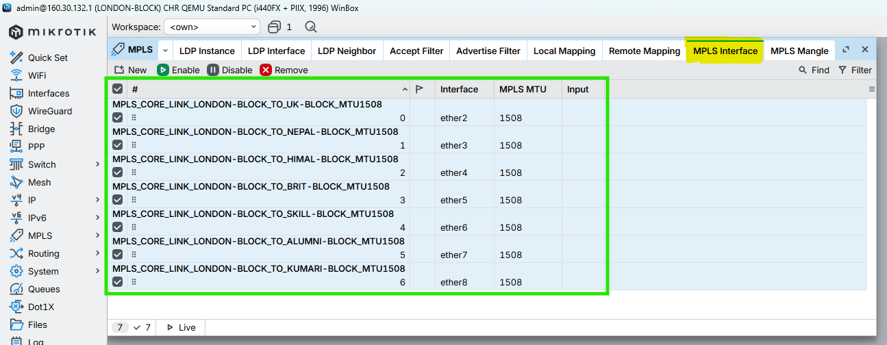

Figure 111: Configuration MPLS MTU on Interfaces to LONDON-BLOCK Router Through WINBOX

## UK-BLOCK

### Enable LDP on Core Interfaces ONLY

CMD

|  |
| --- |
| /mpls ldp interface  add interface=ether2 comment=“LDP_CORE_LINK_UK-BLOCK_10.0.0.2/30_TO_LONDON-BLOCK_10.0.0.1/30”  add interface=ether1 comment=“LDP_CORE_LINK_UK-BLOCK_10.0.0.29/30_TO_NEPAL-BLOCK_10.0.0.30/30”  add interface=ether3 comment=“LDP_CORE_LINK_UK-BLOCK_10.0.0.34/30_TO_HIMAL-BLOCK_10.0.0.33/30”  / |

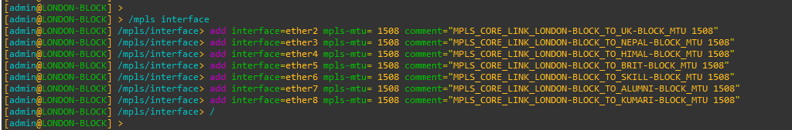

Figure 112: Configuration MPLS LDP Interfaces to UK-BLOCK Router Through CMD

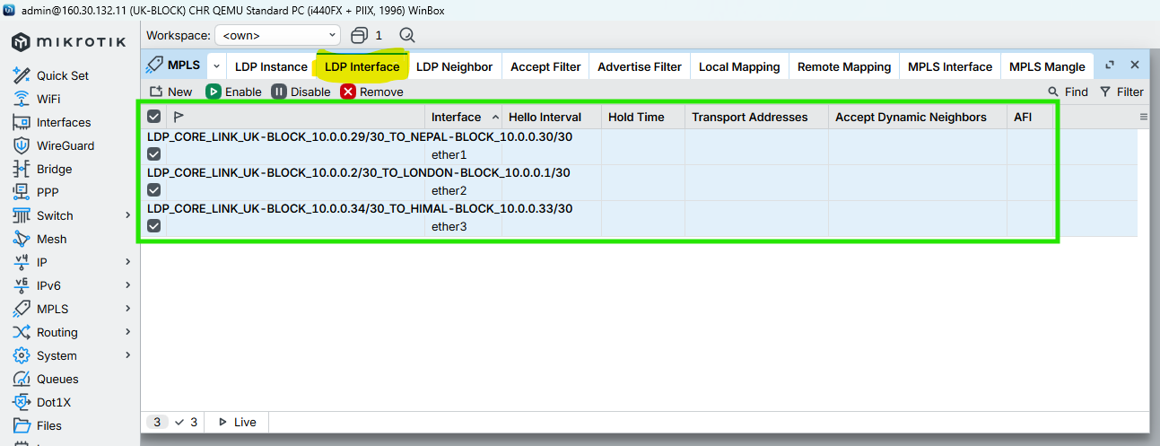

Figure 113: Configuration MPLS LDP Interfaces to UK-BLOCK Router Through WINBOX

### Enable MPLS & Set MPLS MTU on interfaces

CMD

|  |
| --- |
| /mpls interface  add interface=ether2 mpls-mtu= 1508 comment=“MPLS_CORE_LINK_UK-BLOCK_TO_LONDON-BLOCK_MTU 1508”  add interface=ether1 mpls-mtu= 1508 comment=“MPLS_CORE_LINK_UK-BLOCK_TO_NEPAL-BLOCK_MTU 1508”  add interface=ether3 mpls-mtu= 1508 comment=“MPLS_CORE_LINK_UK-BLOCK_TO_HIMAL-BLOCK_MTU 1508”  / |

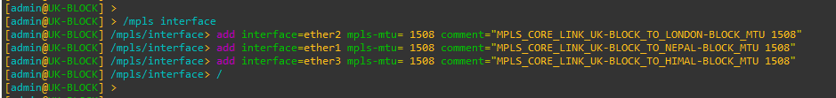

Figure 114: Configuration MPLS MTU on Interfaces to UK-BLOCK Router Through CMD

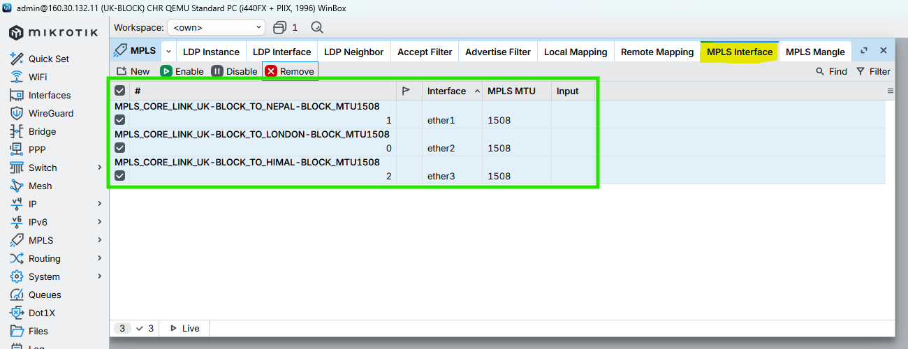

Figure 115: Configuration MPLS MTU on Interfaces to UK-BLOCK Router Through WINBOX

## NEPAL-BLOCK

### Enable LDP on Core Interfaces ONLY

CMD

|  |
| --- |
| /mpls ldp interface  add interface=ether3 comment=“LDP_CORE_LINK_NEPAL-BLOCK_10.0.0.6/30_TO_LONDON-BLOCK_10.0.0.5/30”  add interface=ether1 comment=“LDP_CORE_LINK_NEPAL-BLOCK_10.0.0.30/30_TO_UK-BLOCK_10.0.0.29/30”  add interface=ether2 comment=“LDP_CORE_LINK_NEPAL-BLOCK_10.0.0.37/30_TO_BRIT-BLOCK_10.0.0.38/30”  / |

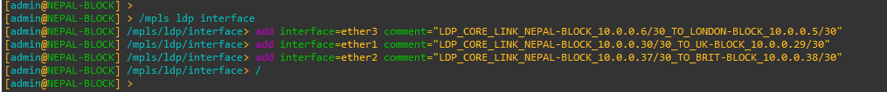

Figure 116: Configuration MPLS LDP Interfaces to NEPAL-BLOCK Router Through CMD

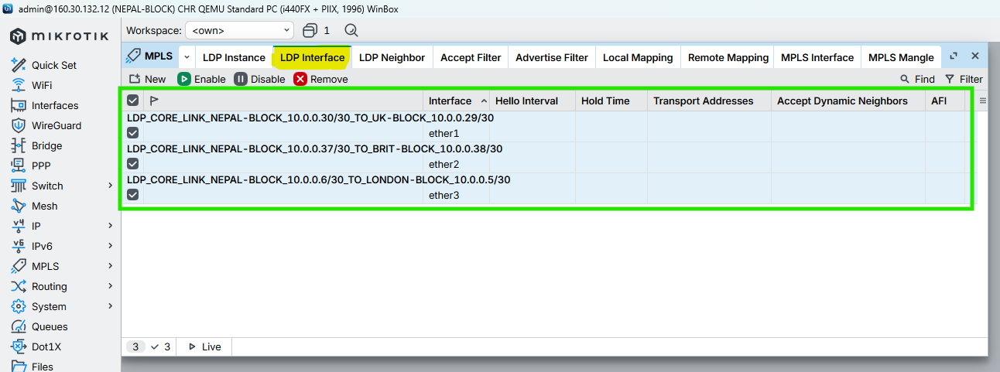

Figure 117: Configuration MPLS LDP Interfaces to NEPAL-BLOCK Router Through WINBOX

### Enable MPLS & Set MPLS MTU on interfaces

CMD

|  |
| --- |
| /mpls interface  add interface=ether3 mpls-mtu= 1508 comment=“MPLS_CORE_LINK_NEPAL-BLOCK_TO_LONDON-BLOCK_MTU 1508”  add interface=ether1 mpls-mtu= 1508 comment=“MPLS_CORE_LINK_NEPAL-BLOCK_TO_UK-BLOCK_MTU 1508”  add interface=ether2 mpls-mtu= 1508 comment=“MPLS_CORE_LINK_NEPAL-BLOCK_TO_BRIT-BLOCK_MTU 1508”  / |

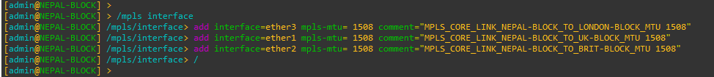

Figure 118: Configuration MPLS MTU on Interfaces to NEPAL-BLOCK Router Through CMD

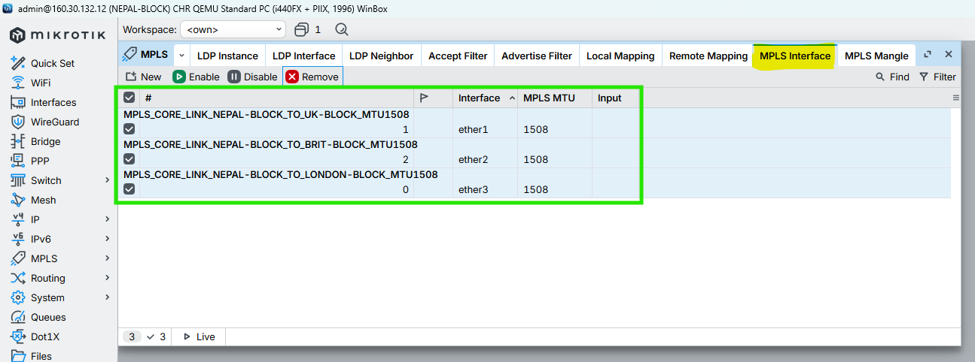

Figure 119: Configuration MPLS MTU on Interfaces to NEPAL-BLOCK Router Through WINBOX

## HIMAL-BLOCK

### Enable LDP on Core Interfaces ONLY

CMD

|  |
| --- |
| /mpls ldp interface  add interface=ether3 comment=“LDP_CORE_LINK_HIMAL-BLOCK_10.0.0.33/30_TO_UK-BLOCK_10.0.0.34/30”  add interface=ether4 comment=“LDP_CORE_LINK_HIMAL-BLOCK_10.0.0.10/30_TO_LONDON-BLOCK_10.0.0.9/30”  add interface=ether2 comment=“LDP_CORE_LINK_HIMAL-BLOCK_10.0.0.42/30_TO_SKILL-BLOCK_10.0.0.41/30”  / |

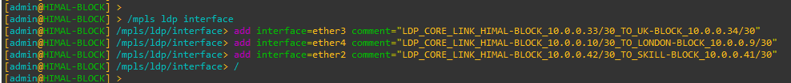

Figure 120: Configuration MPLS LDP Interfaces to HIMAL-BLOCK Router Through CMD

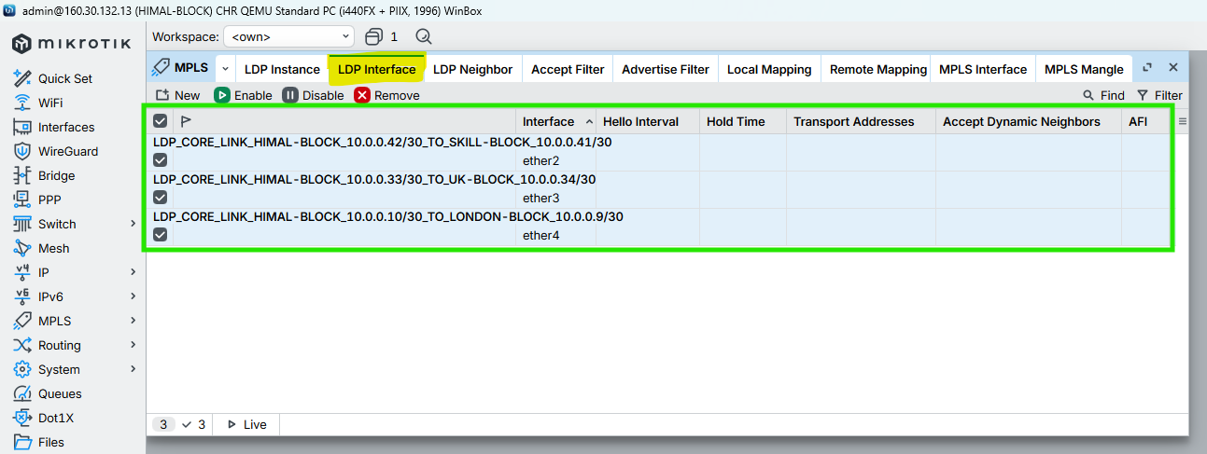

Figure 121: Configuration MPLS LDP Interfaces to HIMAL-BLOCK Router Through WINBOX

### Enable MPLS & Set MPLS MTU on interfaces

CMD

|  |
| --- |
| /mpls interface  add interface=ether3 mpls-mtu= 1508 comment=“MPLS_CORE_LINK_HIMAL-BLOCK_TO_UK-BLOCK_MTU 1508”  add interface=ether4 mpls-mtu= 1508 comment=“MPLS_CORE_LINK_HIMAL-BLOCK_TO_LONDON-BLOCK_MTU 1508”  add interface=ether2 mpls-mtu= 1508 comment=“MPLS_CORE_LINK_HIMAL-BLOCK_TO_SKILL-BLOCK_MTU 1508”  / |

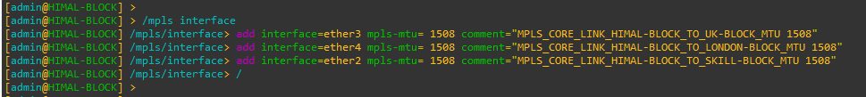

Figure 122: Configuration MPLS MTU on Interfaces to HIMAL-BLOCK Router Through CMD

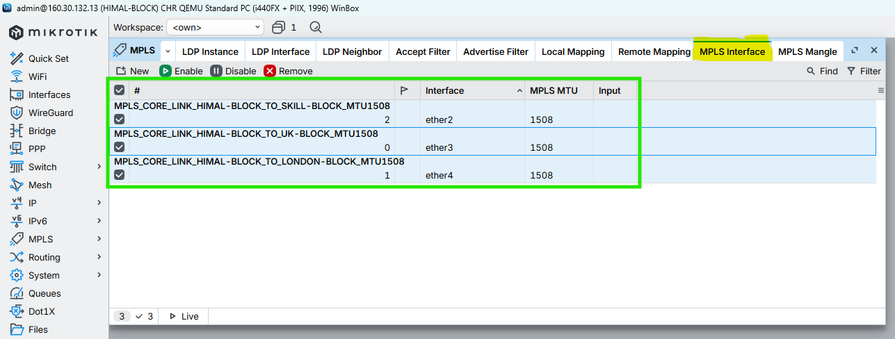

Figure 123: Configuration MPLS MTU on Interfaces to HIMAL-BLOCK Router Through WINBOX

## BRIT-BLOCK

### Enable LDP on Core Interfaces ONLY

CMD

|  |
| --- |
| /mpls ldp interface  add interface=ether2 comment=“LDP_CORE_LINK_BRIT-BLOCK_10.0.0.38/30_TO_NEPAL-BLOCK_10.0.0.37/30”  add interface=ether5 comment=“LDP_CORE_LINK_BRIT-BLOCK_10.0.0.14/30_TO_LONDON-BLOCK_10.0.0.13/30”  add interface=ether1 comment=“LDP_CORE_LINK_BRIT-BLOCK_10.0.0.46/30_TO_KUMARI-BLOCK_10.0.0.44/30”  / |

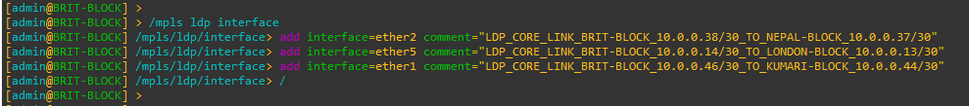

Figure 124: Configuration MPLS LDP Interfaces to BRIT-BLOCK Router Through CMD

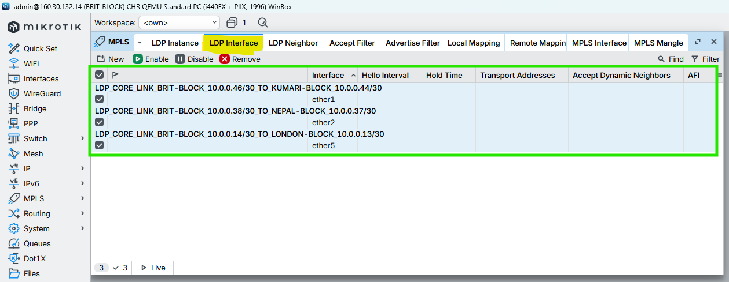

Figure 125: Configuration MPLS LDP Interfaces to BRIT-BLOCK Router Through WINBOX

### Enable MPLS & Set MPLS MTU on interfaces

CMD

|  |
| --- |
| /mpls interface  add interface=ether2 mpls-mtu= 1508 comment=“MPLS_CORE_LINK_BRIT-BLOCK_TO_NEPAL-BLOCK_MTU 1508”  add interface=ether5 mpls-mtu= 1508 comment=“MPLS_CORE_LINK_BRIT-BLOCK_TO_LONDON-BLOCK_MTU 1508”  add interface=ether1 mpls-mtu= 1508 comment=“MPLS_CORE_LINK_BRIT-BLOCK_TO_KUMARI-BLOCK_MTU 1508”  / |

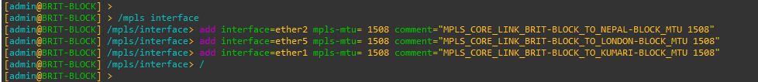

Figure 126: Configuration MPLS MTU on Interfaces to BRIT-BLOCK Router Through CMD

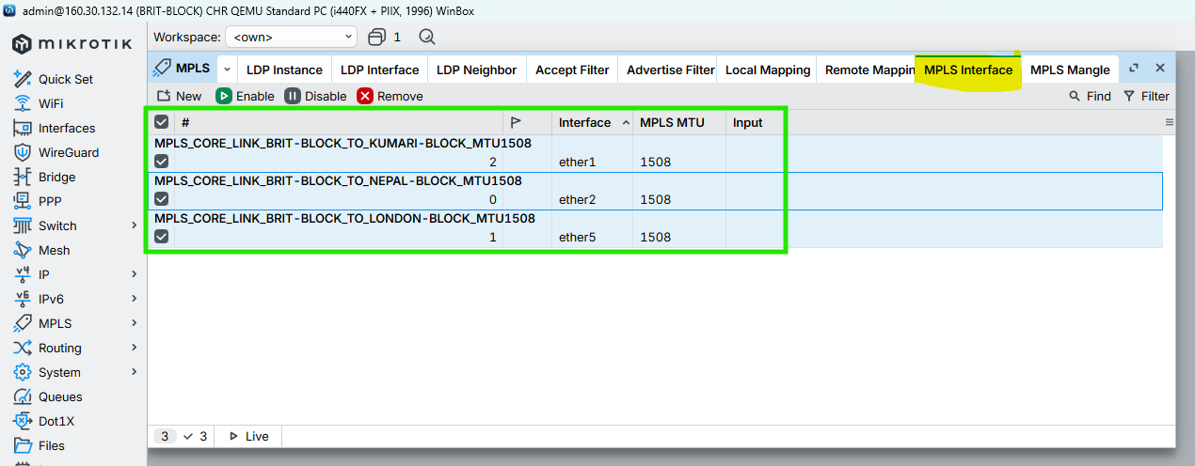

Figure 127: Configuration MPLS MTU on Interfaces to BRIT-BLOCK Router Through WINBOX

## SKILL-BLOCK

### Enable LDP on Core Interfaces ONLY

CMD

|  |
| --- |
| /mpls ldp interface  add interface=ether2 comment=“LDP_CORE_LINK_SKILL-BLOCK_10.0.0.41/30_TO_HIMAL-BLOCK_10.0.0.42/30”  add interface=ether6 comment=“LDP_CORE_LINK_SKILL-BLOCK_10.0.0.18/30_TO_LONDON-BLOCK_10.0.0.17/30”  add interface=ether1 comment=“LDP_CORE_LINK_SKILL-BLOCK_10.0.0.50/30_TO_KUMARI-BLOCK_10.0.0.49/30”  / |

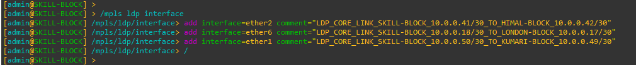

Figure 128: Configuration MPLS LDP Interfaces to SKILL-BLOCK Router Through CMD

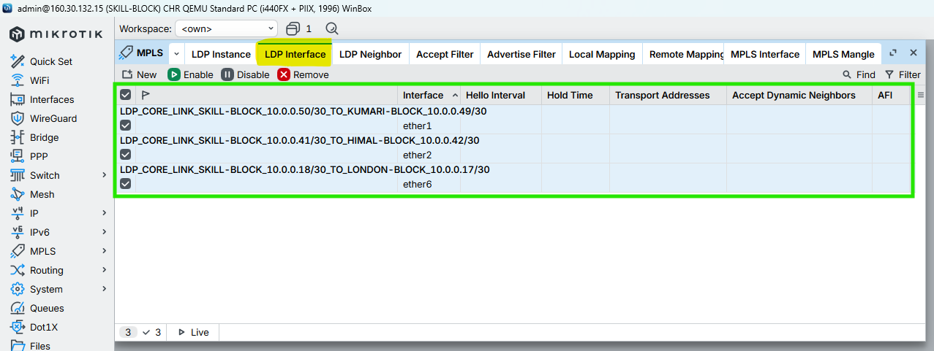

Figure 129: Configuration MPLS LDP Interfaces to SKILL-BLOCK Router Through WINBOX

### Enable MPLS & Set MPLS MTU on interfaces

CMD

|  |
| --- |
| /mpls interface  add interface=ether2 mpls-mtu= 1508 comment=“MPLS_CORE_LINK_SKILL-BLOCK_TO_HIMAL-BLOCK_MTU 1508”  add interface=ether6 mpls-mtu= 1508 comment=“MPLS_CORE_LINK_SKILL-BLOCK_TO_LONDON-BLOCK_MTU 1508”  add interface=ether1 mpls-mtu= 1508 comment=“MPLS_CORE_LINK_SKILL-BLOCK_TO_KUMARI-BLOCK_MTU 1508”  / |

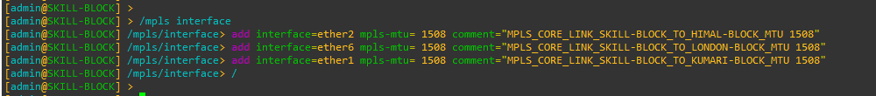

Figure 130: Configuration MPLS MTU on Interfaces to SKILL-BLOCK Router Through CMD

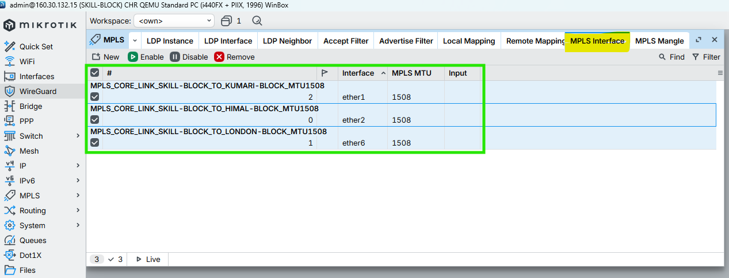

Figure 131: Configuration MPLS MTU on Interfaces to SKILL-BLOCK Router Through WINBOX\

## ALUMNI-BLOCK

### Enable LDP on Core Interfaces ONLY

CMD

|  |
| --- |
| /mpls ldp interface  add interface=ether7 comment=“LDP_CORE_LINK_ALUMNI-BLOCK_10.0.0.22/30_TO_LONDON-BLOCK_10.0.0.21/30”  add interface=ether1 comment=“LDP_CORE_LINK_ALUMNI-BLOCK_10.0.0.49/30_TO_SKILL-BLOCK_10.0.0.50/30”  add interface=ether2 comment=“LDP_CORE_LINK_ALUMNI-BLOCK_10.0.0.53/30_TO_KUMARI-BLOCK_10.0.0.54/30”  / |

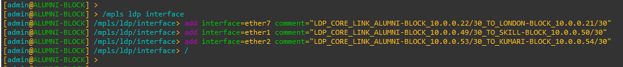

Figure 132: Configuration MPLS LDP Interfaces to ALUMNI-BLOCK Router Through CMD

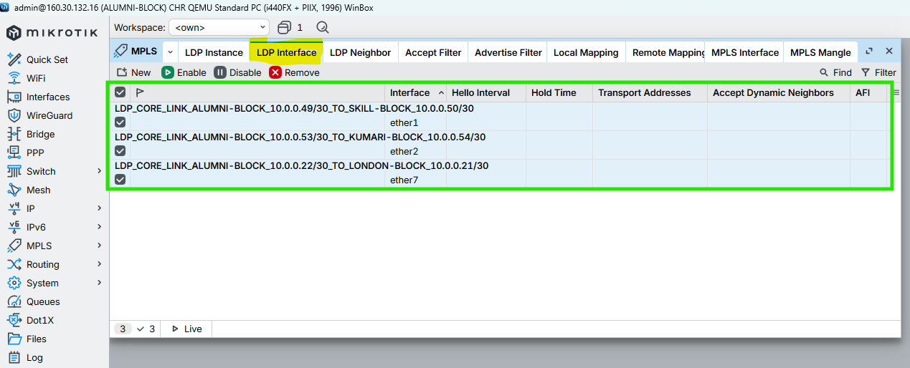

Figure 133: Configuration MPLS LDP Interfaces to ALUMNI-BLOCK Router Through WINBOX

### Enable MPLS & Set MPLS MTU on interfaces

CMD

|  |
| --- |
| /mpls interface  add interface=ether7 mpls-mtu= 1508 comment=“MPLS_CORE_LINK_ALUMNI-BLOCK_TO_LONDON-BLOCK_MTU 1508”  add interface=ether1 mpls-mtu= 1508 comment=“MPLS_CORE_LINK_ALUMNI-BLOCK_TO_SKILL-BLOCK_MTU 1508”  add interface=ether2 mpls-mtu= 1508 comment=“MPLS_CORE_LINK_ALUMNI-BLOCK_TO_KUMARI-BLOCK_MTU 1508”  / |

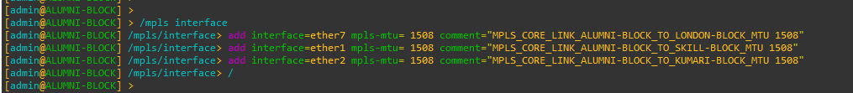

Figure 134: Configuration MPLS MTU on Interfaces to ALUMNI-BLOCK Router Through CMD

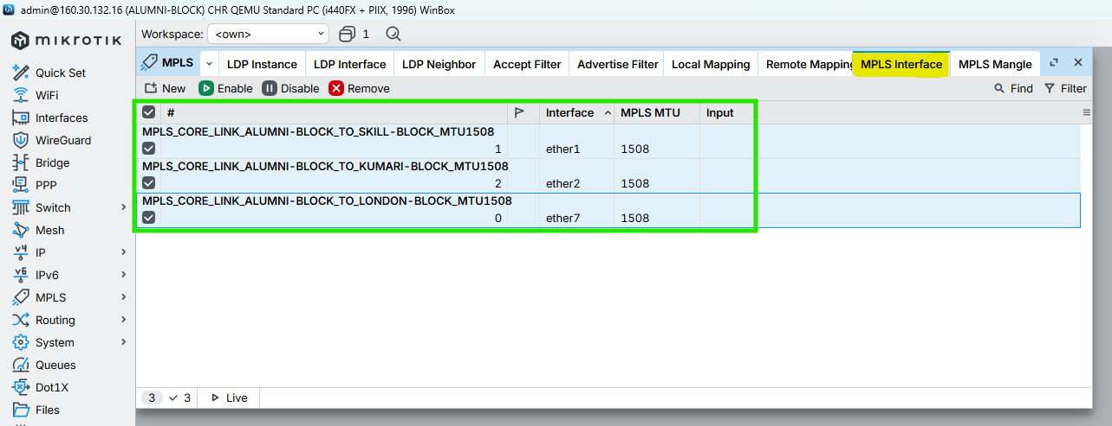

Figure 135: Configuration MPLS MTU on Interfaces to ALUMNI-BLOCK Router Through WINBOX

## KUMARI-BLOCK

### Enable LDP on Core Interfaces ONLY

CMD

|  |
| --- |
| /mpls ldp interface  add interface=ether8 comment=“LDP_CORE_LINK_KUMARI-BLOCK_10.0.0.26/30_TO_LONDON-BLOCK_10.0.0.25/30”  add interface=ether2 comment=“LDP_CORE_LINK_KUMARI-BLOCK_10.0.0.54/30_TO_ALUMNI-BLOCK_10.0.0.53/30”  add interface=ether1 comment=“LDP_CORE_LINK_KUMARI-BLOCK_10.0.0.44/30_TO_BRIT-BLOCK_10.0.0.46/30”  / |

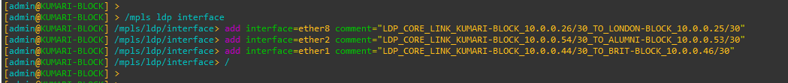

Figure 136: Configuration MPLS LDP Interfaces to KUMARI-BLOCK Router Through CMD

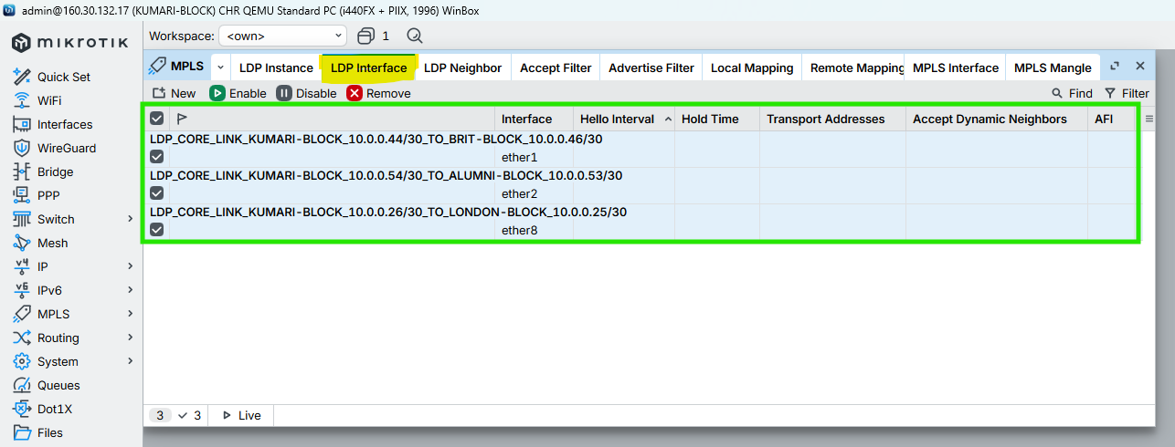

Figure 137: Configuration MPLS LDP Interfaces to KUMARI-BLOCK Router Through WINBOX

### Enable MPLS & Set MPLS MTU on interfaces

CMD

|  |
| --- |
| /mpls interface  add interface=ether8 mpls-mtu= 1508 comment=“MPLS_CORE_LINK_KUMARI-BLOCK_TO_LONDON-BLOCK_MTU 1508”  add interface=ether2 mpls-mtu= 1508 comment=“MPLS_CORE_LINK_KUMARI-BLOCK_TO_ALUMNI-BLOCK_MTU 1508”  add interface=ether1 mpls-mtu= 1508 comment=“MPLS_CORE_LINK_KUMARI-BLOCK_TO_BRIT-BLOCK_MTU 1508”  / |

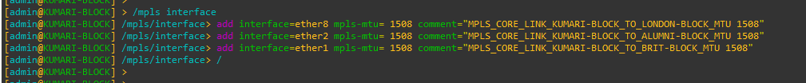

Figure 138: Configuration MPLS MTU on Interfaces to KUMARI-BLOCK Router Through CMD

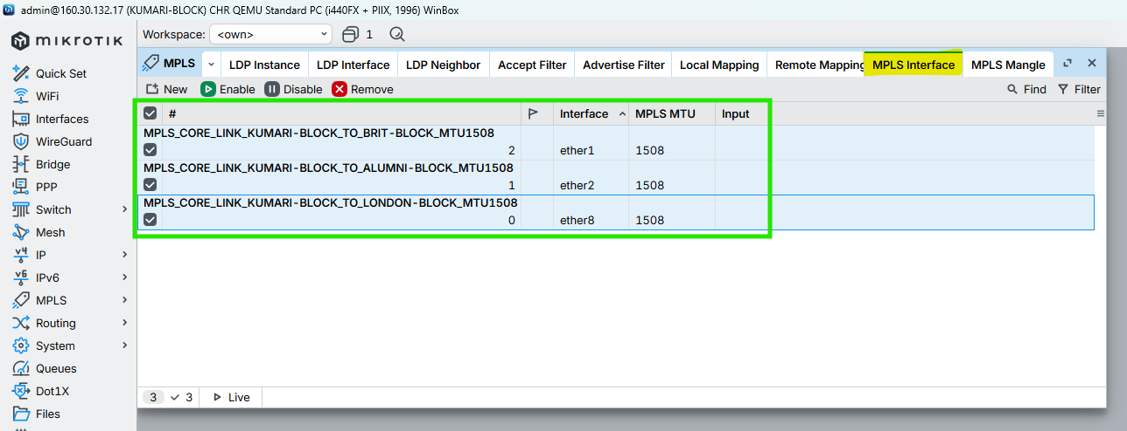

Figure 139: Configuration MPLS MTU on Interfaces to KUMARI-BLOCK Router Through WINBOX

# VPLS Configuration for VLAN Transport (Points to Points) Routers

## LONDON-BLOCK

### Create VPLS BRIDGES (L2 DOMAINS)

CMD

|  |
| --- |
| /interface bridge  add name=BR_VL_STUDENT_100 protocol-mode=none comment=“VL_STUDENT_100 - VPLS Bridge”  add name=BR_VL_TEACHER_200 protocol-mode=none comment=“VL_TEACHER_200 - VPLS Bridge”  add name=BR_VL_STAFF_300 protocol-mode=none comment=“VL_STAFF_300 - VPLS Bridge”  / |

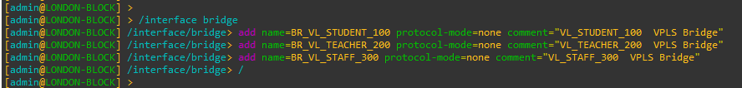

Figure 140: Create VPLS BRIDGES (L2 DOMAINS) on LONDON-BLOCK Router Through CMD

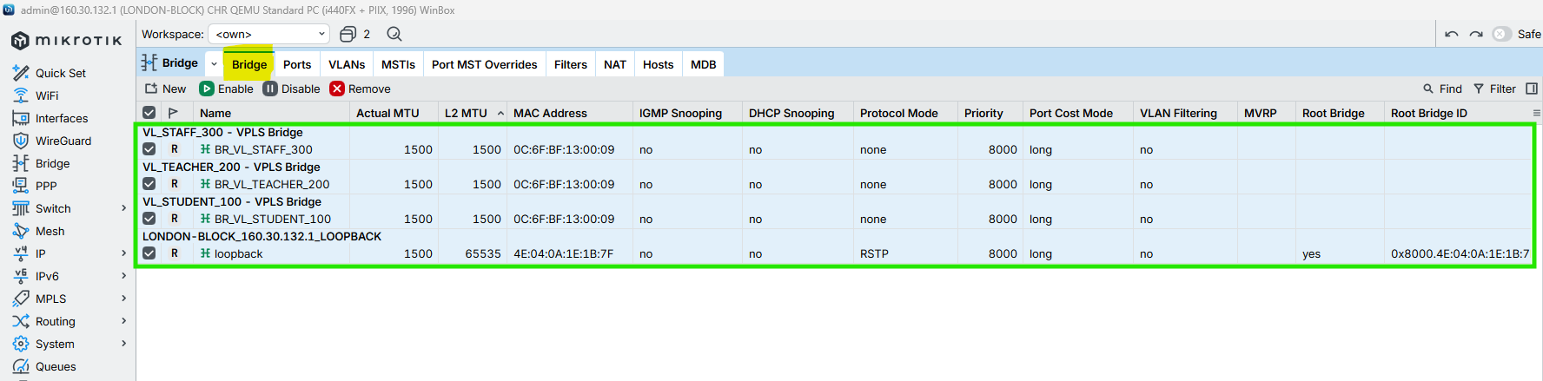

Figure 141: Create VPLS BRIDGES (L2 DOMAINS) on KUMARI-BLOCK Router Through WINBOX

### VPLS Full-Mesh for LONDON-BLOCK

CMD

|  |
| --- |
| /interface vpls  add name=VPLS_UK_VL_STUDENT_100 peer=160.30.132.11 vpls-id=100:0 mtu=1500 bridge=BR_VL_STUDENT_100 comment=“VL_STUDENT_100 - London to UK Block”  add name=VPLS_NEPAL_VL_STUDENT_100 peer=160.30.132.12 vpls-id=100:0 mtu=1500 bridge=BR_VL_STUDENT_100 comment=“VL_STUDENT_100 - London to Nepal Block”  add name=VPLS_HIMAL_VL_STUDENT_100 peer=160.30.132.13 vpls-id=100:0 mtu=1500 bridge=BR_VL_STUDENT_100 comment=“VL_STUDENT_100 - London to Himal Block”  add name=VPLS_BRIT_VL_STUDENT_100 peer=160.30.132.14 vpls-id=100:0 mtu=1500 bridge=BR_VL_STUDENT_100 comment=“VL_STUDENT_100 - London to British Block”  add name=VPLS_SKILL_VL_STUDENT_100 peer=160.30.132.15 vpls-id=100:0 mtu=1500 bridge=BR_VL_STUDENT_100 comment=“VL_STUDENT_100 - London to Skill Block”  add name=VPLS_ALUMNI_VL_STUDENT_100 peer=160.30.132.16 vpls-id=100:0 mtu=1500 bridge=BR_VL_STUDENT_100 comment=“VL_STUDENT_100 - London to Alumni Block”  add name=VPLS_KUMARI_VL_STUDENT_100 peer=160.30.132.17 vpls-id=100:0 mtu=1500 bridge=BR_VL_STUDENT_100 comment=“VL_STUDENT_100 - London to Kumari Block”  /interface vpls  add name=VPLS_UK_VL_TEACHER_200 peer=160.30.132.11 vpls-id=200:0 mtu=1500 bridge=BR_VL_TEACHER_200 comment=“VL_TEACHER_200 - London to UK”  add name=VPLS_NEPAL_VL_TEACHER_200 peer=160.30.132.12 vpls-id=200:0 mtu=1500 bridge=BR_VL_TEACHER_200 comment=“VL_TEACHER_200 - London to Nepal”  add name=VPLS_HIMAL_VL_TEACHER_200 peer=160.30.132.13 vpls-id=200:0 mtu=1500 bridge=BR_VL_TEACHER_200 comment=“VL_TEACHER_200 - London to Himal”  add name=VPLS_BRIT_VL_TEACHER_200 peer=160.30.132.14 vpls-id=200:0 mtu=1500 bridge=BR_VL_TEACHER_200 comment=“VL_TEACHER_200 - London to British”  add name=VPLS_SKILL_VL_TEACHER_200 peer=160.30.132.15 vpls-id=200:0 mtu=1500 bridge=BR_VL_TEACHER_200 comment=“VL_TEACHER_200 - London to Skill”  add name=VPLS_ALUMNI_VL_TEACHER_200 peer=160.30.132.16 vpls-id=200:0 mtu=1500 bridge=BR_VL_TEACHER_200 comment=“VL_TEACHER_200 - London to Alumni”  add name=VPLS_KUMARI_VL_TEACHER_200 peer=160.30.132.17 vpls-id=200:0 mtu=1500 bridge=BR_VL_TEACHER_200 comment=“VL_TEACHER_200 - London to Kumari”  /interface vpls  add name=VPLS_UK_VL_STAFF_300 peer=160.30.132.11 vpls-id=300:0 mtu=1500 bridge=BR_VL_STAFF_300 comment=“VL_STAFF_300 - London to UK”  add name=VPLS_NEPAL_VL_STAFF_300 peer=160.30.132.12 vpls-id=300:0 mtu=1500 bridge=BR_VL_STAFF_300 comment=“VL_STAFF_300 - London to Nepal”  add name=VPLS_HIMAL_VL_STAFF_300 peer=160.30.132.13 vpls-id=300:0 mtu=1500 bridge=BR_VL_STAFF_300 comment=“VL_STAFF_300 - London to Himal”  add name=VPLS_BRIT_VL_STAFF_300 peer=160.30.132.14 vpls-id=300:0 mtu=1500 bridge=BR_VL_STAFF_300 comment=“VL_STAFF_300 - London to British”  add name=VPLS_SKILL_VL_STAFF_300 peer=160.30.132.15 vpls-id=300:0 mtu=1500 bridge=BR_VL_STAFF_300 comment=“VL_STAFF_300 - London to Skill”  add name=VPLS_ALUMNI_VL_STAFF_300 peer=160.30.132.16 vpls-id=300:0 mtu=1500 bridge=BR_VL_STAFF_300 comment=“VL_STAFF_300 - London to Alumni”  add name=VPLS_KUMARI_VL_STAFF_300 peer=160.30.132.17 vpls-id=300:0 mtu=1500 bridge=BR_VL_STAFF_300 comment=“VL_STAFF_300 - London to Kumari”  /  /mpls ldp neighbor print  /interface vpls print  /interface bridge port print  /interface bridge host print |

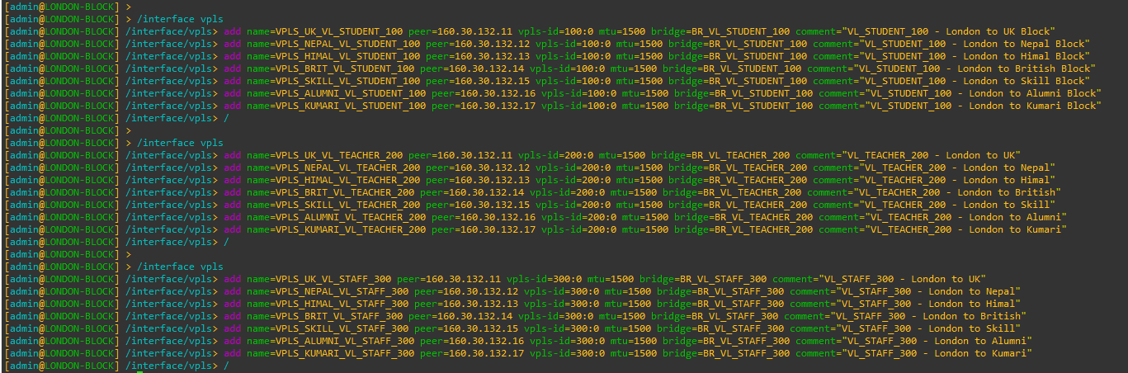

Figure 142: Configuration VPLS Full-Mesh on LONDON-BLOCK Router Through CMD

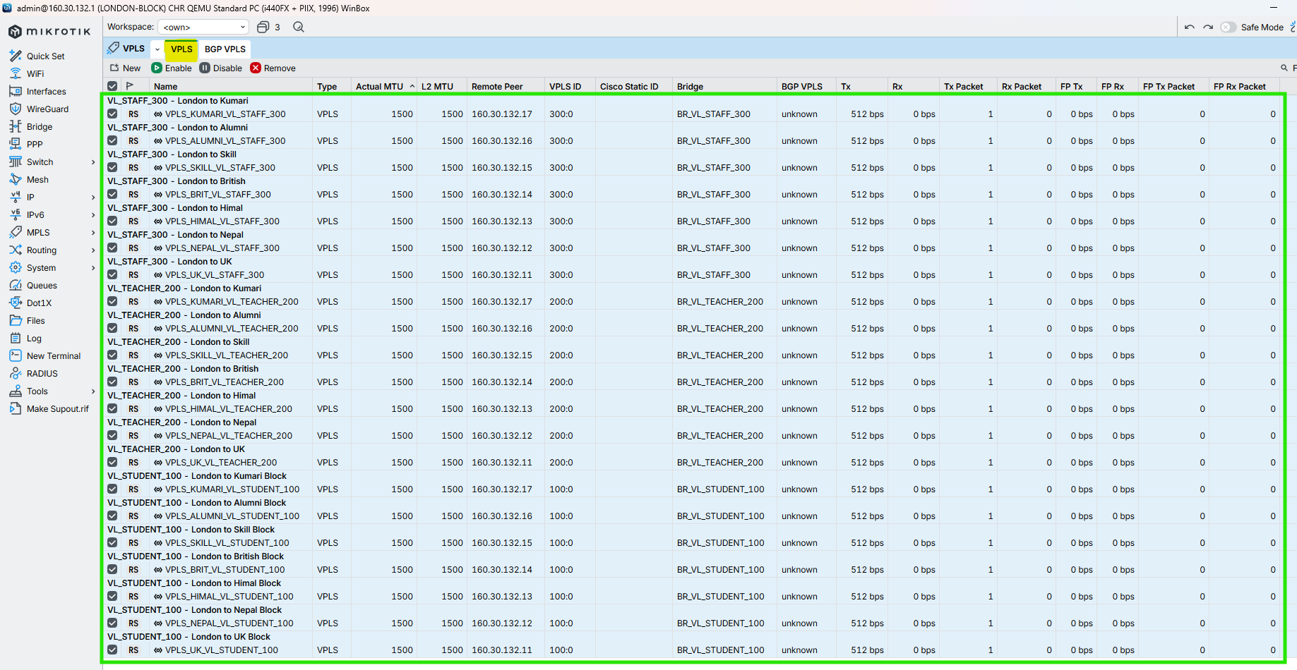

Figure 143: Configuration VPLS Full-Mesh on LONDON-BLOCK Router Through CMD

## UK-BLOCK

### Create VPLS BRIDGES (L2 DOMAINS)

CMD

|  |
| --- |
| /interface bridge  add name=BR_VL_STUDENT_100 protocol-mode=none comment=“VL_STUDENT_100 - VPLS Bridge”  add name=BR_VL_TEACHER_200 protocol-mode=none comment=“VL_TEACHER_200 - VPLS Bridge”  add name=BR_VL_STAFF_300 protocol-mode=none comment=“VL_STAFF_300 - VPLS Bridge”  / |

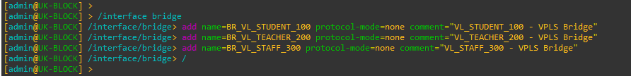

Figure 144: Create VPLS BRIDGES (L2 DOMAINS) on UK-BLOCK Router Through CMD

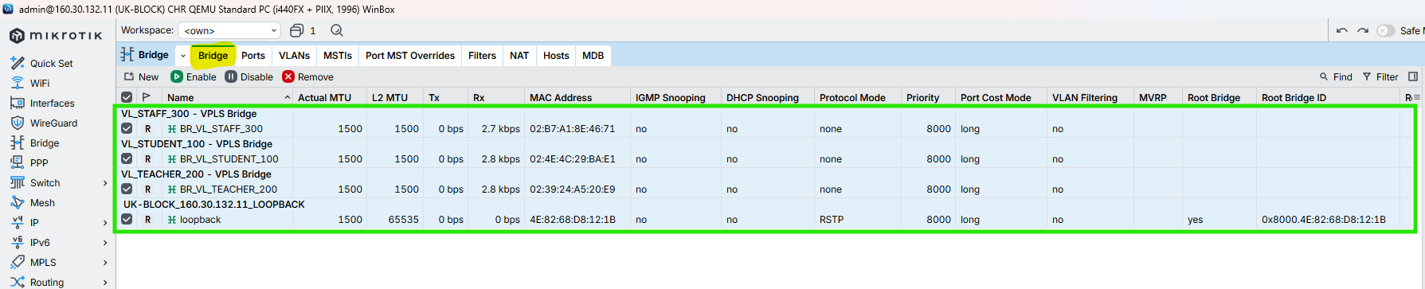

Figure 145: Create VPLS BRIDGES (L2 DOMAINS) on UK-BLOCK Router Through WINBOX

### VPLS Configuration (UK-Points to LONDON-Points)

CMD

|  |
| --- |
| /interface vpls  add name=VPLS_LONDON_VL_STUDENT_100 peer=160.30.132.1 vpls-id=100:0 mtu=1500 bridge=BR_VL_STUDENT_100 comment=“VL_STUDENT_100 - UK to London”  /  /interface vpls  add name=VPLS_LONDON_VL_TEACHER_200 peer=160.30.132.1 vpls-id=200:0 mtu=1500 bridge=BR_VL_TEACHER_200 comment=“VL_TEACHER_200 - UK to London”  /  /interface vpls  add name=VPLS_LONDON_VL_STAFF_300 peer=160.30.132.1 vpls-id=300:0 mtu=1500 bridge=BR_VL_STAFF_300 comment=“VL_STAFF_300 - UK to London”  /  /mpls ldp neighbor print  /interface vpls print  /interface bridge port print  /interface bridge host print |

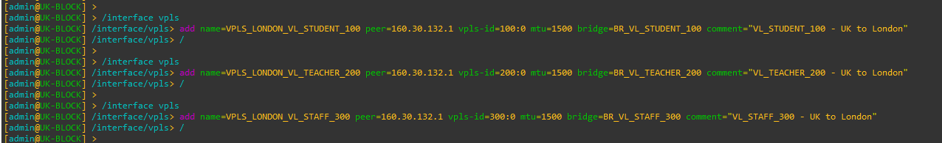

Figure 146: VPLS Configuration (UK-Points to LONDON-Points) on UK-BLOCK Router Through CMD

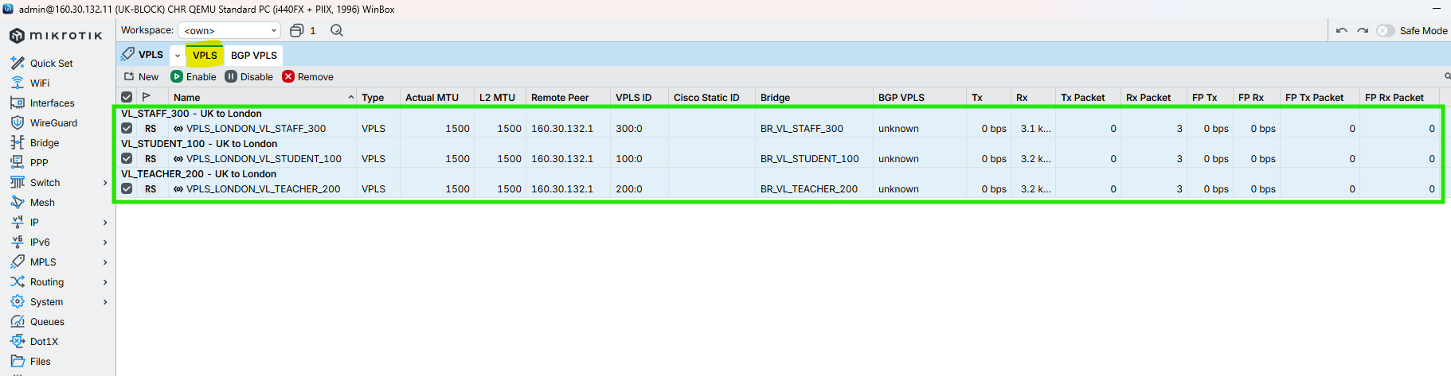

Figure 147: VPLS Configuration (UK-Points to LONDON-Points) on UK-BLOCK Router Through WINBOX

## NEPAL-BLOCK

### Create VPLS BRIDGES (L2 DOMAINS)

CMD

|  |
| --- |
| /interface bridge  add name=BR_VL_STUDENT_100 protocol-mode=none comment=“VL_STUDENT_100 - VPLS Bridge”  add name=BR_VL_TEACHER_200 protocol-mode=none comment=“VL_TEACHER_200 - VPLS Bridge”  add name=BR_VL_STAFF_300 protocol-mode=none comment=“VL_STAFF_300 - VPLS Bridge”  / |

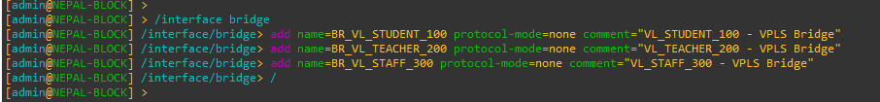

Figure 148: Create VPLS BRIDGES (L2 DOMAINS) on NEPAL-BLOCK Router Through CMD

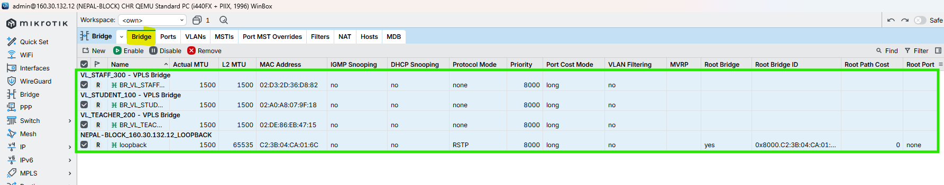

Figure 149: Create VPLS BRIDGES (L2 DOMAINS) on NEPAL-BLOCK Router Through WINBOX

### VPLS Configuration (NEPAL-Points to LONDON-Points)

CMD

|  |
| --- |
| /interface vpls  add name=VPLS_LONDON_VL_STUDENT_100 peer=160.30.132.1 vpls-id=100:0 mtu=1500 bridge=BR_VL_STUDENT_100 comment=“VL_STUDENT_100 - Nepal To London”  /  /interface vpls  add name=VPLS_LONDON_VL_TEACHER_200 peer=160.30.132.1 vpls-id=200:0 mtu=1500 bridge=BR_VL_TEACHER_200 comment=“VL_TEACHER_200 - Nepal To London”  /  /interface vpls  add name=VPLS_LONDON_VL_STAFF_300 peer=160.30.132.1 vpls-id=300:0 mtu=1500 bridge=BR_VL_STAFF_300 comment=“VL_STAFF_300 - Nepal To London”  /  /mpls ldp neighbor print  /interface vpls print  /interface bridge port print  /interface bridge host print |

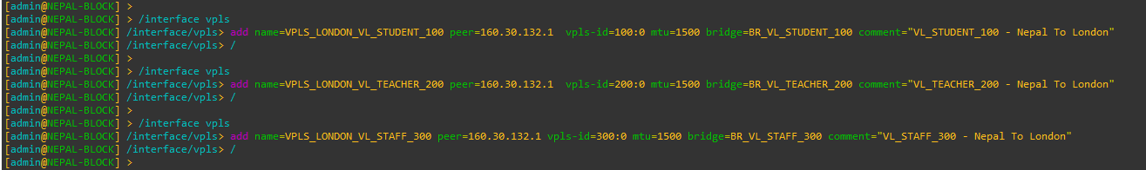

Figure 150: VPLS Configuration (NEPAL-Points to LONDON-Points) on NEPAL-BLOCK Router Through CMD

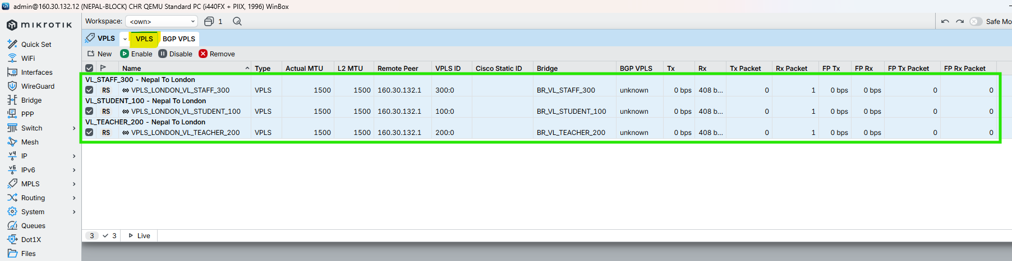

Figure 151: VPLS Configuration (NEPAL-Points to LONDON-Points) on NEPAL-BLOCK Router Through WINBOX

## HIMAL-BLOCK

### Create VPLS BRIDGES (L2 DOMAINS)

CMD

|  |
| --- |
| /interface bridge  add name=BR_VL_STUDENT_100 protocol-mode=none comment=“VL_STUDENT_100 – VPLS Bridge”  add name=BR_VL_TEACHER_200 protocol-mode=none comment=“VL_TEACHER_200 – VPLS Bridge”  add name=BR_VL_STAFF_300 protocol-mode=none comment=“VL_STAFF_300 – VPLS Bridge”  / |

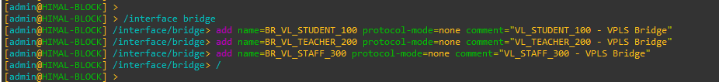

Figure 152: Create VPLS BRIDGES (L2 DOMAINS) on HIMAL-BLOCK Router Through CMD

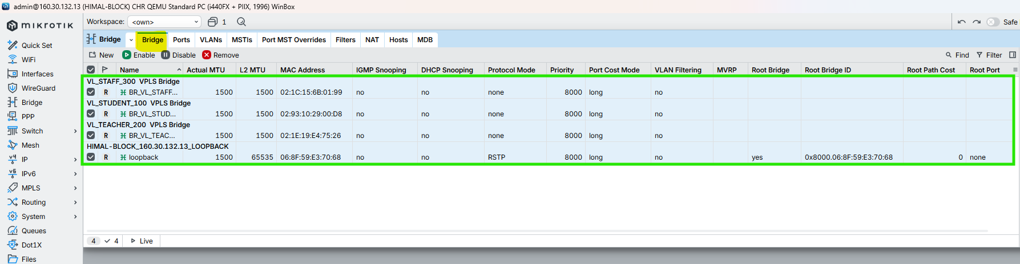

Figure 153: Create VPLS BRIDGES (L2 DOMAINS) on HIMAL-BLOCK Router Through WINBOX

### VPLS Configuration (HIMAL-Points to LONDON-Points)

CMD

|  |
| --- |
| /interface vpls  add name=VPLS_LONDON_VL_STUDENT_100 peer=160.30.132.1 vpls-id=100:0 mtu=1500 bridge=BR_VL_STUDENT_100 comment=“VL_STUDENT_100 - Himal To London”  /  /interface vpls  add name=VPLS_LONDON_VL_TEACHER_200 peer=160.30.132.1 vpls-id=200:0 mtu=1500 bridge=BR_VL_TEACHER_200 comment=“VL_TEACHER_200 - Himal To London”  /  /interface vpls  add name=VPLS_LONDON_VL_STAFF_300 peer=160.30.132.1 vpls-id=300:0 mtu=1500 bridge=BR_VL_STAFF_300 comment=“VL_STAFF_300 - Himal To London”  /  /mpls ldp neighbor print  /interface vpls print  /interface bridge port print  /interface bridge host print |

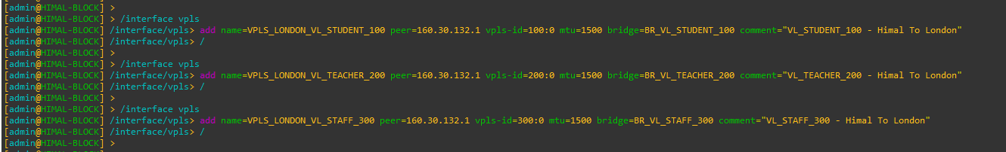

Figure 154: VPLS Configuration (HIMAL-Points to LONDON-Points) on HIMAL-BLOCK Router Through CMD

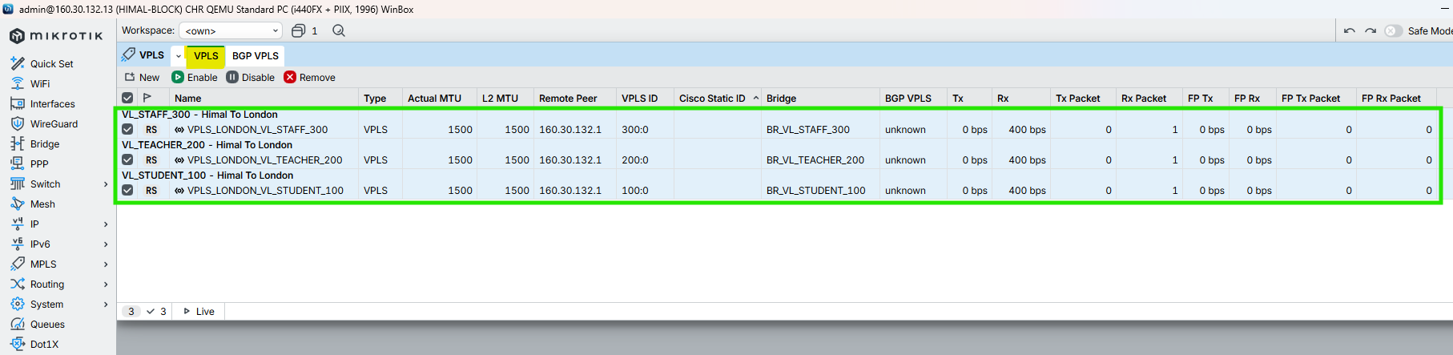

Figure 155: VPLS Configuration (HIMAL-Points to LONDON-Points) on HIMAL-BLOCK Router Through WINBOX

## BRIT-BLOCK

### Create VPLS BRIDGES (L2 DOMAINS)

CMD

|  |
| --- |
| /interface bridge  add name=BR_VL_STUDENT_100 protocol-mode=none comment=“VL_STUDENT_100 – VPLS Bridge”  add name=BR_VL_TEACHER_200 protocol-mode=none comment=“VL_TEACHER_200 – VPLS Bridge”  add name=BR_VL_STAFF_300 protocol-mode=none comment=“VL_STAFF_300 – VPLS Bridge”  / |

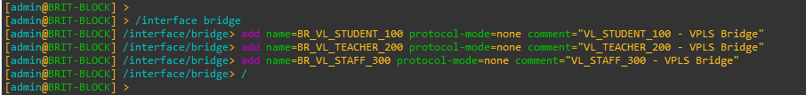

Figure 156: Create VPLS BRIDGES (L2 DOMAINS) on BRIT-BLOCK Router Through CMD

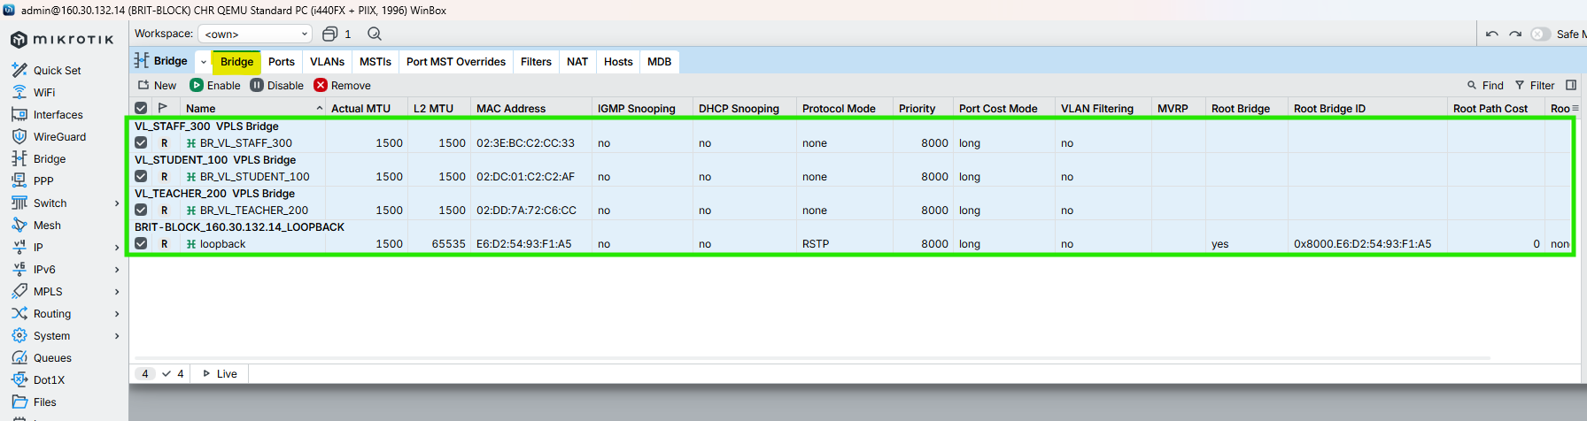

Figure 157: Create VPLS BRIDGES (L2 DOMAINS) on BRIT-BLOCK Router Through WINBOX

### VPLS Configuration (BRIT-Points to LONDON-Points)

CMD

|  |
| --- |
| /interface vpls  add name=VPLS_LONDON_VL_STUDENT_100 peer=160.30.132.1 vpls-id=100:0 mtu=1500 bridge=BR_VL_STUDENT_100 comment=“VL_STUDENT_100 - British To London”  /  /interface vpls  add name=VPLS_LONDON_VL_TEACHER_200 peer=160.30.132.1 vpls-id=200:0 mtu=1500 bridge=BR_VL_TEACHER_200 comment=“VL_TEACHER_200 - British To London”  /  /interface vpls  add name=VPLS_LONDON_VL_STAFF_300 peer=160.30.132.1 vpls-id=300:0 mtu=1500 bridge=BR_VL_STAFF_300 comment=“VL_STAFF_300 - British To London”  /  /mpls ldp neighbor print  /interface vpls print  /interface bridge port print  /interface bridge host print |

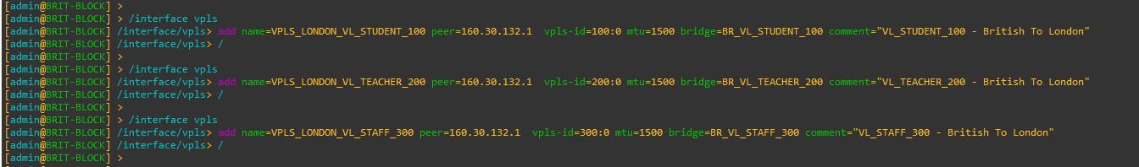

Figure 158: VPLS Configuration (BRIT-Points to LONDON-Points) on BRIT-BLOCK Router Through CMD

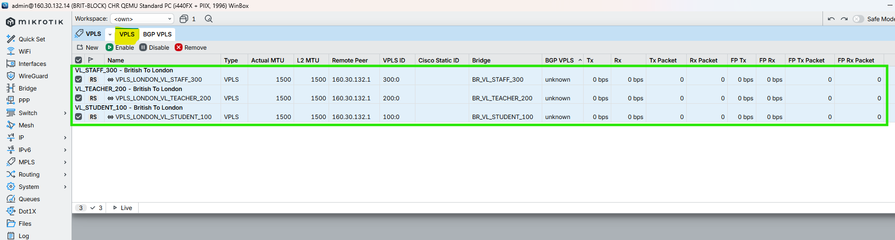

Figure 159: VPLS Configuration (BRIT-Points to LONDON-Points) on BRIT-BLOCK Router Through WINBOX

## SKILL-BLOCK

### Create VPLS BRIDGES (L2 DOMAINS)

CMD

|  |
| --- |
| /interface bridge  add name=BR_VL_STUDENT_100 protocol-mode=none comment=“VL_STUDENT_100 – VPLS Bridge”  add name=BR_VL_TEACHER_200 protocol-mode=none comment=“VL_TEACHER_200 – VPLS Bridge”  add name=BR_VL_STAFF_300 protocol-mode=none comment=“VL_STAFF_300 – VPLS Bridge”  / |

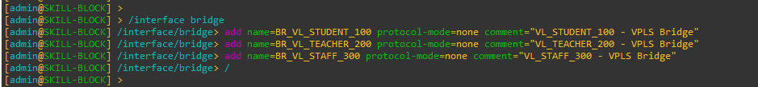

Figure 160: Create VPLS BRIDGES (L2 DOMAINS) on SKILL-BLOCK Router Through CMD

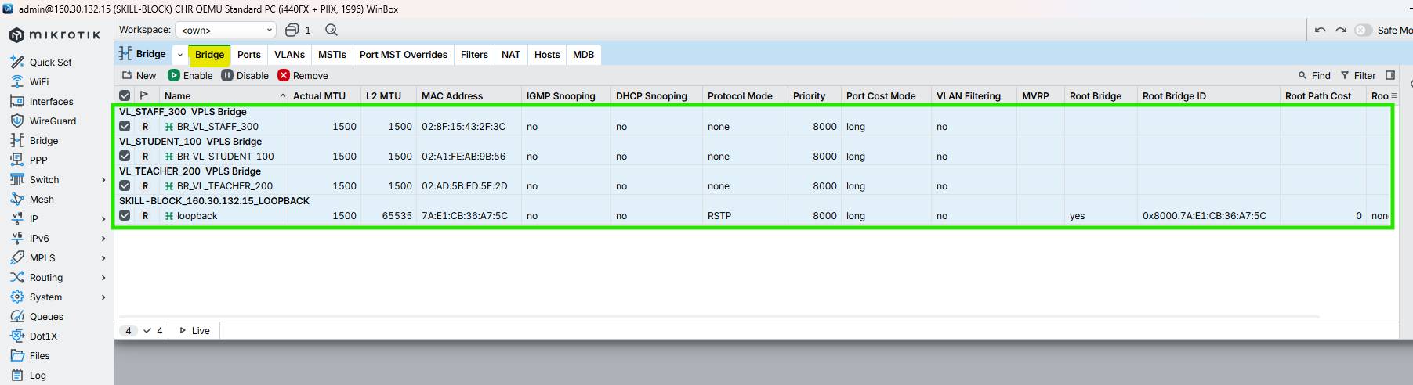

Figure 161: Create VPLS BRIDGES (L2 DOMAINS) on SKILL-BLOCK Router Through WINBOX

### VPLS Configuration (SKILL-Points to LONDON-Points)

CMD

|  |
| --- |
| /interface vpls  add name=VPLS_LONDON_VL_STUDENT_100 peer=160.30.132.1 vpls-id=100:0 mtu=1500 bridge=BR_VL_STUDENT_100 comment=“VL_STUDENT_100 - Skill To London”  /  /interface vpls  add name=VPLS_LONDON_VL_TEACHER_200 peer=160.30.132.1 vpls-id=200:0 mtu=1500 bridge=BR_VL_TEACHER_200 comment=“VL_TEACHER_200 – Skill To London”  /  /interface vpls  add name=VPLS_LONDON_VL_STAFF_300 peer=160.30.132.1 vpls-id=300:0 mtu=1500 bridge=BR_VL_STAFF_300 comment=“VL_STAFF_300 – Skill To London”  /  /mpls ldp neighbor print  /interface vpls print  /interface bridge port print  /interface bridge host print |

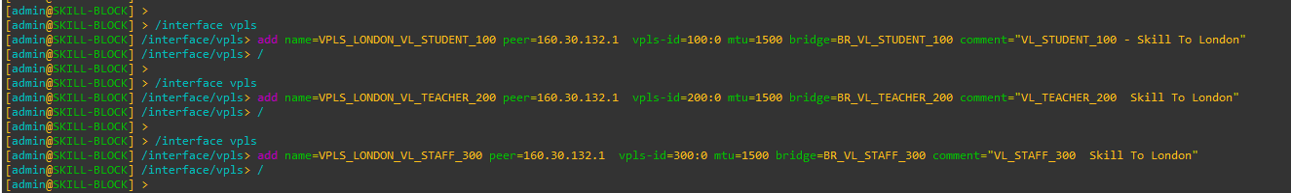

Figure 162: VPLS Configuration (SKILL-Points to LONDON-Points) on SKILL-BLOCK Router Through CMD

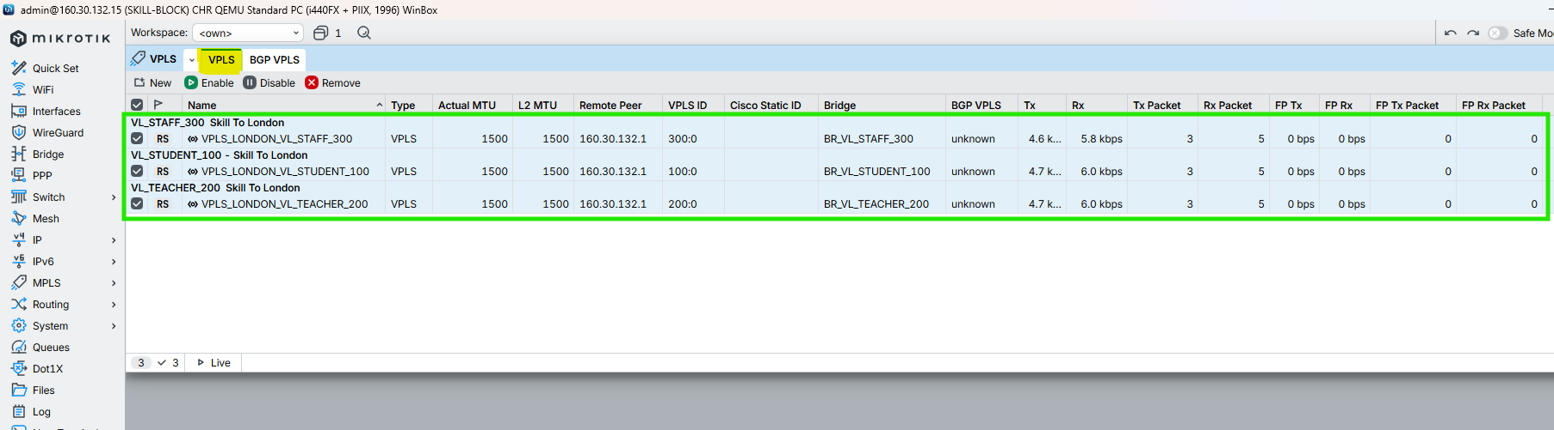

Figure 163: VPLS Configuration (SKILL-Points to LONDON-Points) on SKILL-BLOCK Router Through WINBOX

## ALUMNI-BLOCK

### Create VPLS BRIDGES (L2 DOMAINS)

CMD

|  |
| --- |
| /interface bridge  add name=BR_VL_STUDENT_100 protocol-mode=none comment=“VL_STUDENT_100 – VPLS Bridge”  add name=BR_VL_TEACHER_200 protocol-mode=none comment=“VL_TEACHER_200 – VPLS Bridge”  add name=BR_VL_STAFF_300 protocol-mode=none comment=“VL_STAFF_300 – VPLS Bridge”  / |

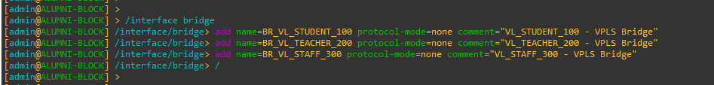

Figure 164: Create VPLS BRIDGES (L2 DOMAINS) on ALUMNI-BLOCK Router Through CMD

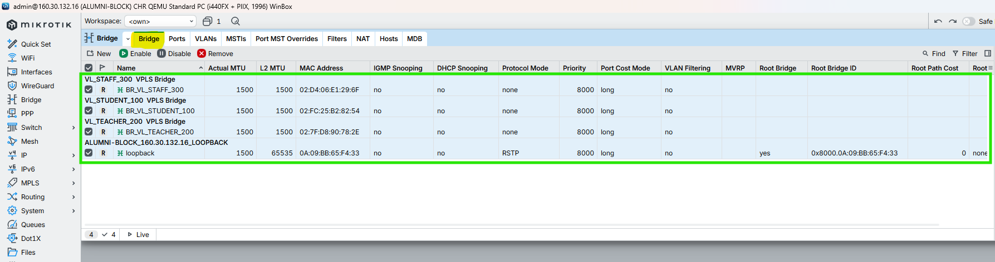

Figure 165: Create VPLS BRIDGES (L2 DOMAINS) on ALUMNI-BLOCK Router Through WINBOX

### VPLS Configuration (ALUMNI-Points to LONDON-Points)

CMD

|  |
| --- |
| /interface vpls  add name=VPLS_LONDON_VL_STUDENT_100 peer=160.30.132.1 vpls-id=100:0 mtu=1500 bridge=BR_VL_STUDENT_100 comment=“VL_STUDENT_100 – Alumni To London”  /  /interface vpls  add name=VPLS_LONDON_VL_TEACHER_200 peer=160.30.132.1 vpls-id=200:0 mtu=1500 bridge=BR_VL_TEACHER_200 comment=“VL_TEACHER_200 – Alumni To London”  /  /interface vpls  add name=VPLS_LONDON_VL_STAFF_300 peer=160.30.132.1 vpls-id=300:0 mtu=1500 bridge=BR_VL_STAFF_300 comment=“VL_STAFF_300 – Alumni To London”  /  /mpls ldp neighbor print  /interface vpls print  /interface bridge port print  /interface bridge host print |

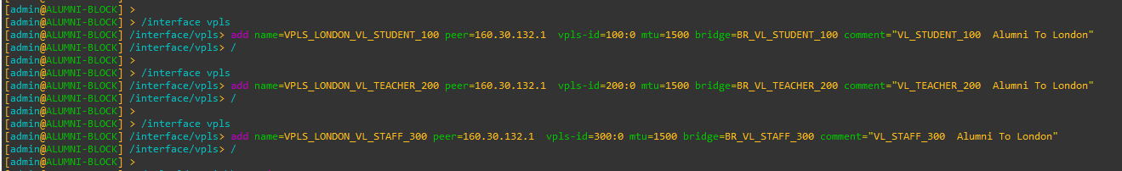

Figure 166: VPLS Configuration (ALUMNI-Points to LONDON-Points) on ALUMNI-BLOCK Router Through CMD

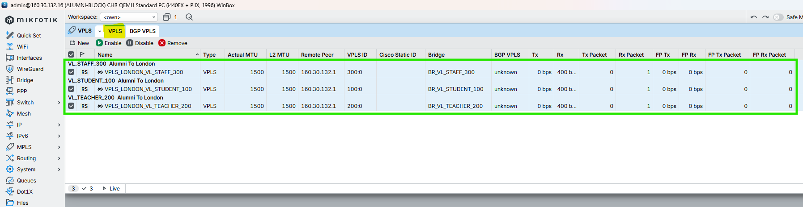

Figure 167: VPLS Configuration (ALUMNI-Points to LONDON-Points) on ALUMNI-BLOCK Router Through WINBOX

## KUMARI-BLOCK

### Create VPLS BRIDGES (L2 DOMAINS)

CMD

|  |
| --- |
| /interface bridge  add name=BR_VL_STUDENT_100 protocol-mode=none comment=“VL_STUDENT_100 – VPLS Bridge”  add name=BR_VL_TEACHER_200 protocol-mode=none comment=“VL_TEACHER_200 – VPLS Bridge”  add name=BR_VL_STAFF_300 protocol-mode=none comment=“VL_STAFF_300 – VPLS Bridge”  / |

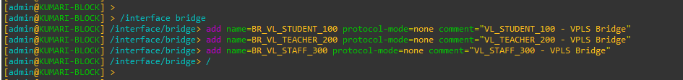

Figure 168: Create VPLS BRIDGES (L2 DOMAINS) on KUMARI-BLOCK Router Through CMD

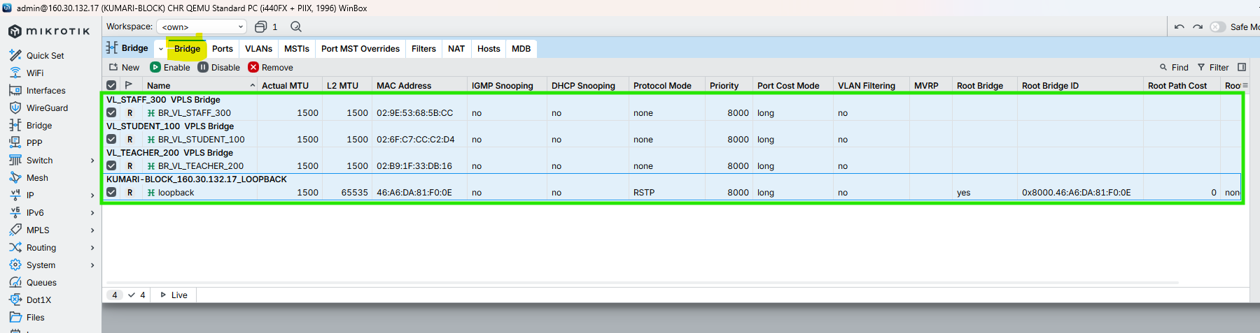

Figure 169: Create VPLS BRIDGES (L2 DOMAINS) on KUMARI-BLOCK Router Through WINBOX

### VPLS Configuration (KUMARI-Points to LONDON-Points)

CMD

|  |
| --- |
| /interface vpls  add name=VPLS_LONDON_VL_STUDENT_100 peer=160.30.132.1 vpls-id=100:0 mtu=1500 bridge=BR_VL_STUDENT_100 comment=“VL_STUDENT_100 – Kumari To London”  /  /interface vpls  add name=VPLS_LONDON_VL_TEACHER_200 peer=160.30.132.1 vpls-id=200:0 mtu=1500 bridge=BR_VL_TEACHER_200 comment=“VL_TEACHER_200 – Kumari To London”  /  /interface vpls  add name=VPLS_LONDON_VL_STAFF_300 peer=160.30.132.1 vpls-id=300:0 mtu=1500 bridge=BR_VL_STAFF_300 comment=“VL_STAFF_300 – Kumari To London”  /  /mpls ldp neighbor print  /interface vpls print  /interface bridge port print  /interface bridge host print |

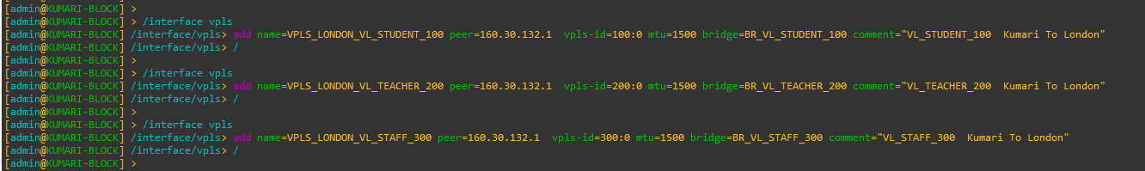

Figure 170: VPLS Configuration (KUMARI-Points to LONDON-Points) on KUMARI-BLOCK Router Through CMD

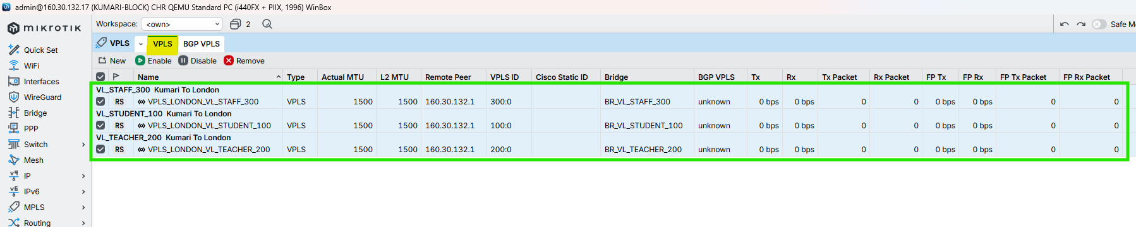

Figure 171: VPLS Configuration (KUMARI-Points to LONDON-Points) on KUMARI-BLOCK Router Through WINBOX

# Switch TO Router Configuration of Each Block

## LONDON-BLOCK

CMD

|  |
| --- |
| enable  configure terminal  hostname LONDON-BLOCK-SW  no ip domain-lookup  ip domain name isling-london-block-sw.com  crypto key generate rsa  1024  ip ssh version 2  line vty 0 15  transport input all  login local  exit  vlan 100  name STUDENTS  exit  vlan 200  name TEACHERS  exit  vlan 300  name STAFFS  exit  vlan 999  name MANAGEMENT-IP  exit  interface GigabitEthernet0/0  description TRUNK_to_LONDON_BLOCK_Router_P10  no shutdown  switchport trunk encapsulation dot1q  switchport mode trunk  switchport trunk allowed vlan 100,200,300,999  switchport trunk native vlan 999  ip dhcp snooping trust  exit  interface range GigabitEthernet0/1-3  no shutdown  switchport trunk encapsulation dot1q  switchport mode trunk  switchport trunk allowed vlan 100,200,300,999  switchport trunk native vlan 999  ip dhcp snooping trust  exit  interface range GigabitEthernet1/0-3  no shutdown  description STUDENTS  switchport mode access  switchport access vlan 100  spanning-tree portfast  spanning-tree bpduguard enable  ip dhcp snooping trust  exit  interface range GigabitEthernet2/0-3  no shutdown  description TEACHERS  switchport mode access  switchport access vlan 200  spanning-tree portfast  spanning-tree bpduguard enable  ip dhcp snooping trust  exit  interface range GigabitEthernet3/0-3  no shutdown  description STAFF  switchport mode access  switchport access vlan 300  spanning-tree portfast  spanning-tree bpduguard enable  ip dhcp snooping trust  exit  spanning-tree mode rapid-pvst  no spanning-tree vlan 100,200,300  do show interface description  do show interface gigabitEthernet0/0  do show interface gigabitEthernet0/1  do show interface trunk |

|  |  |
| --- | --- |
| Figure 172: Configuration of Switch to Router Links at LONDON-BLOCK (i) | Figure 173: Configuration of Switch to Router Links at LONDON-BLOCK (ii) |

## UK-BLOCK

CMD

|  |
| --- |
| enable  conf t  hostname UK-BLOCK-SW  no ip domain-lookup  vlan 100  name STUDENTS  exit  vlan 200  name TEACHERS  exit  vlan 300  name STAFF  exit  vlan 999  name MGMT  exit  interface gi0/0  description TRUNK_to_UK_BLOCK_Router  switchport trunk encapsulation dot1q  switchport mode trunk  switchport trunk allowed vlan 100,200,300,999  switchport trunk native vlan 999  ip dhcp snooping trust  no shutdown  exit  interface gi0/1  description TRUNK_to_NEPAL_BLOCK_Router  switchport trunk encapsulation dot1q  switchport mode trunk  switchport trunk allowed vlan 100,200,300,999  switchport trunk native vlan 999  ip dhcp snooping trust  no shutdown  exit  interface range gi1/0-3  description STUDENTS  switchport mode access  switchport access vlan 100  spanning-tree portfast  spanning-tree bpduguard enable  no shutdown  exit  interface range gi2/0-3  description TEACHERS  switchport mode access  switchport access vlan 200  spanning-tree portfast  spanning-tree bpduguard enable  no shutdown  exit  interface range gi3/0-3  description STAFF  switchport mode access  switchport access vlan 300  spanning-tree portfast  spanning-tree bpduguard enable  no shutdown  exit  end  wr  spanning-tree mode rapid-pvst  no spanning-tree vlan 100,200,300 |

|  |  |
| --- | --- |
| Figure 174: Configuration of Switch to Router Links at UK-BLOCK (i) | Figure 175: Configuration of Switch to Router Links at UK-BLOCK (ii) |

## NEPAL-BLOCK

CMD

|  |
| --- |
| enable  configure terminal  hostname NEPAL-BLOCK-SW  no ip domain-lookup  ip domain name isling-nepal-block-sw.com  crypto key generate rsa  1024  ip ssh version 2  line vty 0 15  transport input all  login local  exit  vlan 100  name STUDENTS  exit  vlan 200  name TEACHERS  exit  vlan 300  name STAFFS  exit  vlan 999  name MANAGEMENT-IP  exit  interface GigabitEthernet0/0  description TRUNK_to_NEPAL_BLOCK_Router_P8  no shutdown  switchport trunk encapsulation dot1q  switchport mode trunk  switchport trunk allowed vlan 100,200,300,999  switchport trunk native vlan 999  ip dhcp snooping trust  exit  interface GigabitEthernet0/1  description TRUNK_to_BRIT_BLOCK_Router_p7  no shutdown  switchport trunk encapsulation dot1q  switchport mode trunk  switchport trunk allowed vlan 100,200,300,999  switchport trunk native vlan 999  ip dhcp snooping trust  exit  interface range GigabitEthernet1/0-3  no shutdown  description STUDENTS  switchport mode access  switchport access vlan 100  spanning-tree portfast  spanning-tree bpduguard enable  ip dhcp snooping trust  exit  interface range GigabitEthernet2/0-3  no shutdown  description TEACHERS  switchport mode access  switchport access vlan 200  spanning-tree portfast  spanning-tree bpduguard enable  ip dhcp snooping trust  exit  interface range GigabitEthernet3/0-3  no shutdown  description STAFF  switchport mode access  switchport access vlan 300  spanning-tree portfast  spanning-tree bpduguard enable  ip dhcp snooping trust  exit  spanning-tree mode rapid-pvst  no spanning-tree vlan 100,200,300  do show interface description  do show interface gigabitEthernet0/0  do show interface gigabitEthernet0/1  do show interface trunk |

|  |  |
| --- | --- |
| Figure 176: Configuration of Switch to Router Links at NEPAL-BLOCK (i) | Figure 177: Configuration of Switch to Router Links at NEPAL-BLOCK (ii) |

## HIMAL-BLOCK

CMD

|  |
| --- |
| enable  configure terminal  hostname HIMAL-BLOCK-SW  no ip domain-lookup  ip domain name isling-himal-block-sw.com  crypto key generate rsa  1024  ip ssh version 2  line vty 0 15  transport input all  login local  exit  vlan 100  name STUDENTS  exit  vlan 200  name TEACHERS  exit  vlan 300  name STAFFS  exit  vlan 999  name MANAGEMENT-IP  exit  interface GigabitEthernet0/0  description TRUNK_to_HIMAL_BLOCK_Router_P8  no shutdown  switchport trunk encapsulation dot1q  switchport mode trunk  switchport trunk allowed vlan 100,200,300,999  switchport trunk native vlan 999  ip dhcp snooping trust  ip dhcp snooping trust  exit  interface GigabitEthernet0/1  description TRUNK_to_UK_BLOCK_Router_p7  no shutdown  switchport trunk encapsulation dot1q  switchport mode trunk  switchport trunk allowed vlan 100,200,300,999  switchport trunk native vlan 999  ip dhcp snooping trust  ip dhcp snooping trust  exit  interface range GigabitEthernet1/0-3  no shutdown  description STUDENTS  switchport mode access  switchport access vlan 100  spanning-tree portfast  spanning-tree bpduguard enable  ip dhcp snooping trust  exit  interface range GigabitEthernet2/0-3  no shutdown  description TEACHERS  switchport mode access  switchport access vlan 200  spanning-tree portfast  spanning-tree bpduguard enable  ip dhcp snooping trust  exit  interface range GigabitEthernet3/0-3  no shutdown  description STAFF  switchport mode access  switchport access vlan 300  spanning-tree portfast  spanning-tree bpduguard enable  ip dhcp snooping trust  exit  spanning-tree mode rapid-pvst  spanning-tree mode rapid-pvst  no spanning-tree vlan 100,200,300  do show interface description  do show interface gigabitEthernet0/0  do show interface gigabitEthernet0/1  do show interface trunk |

|  |  |
| --- | --- |
| Figure 178: Configuration of Switch to Router Links at HIMAL-BLOCK (i) | Figure 179: Configuration of Switch to Router Links at HIMAL-BLOCK (ii) |

## BRIT-BLOCK

CMD

|  |
| --- |
| enable  configure terminal  hostname BRIT-BLOCK-SW  no ip domain-lookup  ip domain name isling-brit-block-sw.com  crypto key generate rsa  1024  ip ssh version 2  line vty 0 15  transport input all  login local  exit  vlan 100  name STUDENTS  exit  vlan 200  name TEACHERS  exit  vlan 300  name STAFFS  exit  vlan 999  name MANAGEMENT-IP  exit  interface GigabitEthernet0/0  description TRUNK_to_BRIT_BLOCK_Router_P8  no shutdown  switchport trunk encapsulation dot1q  switchport mode trunk  switchport trunk allowed vlan 100,200,300,999  switchport trunk native vlan 999  ip dhcp snooping trust  ip dhcp snooping trust  exit  interface GigabitEthernet0/1  description TRUNK_to_KUMARI_BLOCK_Router_p6  no shutdown  switchport trunk encapsulation dot1q  switchport mode trunk  switchport trunk allowed vlan 100,200,300,999  switchport trunk native vlan 999  ip dhcp snooping trust  ip dhcp snooping trust  exit  interface range GigabitEthernet1/0-3  no shutdown  description STUDENTS  switchport mode access  switchport access vlan 100  spanning-tree portfast  spanning-tree bpduguard enable  ip dhcp snooping trust  exit  interface range GigabitEthernet2/0-3  no shutdown  description TEACHERS  switchport mode access  switchport access vlan 200  spanning-tree portfast  spanning-tree bpduguard enable  ip dhcp snooping trust  exit  interface range GigabitEthernet3/0-3  no shutdown  description STAFF  switchport mode access  switchport access vlan 300  spanning-tree portfast  spanning-tree bpduguard enable  ip dhcp snooping trust  exit  spanning-tree mode rapid-pvst  spanning-tree mode rapid-pvst  no spanning-tree vlan 100,200,300  do show interface description  do show interface gigabitEthernet0/0  do show interface gigabitEthernet0/1  do show interface trunk |

|  |  |
| --- | --- |
| Figure 180: Configuration of Switch to Router Links at BRIT-BLOCK (i) | Figure 181: Configuration of Switch to Router Links at BRIT-BLOCK (ii) |

## SKILL-BLOCK

CMD

|  |
| --- |
| enable  configure terminal  hostname SKILL-BLOCK-SW  no ip domain-lookup  ip domain name isling-skill-block-sw.com  crypto key generate rsa  1024  ip ssh version 2  line vty 0 15  transport input all  login local  exit  vlan 100  name STUDENTS  exit  vlan 200  name TEACHERS  exit  vlan 300  name STAFFS  exit  vlan 999  name MANAGEMENT-IP  exit  interface GigabitEthernet0/0  description TRUNK_to_SKILL_BLOCK_Router_P8  no shutdown  switchport trunk encapsulation dot1q  switchport mode trunk  switchport trunk allowed vlan 100,200,300,999  switchport trunk native vlan 999  ip dhcp snooping trust  ip dhcp snooping trust  exit  interface GigabitEthernet0/1  description TRUNK_to_HIMAL_BLOCK_Router_p7  no shutdown  switchport trunk encapsulation dot1q  switchport mode trunk  switchport trunk allowed vlan 100,200,300,999  switchport trunk native vlan 999  ip dhcp snooping trust  ip dhcp snooping trust  exit  interface range GigabitEthernet1/0-3  no shutdown  description STUDENTS  switchport mode access  switchport access vlan 100  spanning-tree portfast  spanning-tree bpduguard enable  ip dhcp snooping trust  exit  interface range GigabitEthernet2/0-3  no shutdown  description TEACHERS  switchport mode access  switchport access vlan 200  spanning-tree portfast  spanning-tree bpduguard enable  ip dhcp snooping trust  exit  interface range GigabitEthernet3/0-3  no shutdown  description STAFF  switchport mode access  switchport access vlan 300  spanning-tree portfast  spanning-tree bpduguard enable  ip dhcp snooping trust  exit  spanning-tree mode rapid-pvst  spanning-tree mode rapid-pvst  no spanning-tree vlan 100,200,300  do show interface description  do show interface gigabitEthernet0/0  do show interface gigabitEthernet0/1  do show interface trunk |

|  |  |
| --- | --- |
| Figure 182: Configuration of Switch to Router Links at SKILL-BLOCK (i) | Figure 183: Configuration of Switch to Router Links at SKILL-BLOCK (ii) |

## ALUMNI-BLOCK

CMD

|  |
| --- |
| ip ssh version 2  line vty 0 15  transport input all  login local  exit  vlan 100  name STUDENTS  exit  vlan 200  name TEACHERS  exit  vlan 300  name STAFFS  exit  vlan 999  name MANAGEMENT-IP  exit  interface GigabitEthernet0/0  description TRUNK_to_ALUMNI_BLOCK_Router_P8  no shutdown  switchport trunk encapsulation dot1q  switchport mode trunk  switchport trunk allowed vlan 100,200,300,999  switchport trunk native vlan 999  ip dhcp snooping trust  ip dhcp snooping trust  exit  interface GigabitEthernet0/1  description TRUNK_to_SKILL_BLOCK_Router_p7  no shutdown  switchport trunk encapsulation dot1q  switchport mode trunk  switchport trunk allowed vlan 100,200,300,999  switchport trunk native vlan 999  ip dhcp snooping trust  ip dhcp snooping trust  exit  interface range GigabitEthernet1/0-3  no shutdown  description STUDENTS  switchport mode access  switchport access vlan 100  spanning-tree portfast  spanning-tree bpduguard enable  ip dhcp snooping trust  exit  interface range GigabitEthernet2/0-3  no shutdown  description TEACHERS  switchport mode access  switchport access vlan 200  spanning-tree portfast  spanning-tree bpduguard enable  exit  interface range GigabitEthernet3/0-3  no shutdown  description STAFF  switchport mode access  switchport access vlan 300  spanning-tree portfast  spanning-tree bpduguard enable  ip dhcp snooping trust  exit  spanning-tree mode rapid-pvst  spanning-tree mode rapid-pvst  no spanning-tree vlan 100,200,300  do show interface description  do show interface gigabitEthernet0/0  do show interface gigabitEthernet0/1  do show interface trunk |

|  |  |
| --- | --- |
| Figure 184: Configuration of Switch to Router Links at ALUMNI-BLOCK (i) | Figure 185: Configuration of Switch to Router Links at ALUMNI-BLOCK (ii) |

## KUMARI-BLOCK

CMD

|  |
| --- |
| enable  configure terminal  hostname KUMARI-BLOCK-SW  no ip domain-lookup  ip domain name isling-kumari-block-sw.com  crypto key generate rsa  1024  ip ssh version 2  line vty 0 15  transport input all  login local  exit  vlan 100  name STUDENTS  exit  vlan 200  name TEACHERS  exit  vlan 300  name STAFFS  exit  vlan 999  name MANAGEMENT-IP  exit  interface GigabitEthernet0/0  description TRUNK_to_KUMARI_BLOCK_Router_P7  no shutdown  switchport trunk encapsulation dot1q  switchport mode trunk  switchport trunk allowed vlan 100,200,300,999  switchport trunk native vlan 999  ip dhcp snooping trust  ip dhcp snooping trust  exit  interface GigabitEthernet0/1  description TRUNK_to_ALUMNI_BLOCK_Router_p6  no shutdown  switchport trunk encapsulation dot1q  switchport mode trunk  switchport trunk allowed vlan 100,200,300,999  switchport trunk native vlan 999  ip dhcp snooping trust  ip dhcp snooping trust  exit  interface range GigabitEthernet1/0-3  no shutdown  description STUDENTS  switchport mode access  switchport access vlan 100  spanning-tree portfast  spanning-tree bpduguard enable  ip dhcp snooping trust  exit  interface range GigabitEthernet2/0-3  no shutdown  description TEACHERS  switchport mode access  switchport access vlan 200  spanning-tree portfast  spanning-tree bpduguard enable  ip dhcp snooping trust  exit  interface range GigabitEthernet3/0-3  no shutdown  description STAFF  switchport mode access  switchport access vlan 300  spanning-tree portfast  spanning-tree bpduguard enable  ip dhcp snooping trust  exit  spanning-tree mode rapid-pvst  spanning-tree mode rapid-pvst  no spanning-tree vlan 100,200,300  do show interface description  do show interface gigabitEthernet0/0  do show interface gigabitEthernet0/1  do show interface trunk |

|  |  |
| --- | --- |
| Figure 186: Configuration of Switch to Router Links at KUMARI-BLOCK (i) | Figure 187: Configuration of Switch to Router Links at KUMARI-BLOCK (ii) |

# Router TO Switch Trunk Configuration of Each Block

## LONDON-BLOCK

|  |
| --- |
| # Create VLAN subinterfaces on trunk port (to UK switch)  /interface vlan  add name=LONDON-SW.v100-ETHER-10 interface=ether10 vlan-id=100 comment=“LONDON-BLOCK trunk to LONDON switch – VLAN 100 STUDENT”  add name=LONDON-SW.v200-ETHER-10 interface=ether10 vlan-id=200 comment=“LONDON-BLOCK trunk to LONDON switch – VLAN 200 TEACHER”  add name=LONDON-SW.v300-ETHER-10 interface=ether10 vlan-id=300 comment=“LONDON-BLOCK trunk to LONDON switch – VLAN 300 STAFF”  /  # Add VLANs into correct VPLS bridges  /interface bridge port  add bridge=BR_VL_STUDENT_100 interface=LONDON-SW.v100-ETHER-10 comment=“LONDON-BLOCK VLAN100 to VPLS STUDENT bridge”  add bridge=BR_VL_TEACHER_200 interface=LONDON-SW.v200-ETHER-10 comment=“LONDON-BLOCK VLAN200 to VPLS TEACHER bridge”  add bridge=BR_VL_STAFF_300 interface= LONDON-SW.v300-ETHER-10 comment=“LONDON-BLOCK VLAN300 to VPLS STAFF bridge”  / |

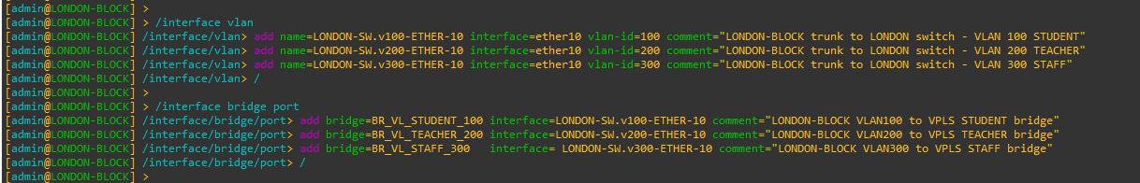

Figure 188: Router TO Switch Trunk Configuration on LONDON-BLOCK Router Through CMD

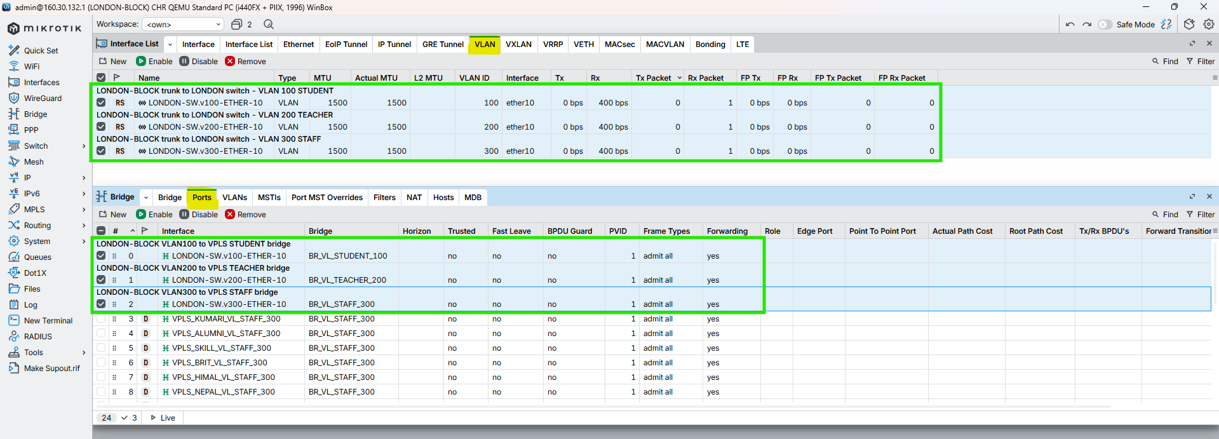

Figure 189: Router TO Switch Trunk Configuration on LONDON-BLOCK Router Through WINBOX

## UK-BLOCK

### Primary UK-BLOCK- SWITCH

|  |
| --- |
| /interface vlan  add name=UK-SW.v100-ETHER-8 interface=ether8 vlan-id=100 comment=“UK-BLOCK trunk to UK switch – VLAN 100 STUDENT”  add name=UK-SW.v200-ETHER-8 interface=ether8 vlan-id=200 comment=“UK-BLOCK trunk to UK switch – VLAN 200 TEACHER”  add name=UK-SW.v300-ETHER-8 interface=ether8 vlan-id=300 comment=“UK-BLOCK trunk to UK switch – VLAN 300 STAFF”  /interface bridge port  add bridge=BR_VL_STUDENT_100 interface=UK-SW.v100-ETHER-8 comment=“UK-BLOCK VLAN100 to VPLS STUDENT bridge”  add bridge=BR_VL_TEACHER_200 interface=UK-SW.v200-ETHER-8 comment=“UK-BLOCK VLAN200 to VPLS TEACHER bridge”  add bridge=BR_VL_STAFF_300 interface=UK-SW.v300-ETHER-8 comment=“UK-BLOCK VLAN300 to VPLS STAFF bridge” |

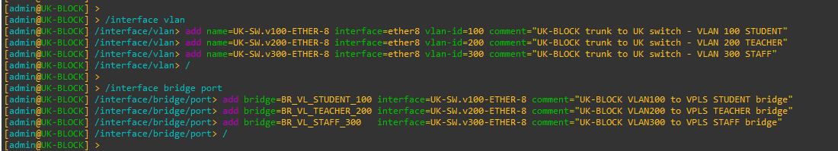

Figure 190: Router TO Switch Primary Trunk Configuration on UK-BLOCK Router Through CMD

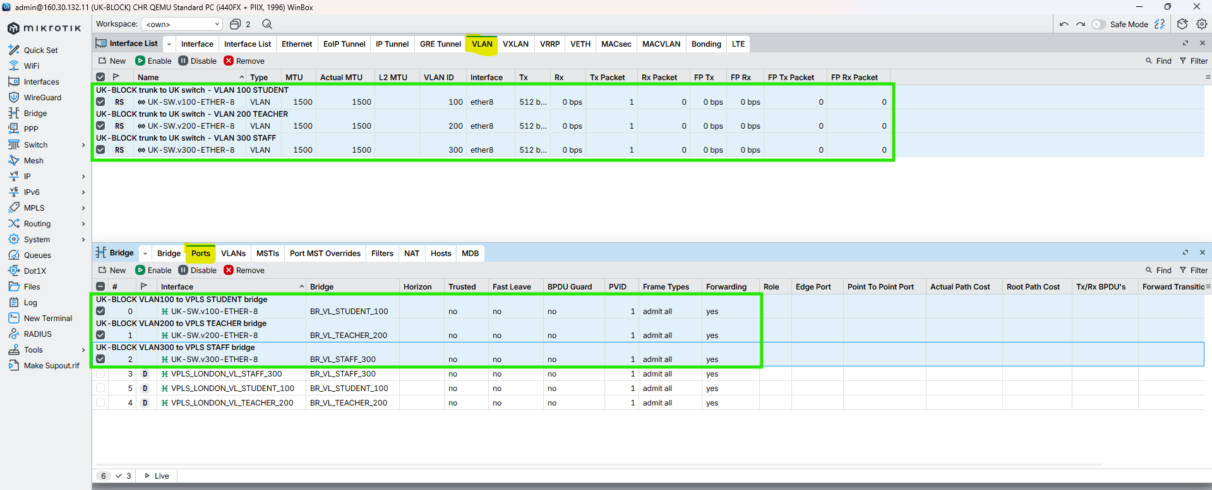

Figure 191: Router TO Switch Primary Trunk Configuration on UK-BLOCK Router Through WINBOX

### Secondary HIMAL-BLOCK-SWITCH

CMD

|  |
| --- |
| /interface vlan  add name=HIMAL-SW.v100-ETHER-7 interface=ether7 vlan-id=100 comment=“UK-BLOCK trunk to HIMAL switch – VLAN 100 STUDENT”  add name=HIMAL-SW.v200-ETHER-7 interface=ether7 vlan-id=200 comment=“UK-BLOCK trunk to HIMAL switch – VLAN 200 TEACHER”  add name=HIMAL-SW.v300-ETHER-7 interface=ether7 vlan-id=300 comment=“UK-BLOCK trunk to HIMAL switch – VLAN 300 STAFF”  /  /interface bridge port  add bridge=BR_VL_STUDENT_100 interface=HIMAL-SW.v100-ETHER-7 comment=“UK-BLOCK VLAN100 to VPLS STUDENT bridge”  add bridge=BR_VL_TEACHER_200 interface=HIMAL-SW.v200-ETHER-7 comment=“UK-BLOCK VLAN200 to VPLS TEACHER bridge”  add bridge=BR_VL_STAFF_300 interface=HIMAL-SW.v300-ETHER-7 comment=“UK-BLOCK VLAN300 to VPLS STAFF bridge”  / |

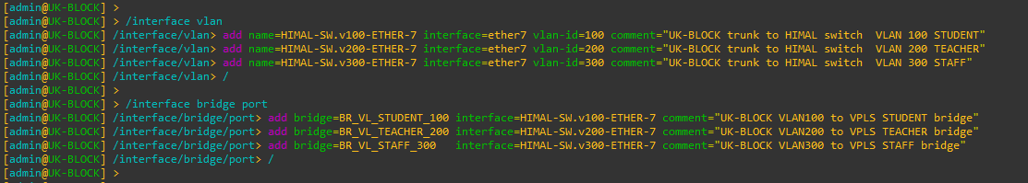

Figure 192: Router TO Switch Secondary Trunk Configuration on UK-BLOCK Router Through CMD

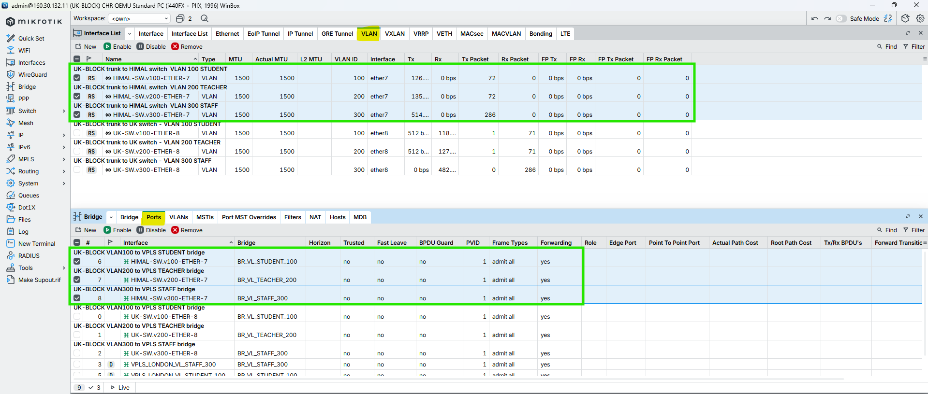

Figure 193: Router TO Switch Secondary Trunk Configuration on UK-BLOCK Router Through WINBOX

## NEPAL-BLOCK

### Primary NEPAL-BLOCK-SWITCH

CMD

|  |
| --- |
| /interface vlan  add name=NEPAL-SW.v100-ETHER-8 interface=ether8 vlan-id=100 comment=“NEPAL-BLOCK trunk to NEPAL switch – VLAN 100 STUDENT”  add name=NEPAL-SW.v200-ETHER-8 interface=ether8 vlan-id=200 comment=“NEPAL-BLOCK trunk to NEPAL switch – VLAN 200 TEACHER”  add name=NEPAL-SW.v300-ETHER-8 interface=ether8 vlan-id=300 comment=“NEPAL-BLOCK trunk to NEPAL switch – VLAN 300 STAFF”  /  /interface bridge port  add bridge=BR_VL_STUDENT_100 interface=NEPAL-SW.v100-ETHER-8 comment=“NEPAL-BLOCK VLAN100 to VPLS STUDENT bridge”  add bridge=BR_VL_TEACHER_200 interface=NEPAL-SW.v200-ETHER-8 comment=“NEPAL-BLOCK VLAN200 to VPLS TEACHER bridge”  add bridge=BR_VL_STAFF_300 interface=NEPAL-SW.v300-ETHER-8 comment=“NEPAL-BLOCK VLAN300 to VPLS STAFF bridge”  / |

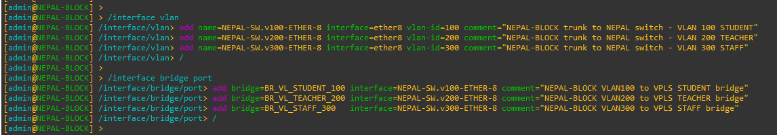

Figure 194: Router TO Switch Primary Trunk Configuration on NEPAL-BLOCK Router Through CMD

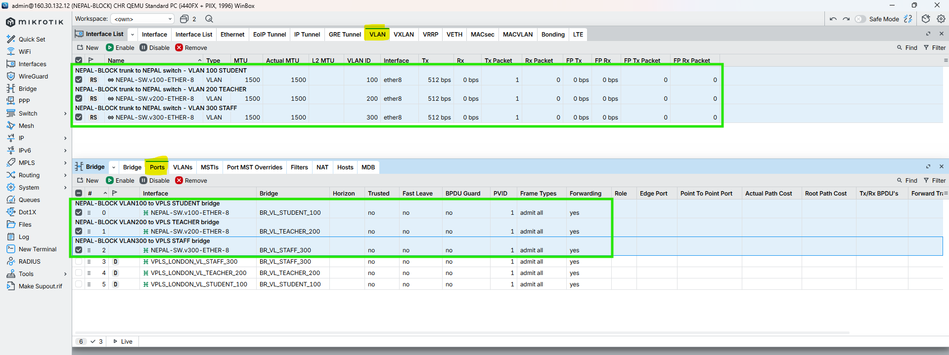

Figure 195: Router TO Switch Primary Trunk Configuration on NEPAL-BLOCK Router Through WINBOX

### Secondary-UK-BLOCK-SWITCH

CMD

|  |
| --- |
| /interface vlan  add name=NP-SW.v100-ETHER-7 interface=ether7 vlan-id=100 comment=“NEPAL-BLOCK trunk to UK switch – VLAN 100 STUDENT”  add name=NP-SW.v200-ETHER-7 interface=ether7 vlan-id=200 comment=“NEPAL-BLOCK trunk to UK switch – VLAN 200 TEACHER”  add name=NP-SW.v300-ETHER-7 interface=ether7 vlan-id=300 comment=“NEPAL-BLOCK trunk to UK switch – VLAN 300 STAFF”  /  /interface bridge port  add bridge=BR_VL_STUDENT_100 interface=NP-SW.v100-ETHER-7 comment=“NEPAL-BLOCK VLAN100 to VPLS STUDENT bridge”  add bridge=BR_VL_TEACHER_200 interface=NP-SW.v200-ETHER-7 comment=“NEPAL-BLOCK VLAN200 to VPLS TEACHER bridge”  add bridge=BR_VL_STAFF_300 interface=NP-SW.v300-ETHER-7 comment=“NEPAL-BLOCK VLAN300 to VPLS STAFF bridge”  / |

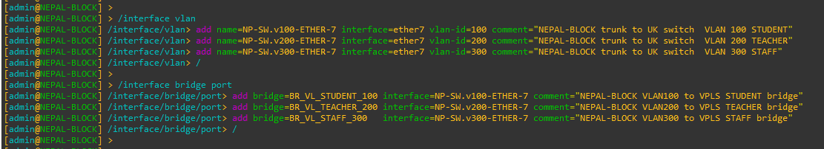

Figure 196: Router TO Switch Secondary Trunk Configuration on SKILL-BLOCK Router Through CMD

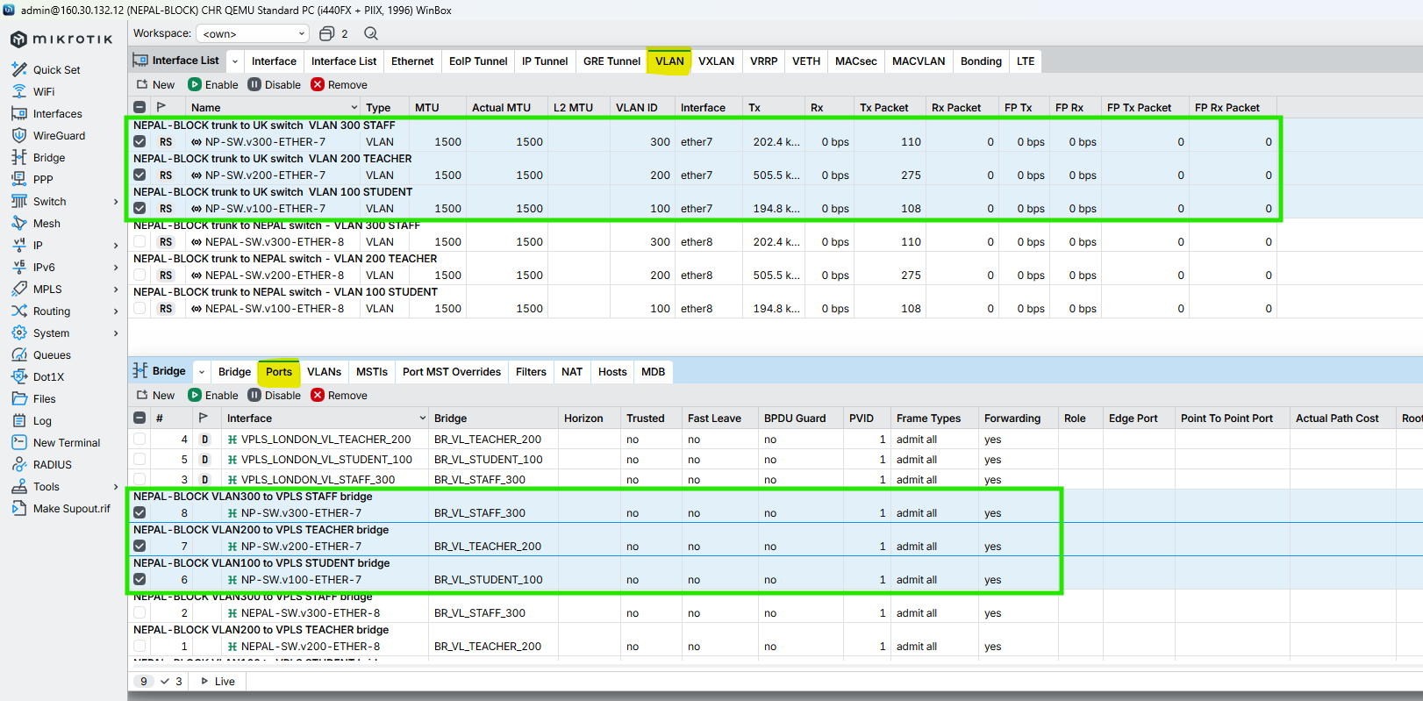

Figure 197: Router TO Switch Secondary Trunk Configuration on SKILL-BLOCK Router Through WINBOX

## HIMAL-BLOCK

### Primary HIMAL-BLOCK-SWITCH

CMD

|  |
| --- |
| /interface vlan  add name=HIMAL-SW.v100-ETHER-8 interface=ether8 vlan-id=100 comment=“HIMAL-BLOCK trunk to HIMAL switch – VLAN 100 STUDENT”  add name=HIMAL-SW.v200-ETHER-8 interface=ether8 vlan-id=200 comment=“HIMAL-BLOCK trunk to HIMAL switch – VLAN 200 TEACHER”  add name=HIMAL-SW.v300-ETHER-8 interface=ether8 vlan-id=300 comment=“HIMAL-BLOCK trunk to HIMAL switch – VLAN 300 STAFF”  /  /interface bridge port  add bridge=BR_VL_STUDENT_100 interface=HIMAL-SW.v100-ETHER-8 comment=“HIMAL-BLOCK VLAN100 to VPLS STUDENT bridge”  add bridge=BR_VL_TEACHER_200 interface=HIMAL-SW.v200-ETHER-8 comment=“HIMAL-BLOCK VLAN200 to VPLS TEACHER bridge”  add bridge=BR_VL_STAFF_300 interface=HIMAL-SW.v300-ETHER-8 comment=“HIMAL-BLOCK VLAN300 to VPLS STAFF bridge”  / |

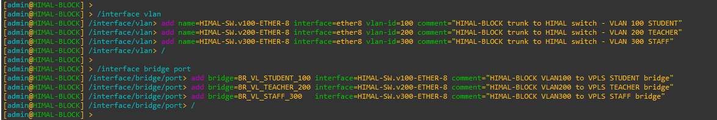

Figure 198: Router TO Switch Primary Trunk Configuration on HIMAL-BLOCK Router Through CMD

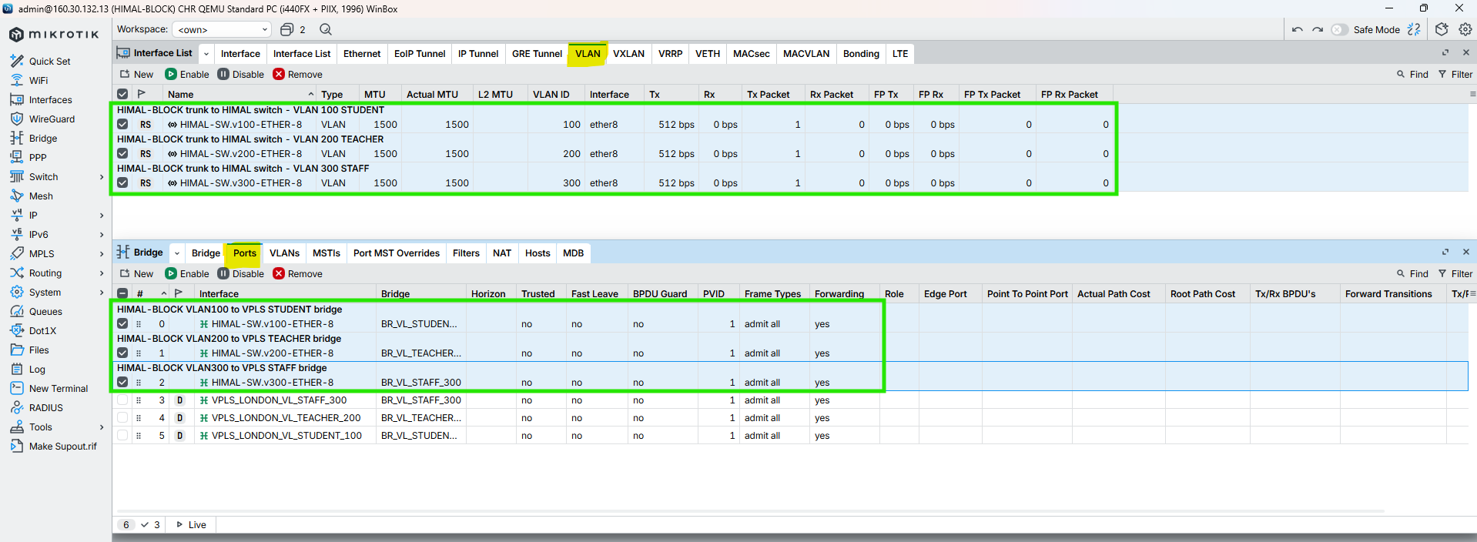

Figure 199: Router TO Switch Primary Trunk Configuration on HIMAL-BLOCK Router Through WINBOX

### Secondary SKILL-BLOCK-SWITCH

|  |
| --- |
| /interface vlan  add name=SKILL-SW.v100-ETHER-7 interface=ether7 vlan-id=100 comment=“HIMAL-BLOCK trunk to SKILL switch – VLAN 100 STUDENT”  add name=SKILL-SW.v200-ETHER-7 interface=ether7 vlan-id=200 comment=“HIMAL-BLOCK trunk to SKILL switch – VLAN 200 TEACHER”  add name=SKILL-SW.v300-ETHER-7 interface=ether7 vlan-id=300 comment=“HIMAL-BLOCK trunk to SKILL switch – VLAN 300 STAFF”  /  /interface bridge port  add bridge=BR_VL_STUDENT_100 interface=SKILL-SW.v100-ETHER-7 comment=“HIMAL-BLOCK VLAN100 to VPLS STUDENT bridge”  add bridge=BR_VL_TEACHER_200 interface=SKILL-SW.v200-ETHER-7 comment=“HIMAL-BLOCK VLAN200 to VPLS TEACHER bridge”  add bridge=BR_VL_STAFF_300 interface=SKILL-SW.v300-ETHER-7 comment=“HIMAL-BLOCK VLAN300 to VPLS STAFF bridge”  / |

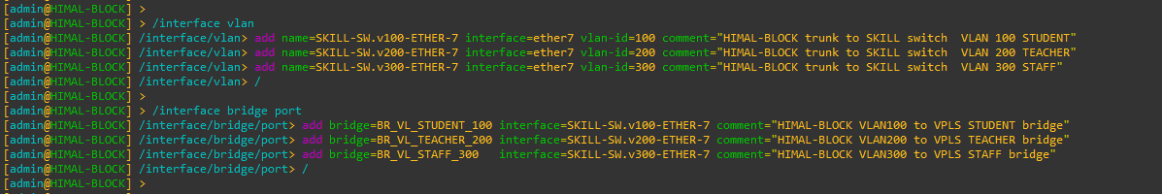

Figure 200: Router TO Switch Secondary Trunk Configuration on HIMAL-BLOCK Router Through CMD

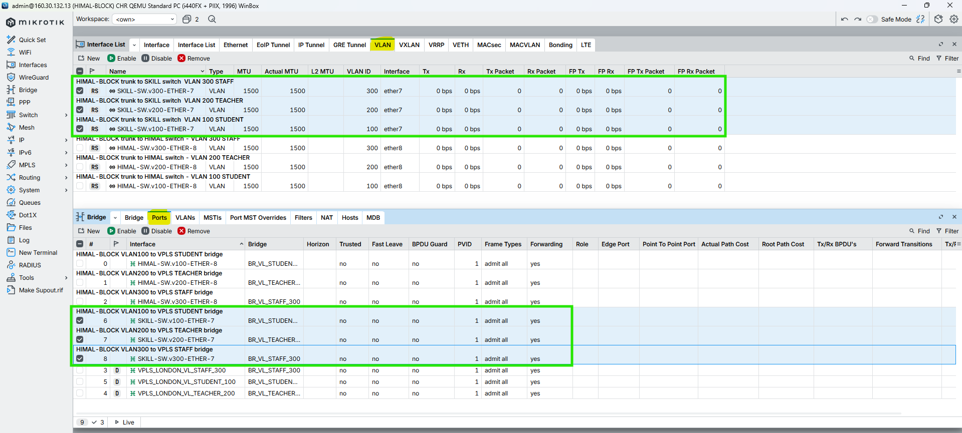

Figure 201: Router TO Switch Secondary Trunk Configuration on HIMAL-BLOCK Router Through WINBOX

## BRIT-BLOCK

### Primary BRIT-BLOCK-SWITCH

CMD

|  |
| --- |
| /interface vlan  add name=BRIT-SW.v100-ETHER-8 interface=ether8 vlan-id=100 comment=“BRIT-BLOCK trunk to BRIT switch – VLAN 100 STUDENT”  add name=BRIT-SW.v200-ETHER-8 interface=ether8 vlan-id=200 comment=“BRIT-BLOCK trunk to BRIT switch – VLAN 200 TEACHER”  add name=BRIT-SW.v300-ETHER-8 interface=ether8 vlan-id=300 comment=“BRIT-BLOCK trunk to BRIT switch – VLAN 300 STAFF”  /  /interface bridge port  add bridge=BR_VL_STUDENT_100 interface=BRIT-SW.v100-ETHER-8 comment=“BRIT-BLOCK VLAN100 to VPLS STUDENT bridge”  add bridge=BR_VL_TEACHER_200 interface=BRIT-SW.v200-ETHER-8 comment=“BRIT-BLOCK VLAN200 to VPLS TEACHER bridge”  add bridge=BR_VL_STAFF_300 interface=BRIT-SW.v300-ETHER-8 comment=“BRIT-BLOCK VLAN300 to VPLS STAFF bridge”  / |

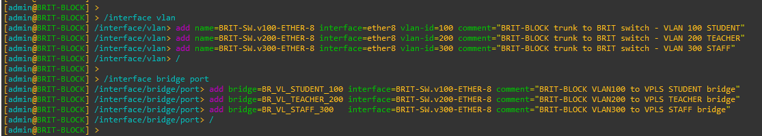

Figure 202: Router TO Switch Primary Trunk Configuration on BRIT-BLOCK Router Through CMD

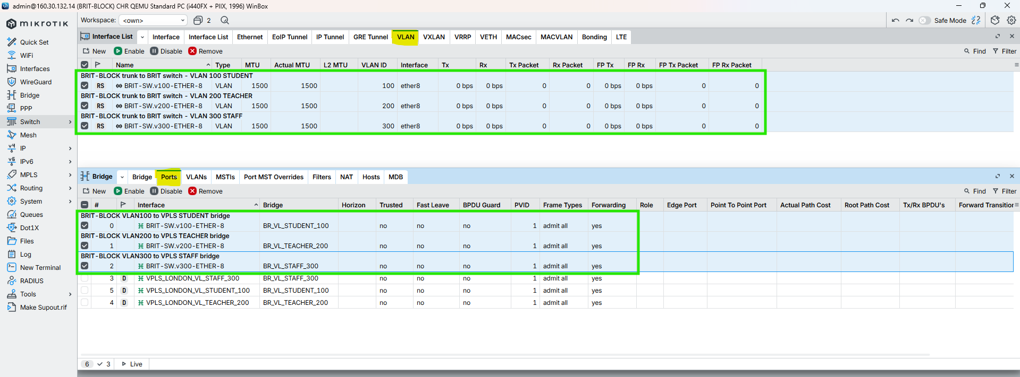

Figure 203: Router TO Switch Primary Trunk Configuration on BRIT-BLOCK Router Through WINBOX

### Secondary NEPAL-BLOCK-SWITCH

CMD

|  |
| --- |
| /interface vlan  add name=NEPAL-SW.v100-ETHER-7 interface=ether7 vlan-id=100 comment=“BRIT-BLOCK trunk to NEPAL switch – VLAN 100 STUDENT”  add name=NEPAL-SW.v200-ETHER-7 interface=ether7 vlan-id=200 comment=“BRIT-BLOCK trunk to NEPAL switch – VLAN 200 TEACHER”  add name=NEPAL-SW.v300-ETHER-7 interface=ether7 vlan-id=300 comment=“BRIT-BLOCK trunk to NEPAL switch – VLAN 300 STAFF”  /  /interface bridge port  add bridge=BR_VL_STUDENT_100 interface=NEPAL-SW.v100-ETHER-7 comment=“BRIT-BLOCK VLAN100 to VPLS STUDENT bridge”  add bridge=BR_VL_TEACHER_200 interface=NEPAL-SW.v200-ETHER-7 comment=“BRIT-BLOCK VLAN200 to VPLS TEACHER bridge”  add bridge=BR_VL_STAFF_300 interface=NEPAL-SW.v300-ETHER-7 comment=“BRIT-BLOCK VLAN300 to VPLS STAFF bridge”  / |

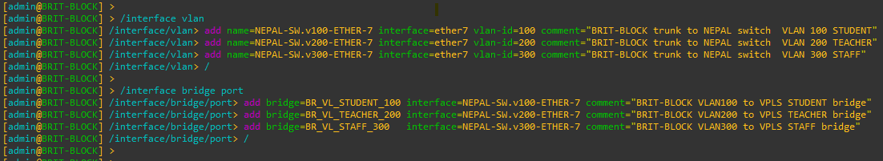

Figure 204: Router TO Switch Secondary Trunk Configuration on BRIT-BLOCK Router Through CMD

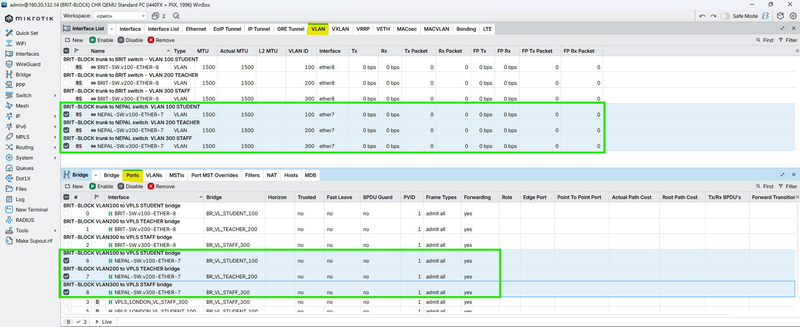

Figure 205: Router TO Switch Secondary Trunk Configuration on BRIT-BLOCK Router Through WINBOX

## SKILL-BLOCK

### Primary SKILL-BLOCK-SWITCH

CMD

|  |
| --- |
| /interface vlan  add name=SLILL-SW.v100-ETHER-8 interface=ether8 vlan-id=100 comment=“SLILL-BLOCK trunk to SLILL switch – VLAN 100 STUDENT”  add name=SLILL-SW.v200-ETHER-8 interface=ether8 vlan-id=200 comment=“SLILL-BLOCK trunk to SLILL switch – VLAN 200 TEACHER”  add name=SLILL-SW.v300-ETHER-8 interface=ether8 vlan-id=300 comment=“SLILL-BLOCK trunk to SLILL switch – VLAN 300 STAFF”  /  /interface bridge port  add bridge=BR_VL_STUDENT_100 interface=SLILL-SW.v100-ETHER-8 comment=“SLILL-BLOCK VLAN100 to VPLS STUDENT bridge”  add bridge=BR_VL_TEACHER_200 interface=SLILL-SW.v200-ETHER-8 comment=“SLILL-BLOCK VLAN200 to VPLS TEACHER bridge”  add bridge=BR_VL_STAFF_300 interface=SLILL-SW.v300-ETHER-8 comment=“SLILL-BLOCK VLAN300 to VPLS STAFF bridge”  / |

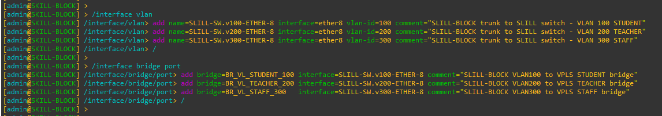

Figure 206: Router TO Switch Primary Trunk Configuration on SKILL-BLOCK Router Through CMD

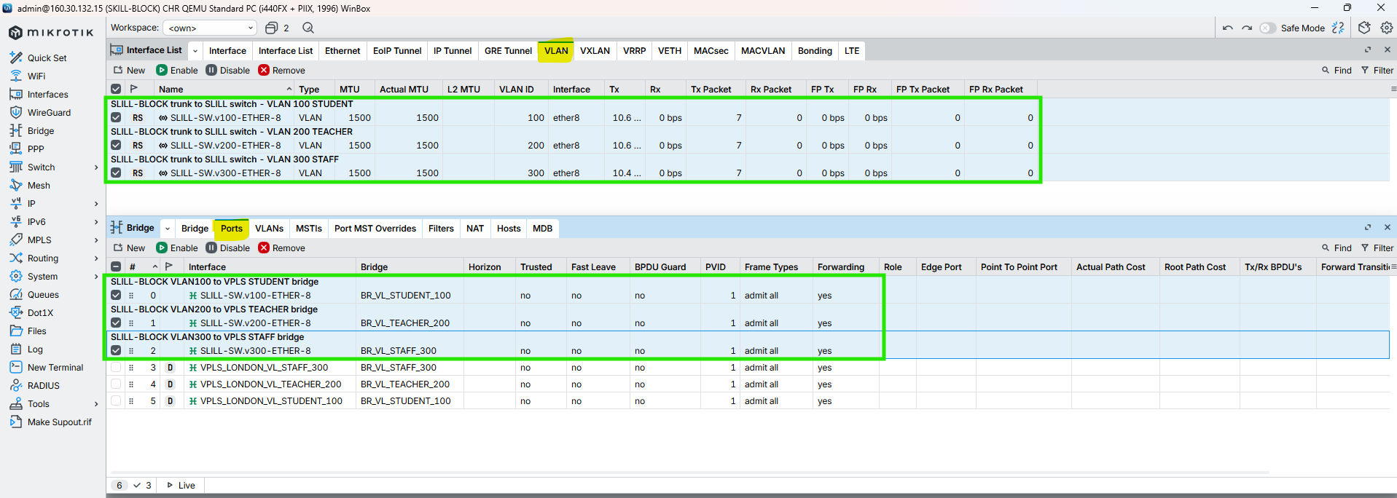

Figure 207: Router TO Switch Primary Trunk Configuration on SKILL-BLOCK Router Through WINBOX

### Secondary ALUMNI-BLOCK-SWITCH

CMD

|  |
| --- |
| /interface vlan  add name=ALUMNI-SW.v100-ETHER-7 interface=ether7 vlan-id=100 comment=“SKILL-BLOCK trunk to ALUMNI switch – VLAN 100 STUDENT”  add name=ALUMNI-SW.v200-ETHER-7 interface=ether7 vlan-id=200 comment=“SKILL-BLOCK trunk to ALUMNI switch – VLAN 200 TEACHER”  add name=ALUMNI-SW.v300-ETHER-7 interface=ether7 vlan-id=300 comment=“SKILL-BLOCK trunk to ALUMNI switch – VLAN 300 STAFF”  /  /interface bridge port  add bridge=BR_VL_STUDENT_100 interface=ALUMNI-SW.v100-ETHER-7 comment=“SKILL-BLOCK VLAN100 to VPLS STUDENT bridge”  add bridge=BR_VL_TEACHER_200 interface=ALUMNI-SW.v200-ETHER-7 comment=“SKILL-BLOCK VLAN200 to VPLS TEACHER bridge”  add bridge=BR_VL_STAFF_300 interface=ALUMNI-SW.v300-ETHER-7 comment=“SKILL-BLOCK VLAN300 to VPLS STAFF bridge”  / |

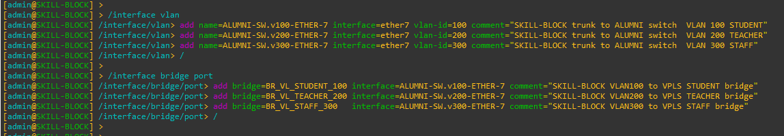

Figure 208: Router TO Switch Secondary Trunk Configuration on SKILL-BLOCK Router Through CMD

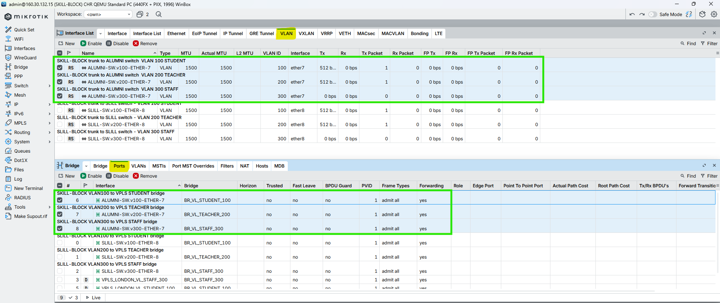

Figure 209: Router TO Switch Secondary Trunk Configuration on SKILL-BLOCK Router Through WINBOX

## ALUMNI-BLOCK

### Primary ALUMNI-BLOCK-SWITCH

CMD

|  |
| --- |
| /interface vlan  add name=ALUMNI-SW.v100-ETHER-8 interface=ether8 vlan-id=100 comment=“ALUMNI-BLOCK trunk to ALUMNI switch - VLAN 100 STUDENT”  add name=ALUMNI-SW.v200-ETHER-8 interface=ether8 vlan-id=200 comment=“ALUMNI-BLOCK trunk to ALUMNI switch - VLAN 200 TEACHER”  add name=ALUMNI-SW.v300-ETHER-8 interface=ether8 vlan-id=300 comment=“ALUMNI-BLOCK trunk to ALUMNI switch - VLAN 300 STAFF”  /  /interface bridge port  add bridge=BR_VL_STUDENT_100 interface=ALUMNI-SW.v100-ETHER-8 comment=“ALUMNI-BLOCK VLAN100 to VPLS STUDENT bridge”  add bridge=BR_VL_TEACHER_200 interface=ALUMNI-SW.v200-ETHER-8 comment=“ALUMNI-BLOCK VLAN200 to VPLS TEACHER bridge”  add bridge=BR_VL_STAFF_300 interface=ALUMNI-SW.v300-ETHER-8 comment=“ALUMNI-BLOCK VLAN300 to VPLS STAFF bridge”  / |

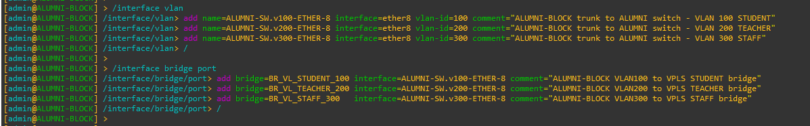

Figure 210: Router TO Switch Primary Trunk Configuration on ALUMNI-BLOCK Router Through CMD

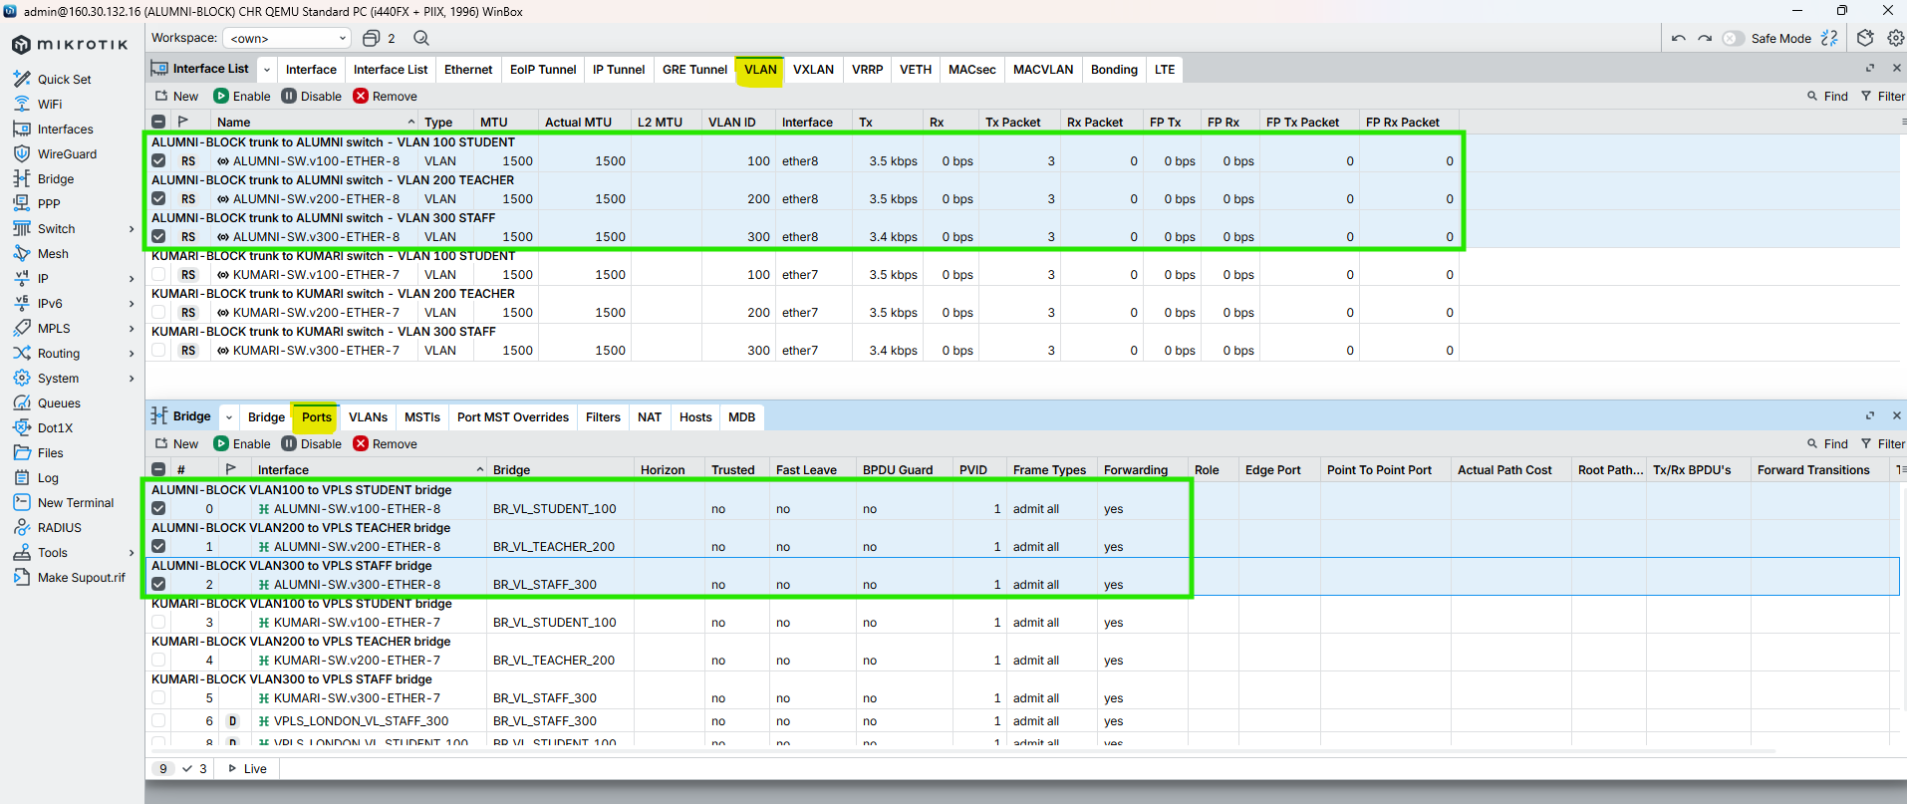

Figure 211: Router TO Switch Primary Trunk Configuration on ALUMNI-BLOCK Router Through WINBOX

### Secondary KUMARI-BLOCK-SWITCH

CMD

|  |
| --- |
| /interface vlan  add name=KUMARI-SW.v100-ETHER-6 interface=ether6 vlan-id=100 comment=“ALUMNI-BLOCK trunk to KUMARI switch – VLAN 100 STUDENT”  add name=KUMARI-SW.v200-ETHER-6 interface=ether6 vlan-id=200 comment=“ALUMNI-BLOCK trunk to KUMARI switch – VLAN 200 TEACHER”  add name=KUMARI-SW.v300-ETHER-6 interface=ether6 vlan-id=300 comment=“ALUMNI-BLOCK trunk to KUMARI switch – VLAN 300 STAFF”  /  /interface bridge port  add bridge=BR_VL_STUDENT_100 interface=KUMARI-SW.v100-ETHER-6 comment=“ALUMNI-BLOCK VLAN100 to VPLS STUDENT bridge”  add bridge=BR_VL_TEACHER_200 interface=KUMARI-SW.v200-ETHER-6 comment=“ALUMNI-BLOCK VLAN200 to VPLS TEACHER bridge”  add bridge=BR_VL_STAFF_300 interface=KUMARI-SW.v300-ETHER-6 comment=“ALUMNI-BLOCK VLAN300 to VPLS STAFF bridge”  / |

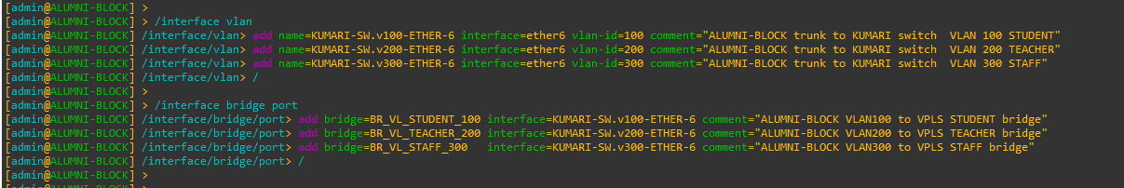

Figure 212: Router TO Switch Secondary Trunk Configuration on ALUMNI-BLOCK Router Through CMD

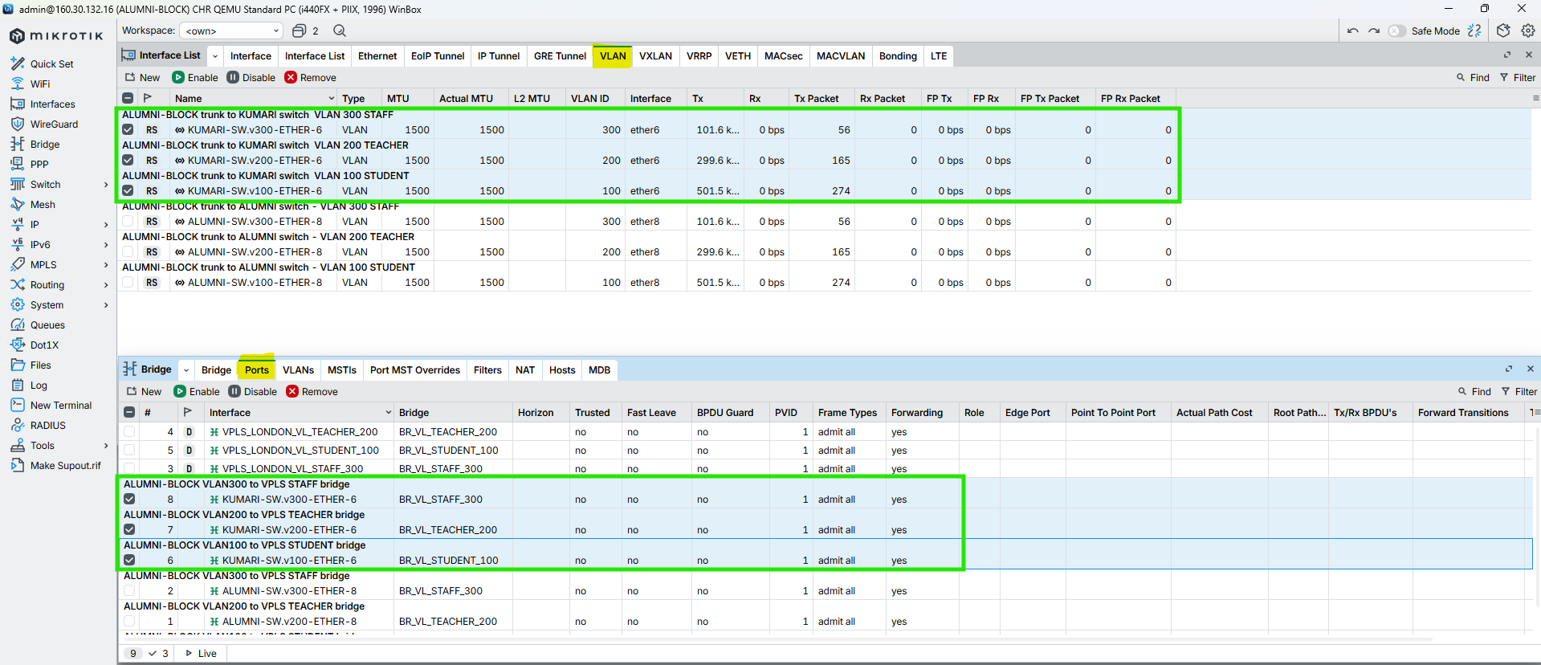

Figure 213: Router TO Switch Secondary Trunk Configuration on ALUMNI-BLOCK Router Through WINBOX

## KUMARI-BLOCK

### Primary KUMARI-BLOCK-SWITCH

CMD

|  |
| --- |
| /interface vlan  add name=KUMARI-SW.v100-ETHER-7 interface=ether7 vlan-id=100 comment=“KUMARI-BLOCK trunk to KUMARI switch – VLAN 100 STUDENT”  add name=KUMARI-SW.v200-ETHER-7 interface=ether7 vlan-id=200 comment=“KUMARI-BLOCK trunk to KUMARI switch – VLAN 200 TEACHER”  add name=KUMARI-SW.v300-ETHER-7 interface=ether7 vlan-id=300 comment=“KUMARI-BLOCK trunk to KUMARI switch – VLAN 300 STAFF”  /  /interface bridge port  add bridge=BR_VL_STUDENT_100 interface=KUMARI-SW.v100-ETHER-7 comment=“KUMARI-BLOCK VLAN100 to VPLS STUDENT bridge”  add bridge=BR_VL_TEACHER_200 interface=KUMARI-SW.v200-ETHER-7 comment=“KUMARI-BLOCK VLAN200 to VPLS TEACHER bridge”  add bridge=BR_VL_STAFF_300 interface=KUMARI-SW.v300-ETHER-7 comment=“KUMARI-BLOCK VLAN300 to VPLS STAFF bridge”  / |

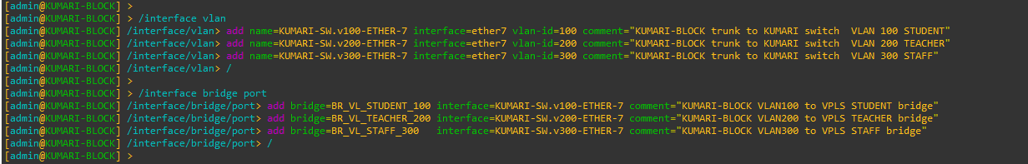

Figure 214: Router TO Switch Primary Trunk Configuration on KUMARI-BLOCK Router Through CMD

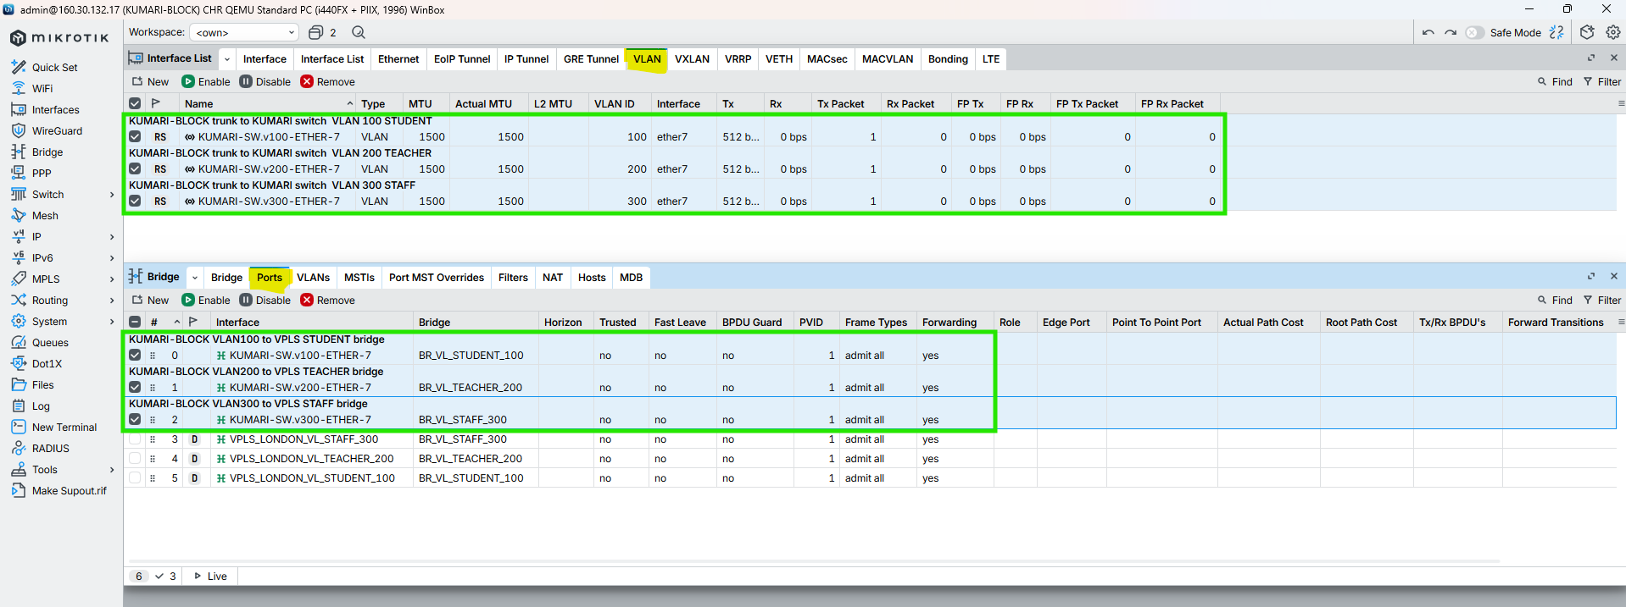

Figure 215: Router TO Switch Primary Trunk Configuration on KUMARI-BLOCK Router Through WINBOX

### Secondary BRIT-BLOCK-SWITCH

CMD

|  |
| --- |
| /interface vlan  add name=BRIT-SW.v100-ETHER-6 interface=ether6 vlan-id=100 comment=“KUMARI-BLOCK trunk to BRIT switch – VLAN 100 STUDENT”  add name=BRIT-SW.v200-ETHER-6 interface=ether6 vlan-id=200 comment=“KUMARI-BLOCK trunk to BRIT switch – VLAN 200 TEACHER”  add name=BRIT-SW.v300-ETHER-6 interface=ether6 vlan-id=300 comment=“KUMARI-BLOCK trunk to BRIT switch – VLAN 300 STAFF”  /  /interface bridge port  add bridge=BR_VL_STUDENT_100 interface=BRIT-SW.v100-ETHER-6 comment=“KUMARI-BLOCK VLAN100 to VPLS STUDENT bridge”  add bridge=BR_VL_TEACHER_200 interface=BRIT-SW.v200-ETHER-6 comment=“KUMARI-BLOCK VLAN200 to VPLS TEACHER bridge”  add bridge=BR_VL_STAFF_300 interface=BRIT-SW.v300-ETHER-6 comment=“KUMARI-BLOCK VLAN300 to VPLS STAFF bridge”  / |

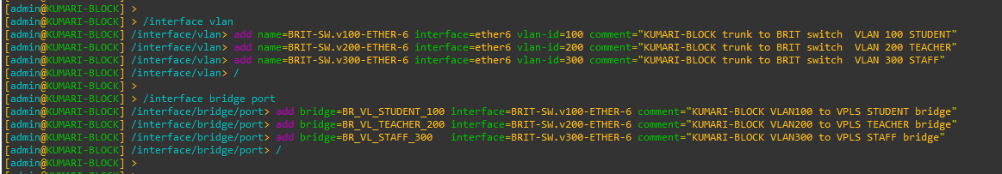

Figure 216: Router TO Switch Secondary Trunk Configuration on KUMARI-BLOCK Router Through CMD

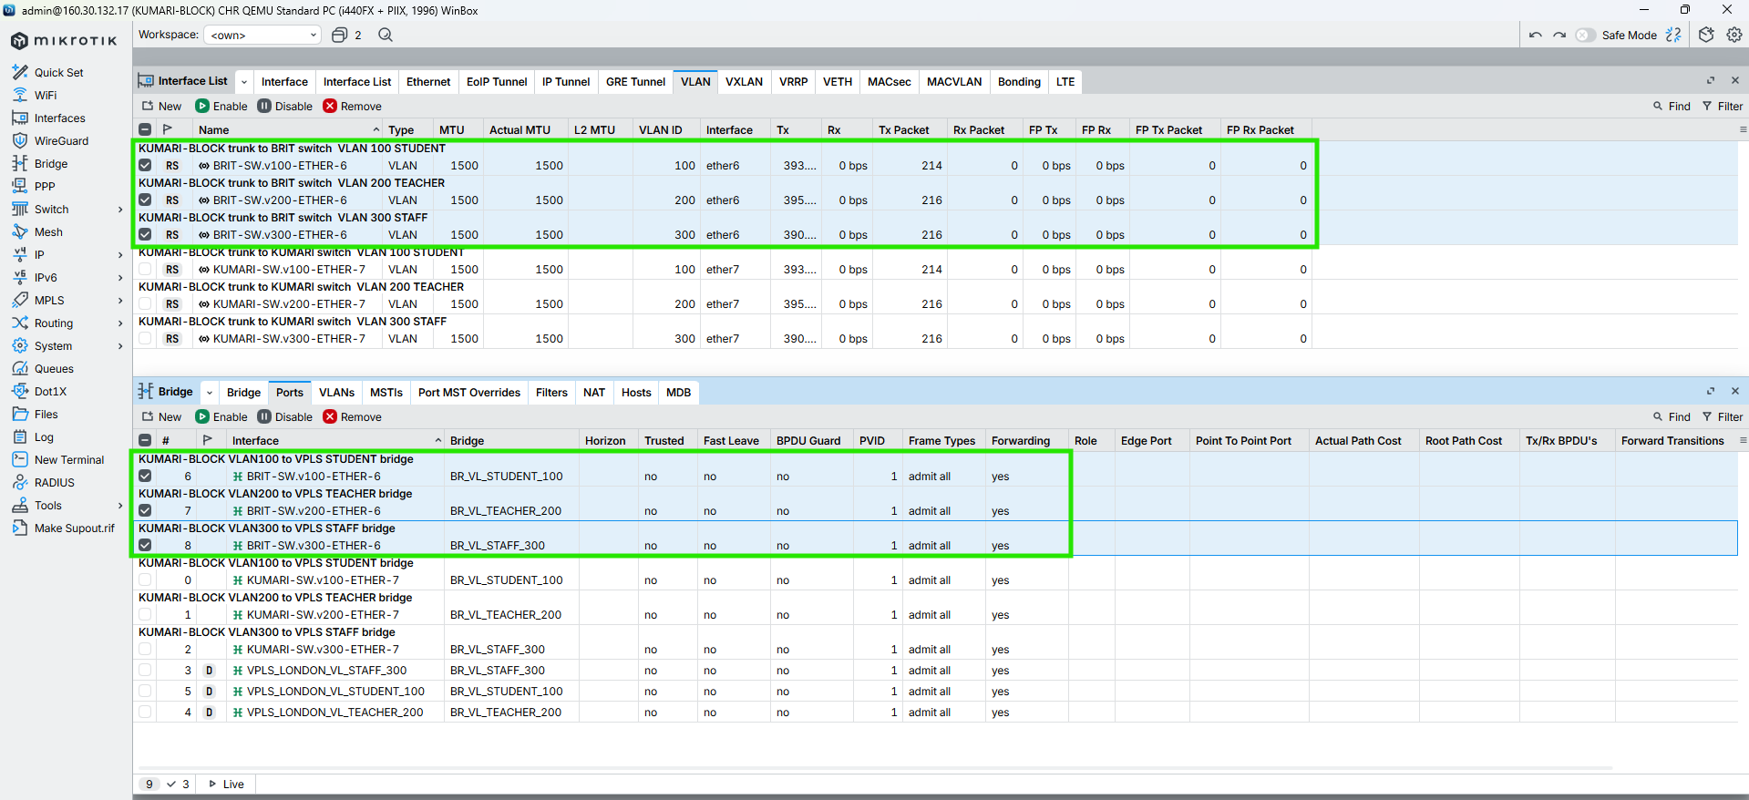

Figure 217: Router TO Switch Secondary Trunk Configuration on KUMARI-BLOCK Router Through WINBOX

# Centralized DHCP Server Configuration

## LONDON-BLOCK

### Assign Gateway IPs to VLAN bridges

CMD

|  |
| --- |
| /ip address  add address=172.16.0.1/19 interface=BR_VL_STUDENT_100 comment=“GW VLAN100 STUDENT - LONDON DHCP”  add address=172.16.32.1/22 interface=BR_VL_TEACHER_200 comment=“GW VLAN200 TEACHER - LONDON DHCP”  add address=172.16.40.1/21 interface=BR_VL_STAFF_300 comment=“GW VLAN300 STAFF - LONDON DHCP”  / |

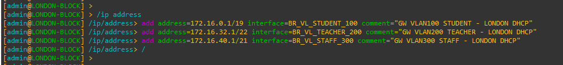

Figure 218: Assign Gateway IPs to VLAN bridges for DHCP on LONDON-BLOCK Router Through CMD

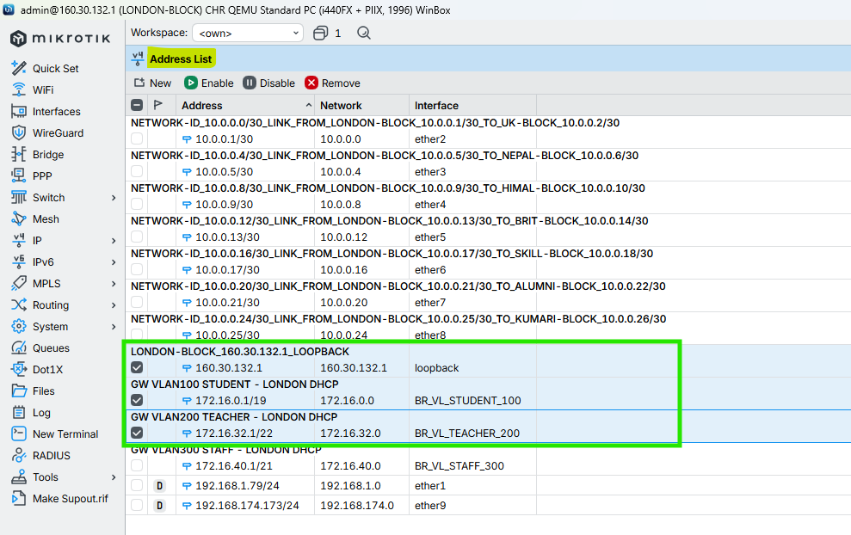

Figure 219: Assign Gateway IPs to VLAN bridges for DHCP on LONDON-BLOCK Router Through WINBOX

### Create DHCP pools

CMD

|  |
| --- |
| /ip pool  add name=POOL_VLAN100 ranges=172.16.0.10-172.16.31.254 comment=“Student DHCP pool”  add name=POOL_VLAN200 ranges=172.16.32.10-172.16.35.254 comment=“Teacher DHCP pool”  add name=POOL_VLAN300 ranges=172.16.40.10-172.16.47.254 comment=“Staff DHCP pool”  / |

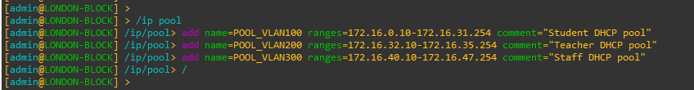

Figure 220: Create DHCP pools for DHCP on LONDON-BLOCK Router Through CMD

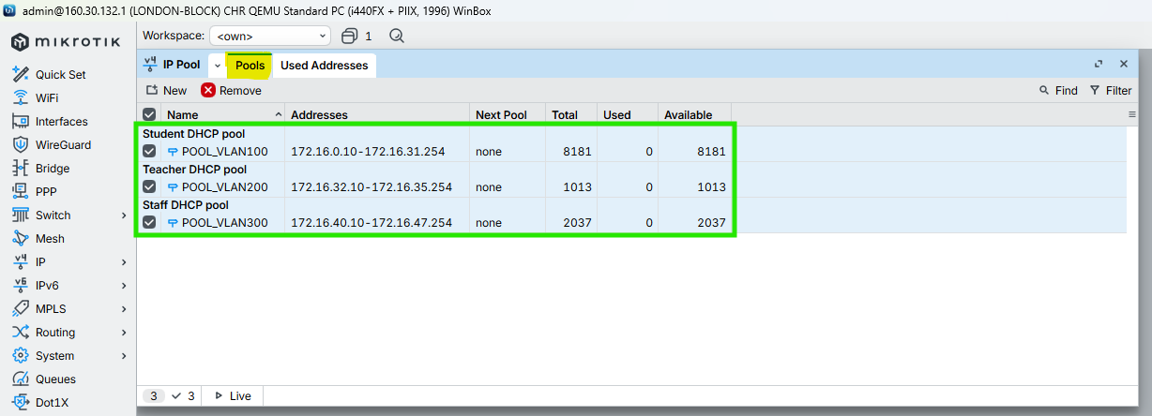

Figure 221: Create DHCP pools for DHCP on LONDON-BLOCK Router Through WINBOX

### Create DHCP servers (one per VLAN bridge)

CMD

|  |
| --- |
| /ip dhcp-server  add name=DHCP_VLAN100 interface=BR_VL_STUDENT_100 address-pool=POOL_VLAN100 lease-time=12h disabled=no comment=“DHCP STUDENT VLAN100”  add name=DHCP_VLAN200 interface=BR_VL_TEACHER_200 address-pool=POOL_VLAN200 lease-time=12h disabled=no comment=“DHCP TEACHER VLAN200”  add name=DHCP_VLAN300 interface=BR_VL_STAFF_300 address-pool=POOL_VLAN300 lease-time=12h disabled=no comment=“DHCP STAFF VLAN300”  / |



Figure 222: Create DHCP servers (one per VLAN bridge) on LONDON-BLOCK Router Through CMD

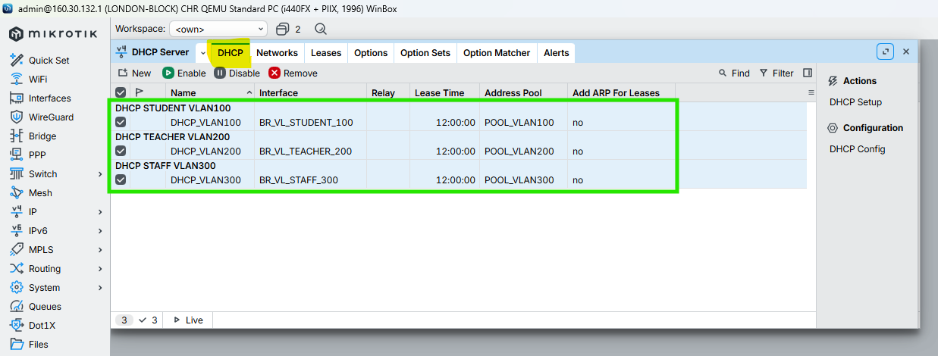

Figure 223: Create DHCP servers (one per VLAN bridge) on LONDON-BLOCK Router Through WINBOX

### Define DHCP network options

CMD

|  |
| --- |
| /ip dhcp-server network  add address=172.16.0.0/19 gateway=172.16.0.1 dns-server=8.8.8.8,1.1.1.1 comment=“Student VLAN100 DHCP options”  add address=172.16.32.0/22 gateway=172.16.32.1 dns-server=8.8.8.8,1.1.1.1 comment=“Teacher VLAN200 DHCP options”  add address=172.16.40.0/21 gateway=172.16.40.1 dns-server=8.8.8.8,1.1.1.1 comment=“Staff VLAN300 DHCP options”  / |



Figure 224: Define DHCP network options on LONDON-BLOCK Router Through CMD

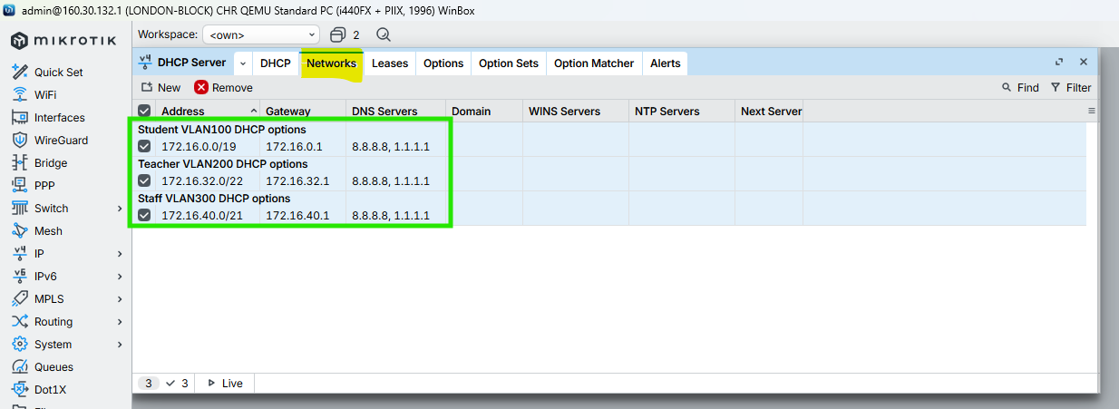

Figure 225: Define DHCP network options on LONDON-BLOCK Router Through WINBOX

# DHCP Verification

## LONDON-BLOCK

|  |
| --- |
| Figure 226: DHCP Verification of Student PC on LONDON-BLOCK |
| Figure 227: DHCP Verification of Teacher PC on LONDON-BLOCK |
| Figure 228: DHCP Verification of Staff PC on LONDON-BLOCK |

## UK-BLOCK

|  |
| --- |
| Figure 229: DHCP Verification of Student PC on UK-BLOCK |
| Figure 230: DHCP Verification of Teacher PC on UK-BLOCK |
| Figure 231: DHCP Verification of Staff PC on UK-BLOCK |

# Network Topology and Diagrams

## Full Network Topology Diagram



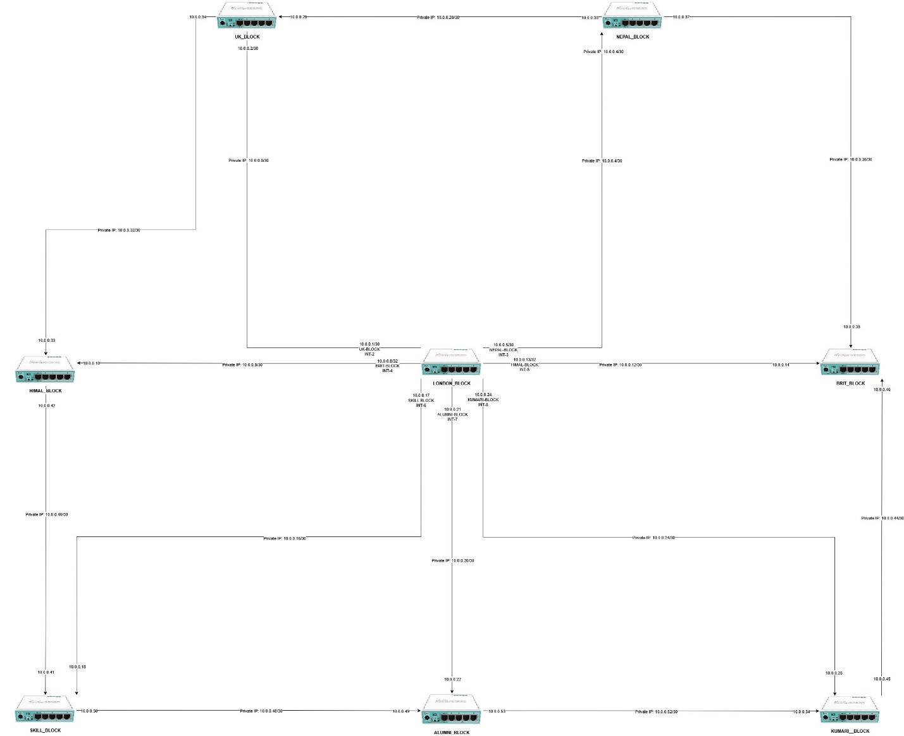

# Conclusion and Future Enhancements

## Conclusion

This project successfully designed, implemented, and verified an MPLS and VPLS-based backbone network for a multi-block campus environment inspired by the infrastructure of Islington College. Using GNS3 and MikroTik routers, a scalable and resilient core network was created to interconnect nine academic and administrative blocks through a combination of OSPF, MPLS with LDP, and VPLS-based Layer-2 VPNs.

The implementation demonstrated how OSPF can efficiently provide dynamic routing and fast convergence within an MPLS core, while MPLS with LDP enabled label-switched paths for optimized packet forwarding and load balancing using ECMP. The use of VPLS allowed VLANs to be transparently extended across geographically separated blocks, ensuring consistent Layer-2 connectivity for Students, Teachers, and Staff without deploying local DHCP services on each router.

A centralized DHCP architecture was successfully integrated, proving that IP address management can be simplified while maintaining VLAN separation across the MPLS backbone. End-to-end testing confirmed correct IP allocation, VLAN transport, inter-block connectivity, redundancy, and failover behavior across multiple paths.

Throughout the project, several real-world networking challenges—such as MTU mismatches, VPLS bridging behavior, and routing visibility—were identified and resolved. Addressing these issues provided practical insight into service provider–style network design and reinforced the importance of structured planning, verification, and troubleshooting in large-scale networks.

Overall, this project strengthened practical understanding of service provider technologies, particularly MPLS, VPLS, and OSPF, and demonstrated how enterprise and campus networks can be designed with scalability, redundancy, and centralized management in mind. The completed design serves as a strong foundation for further enhancements and reflects real-world networking principles applicable to ISP and enterprise environments.

## Future Enhancements

Load Balancing Internal Network

Security and Access Control Management (SSH / Winbox)

ACLs / Firewall Rules for Router Interfaces

System Monitoring

Jumbo MTU